G. Clarification through communication
• Program of talks from a previous year's course.
• Example of a student's overall argument and my summary and title for the project after digesting the argument
• The first example of an outline is preceded by my comments so you can see what I made of it.
• The next outline is one that I reworked as an example.
• The next example of an outline is equivalent to a nested and connected table of contents, but it was straightforward to convert it to the narrative outline that follows.
• The other five examples include narrative.
Public work-in-progress presentations
from Critical & Creative Thinking 698

In this course students choose a current social or educational issue that concerns them, i.e., they want to know more about it, advocate a change, or design an intervention or engagement. They work through the different stages of research and action—from defining a manageable project to communicating their findings and plans for further work. (For more information contact peter.taylor@umb.edu)

Part I: Tuesday, Nov. 12, 6.45-9.30pm, Mc C 2-628
6.45pm
Fostering powerful writers through workshop communities: Using writer's workshop to facilitate a more inclusive and expansive approach and attitude towards writing -- Dory Oppenheim
Creating original music -- Joe Herosy
Strategic ways to eradicate corruption in Nigeria -- Benjamin Okafor
Using dialogue and dialogic discourse to practice meta-cognition & build community in classrooms -- Jane Kenefick
7.45pm
Family-friendly practices in the workplace -- Melissa Moynihan
Towards teamwork in nursing -- Jeanne Hammond
Dialogue process for exchange around homosexuality -- Gloria Perez
Creating a more productive learning environment within a music classroom through the development of a learning organization -- Kathleen Walsh
8.45pm
Guiding 6th grade students through an experimental science project: Management, coaching & implementation suggestions to instill wonder while using the scientific method -- Kristen Rushworth
*Advertising in the United States: The development of an international renaissance style -- April Rucker
Part II: Monday, Nov. 18, 5.30-9.30pm, Mc C 2-628
5.30pm
Reflections on writing novels for young adults -- Susan Butler
Integrating philosophy into a high school English class -- Cynthia Than
* Successful transition back from alternative schools -- Malcolm Smith
6.45pm
Empowerment issues in nursing -- Gloria Hicks
Sexuality ed. in global context -- Barbara Huscher
Media manipulation -- Kevin Johnson
The components of a career change: What are the reasons you want to do this? -- John Lewis
7.45pm
The awareness of how bureaucracy affects us in everyday life -- Bob Lingley
Overview of CCT skills that support the big six information problem solving process -- Mary Moniz
How to get people interested in the dialogue process in Japan -- Tamami Nakashima
How collecting and sharing music creates connections to history -- Matthew Puma
8.45pm
Why is breed-specific legislation ineffective? -- Heidi Straghan
A holistic approach to the studio experience is vital for all visual arts disciplines -- Luanne Witkowski
(*tentative)
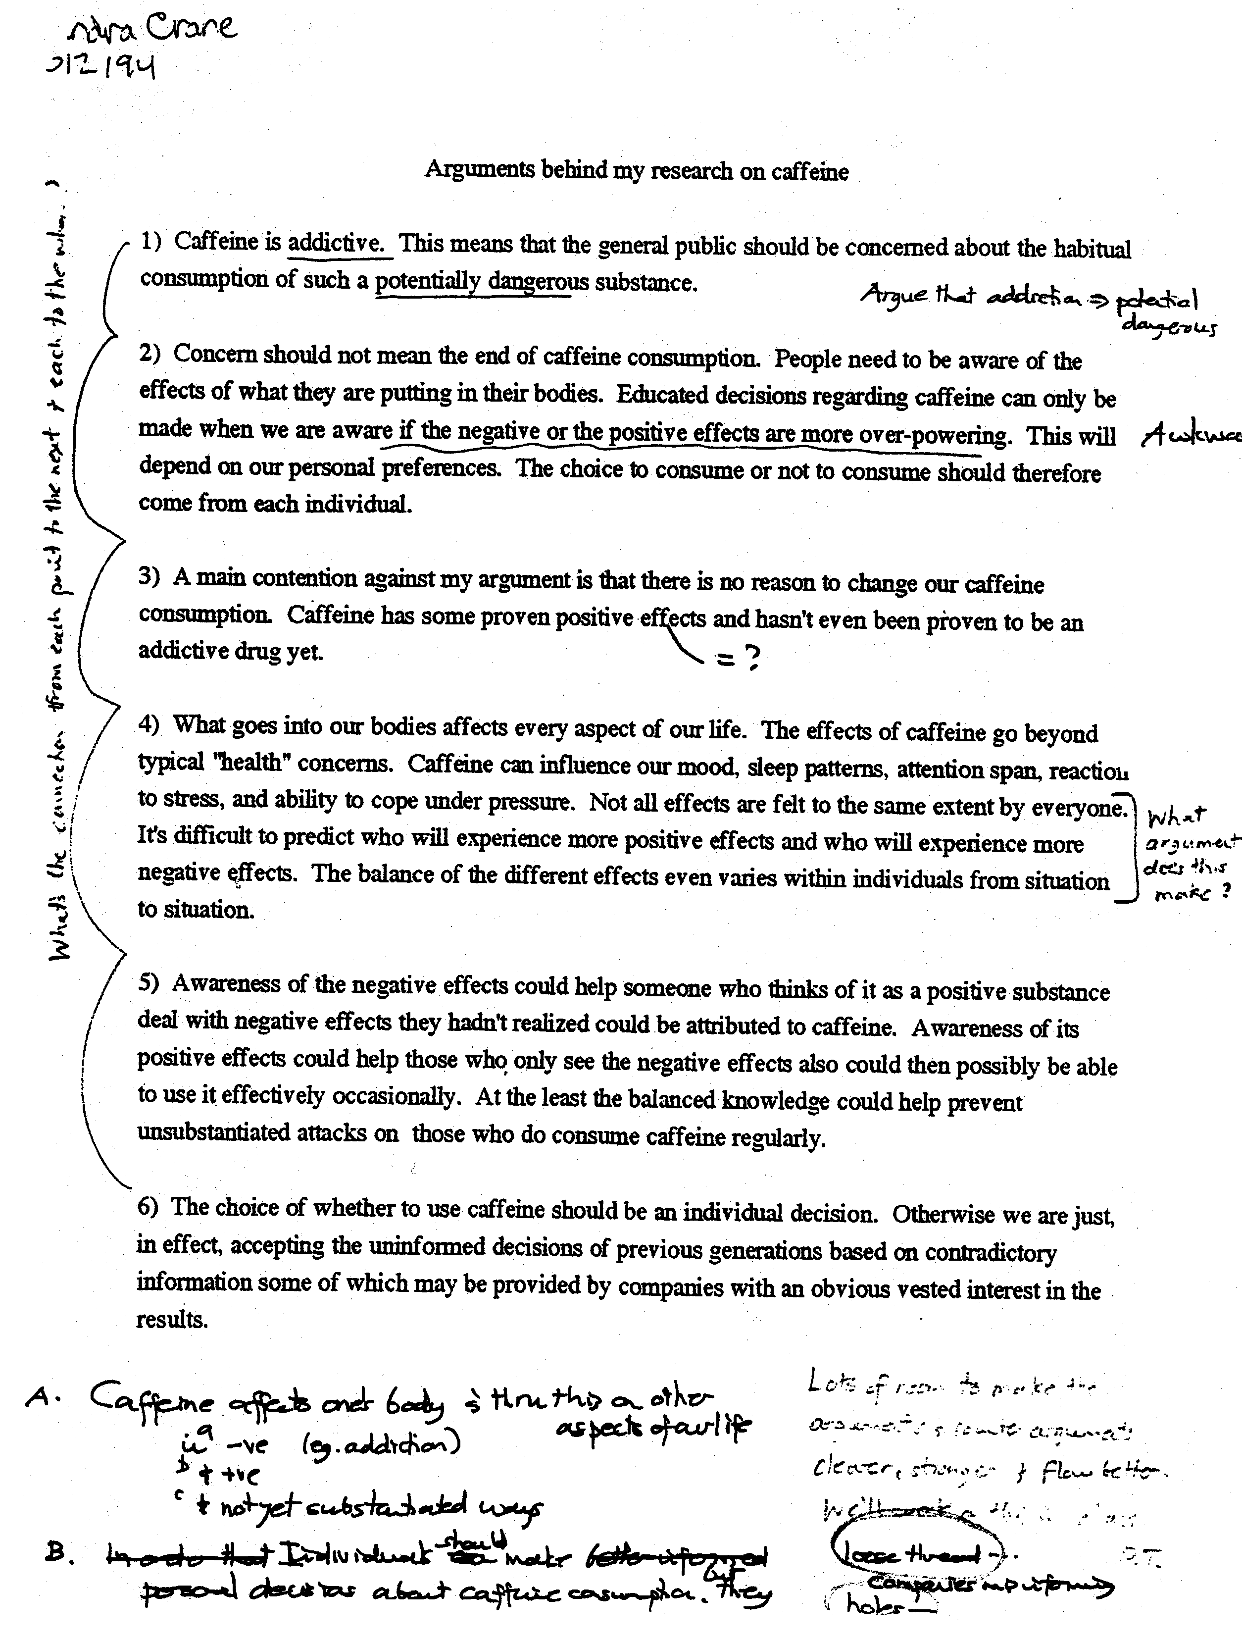
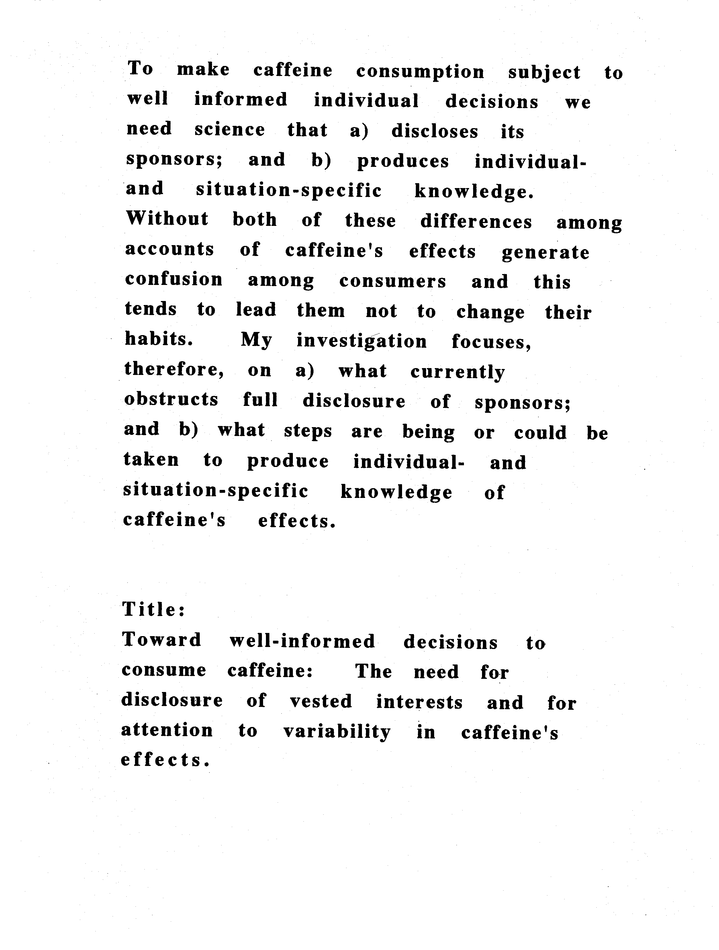
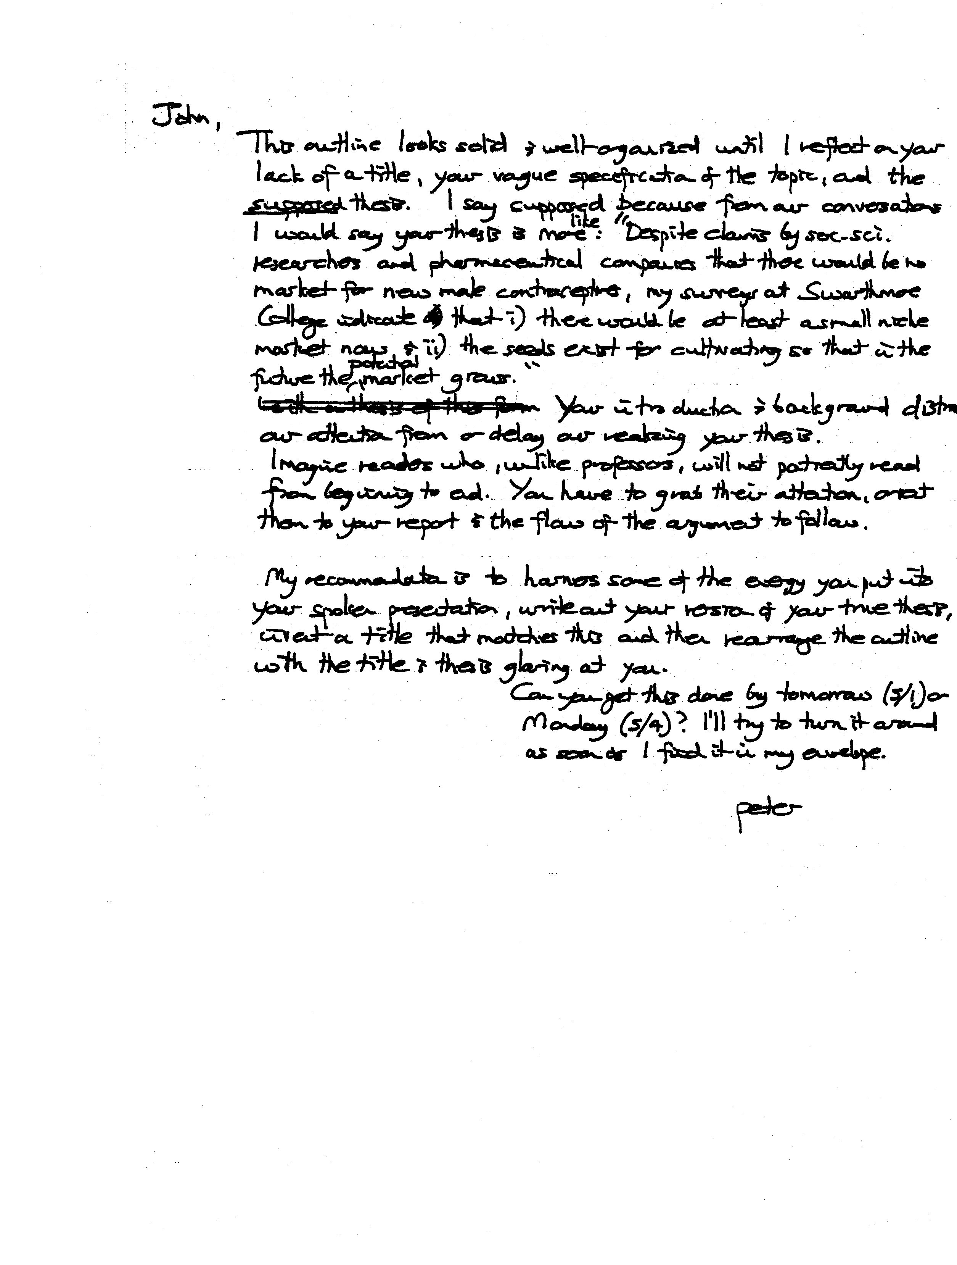
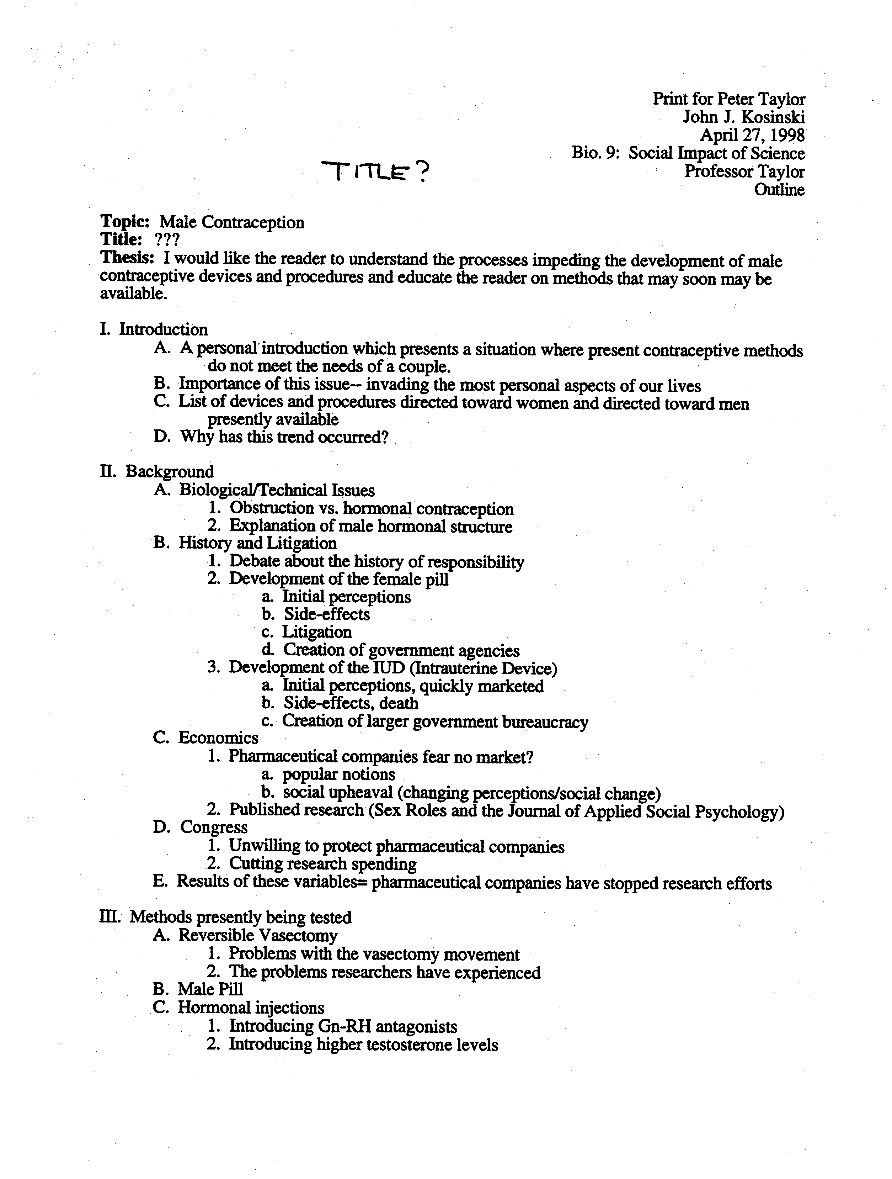
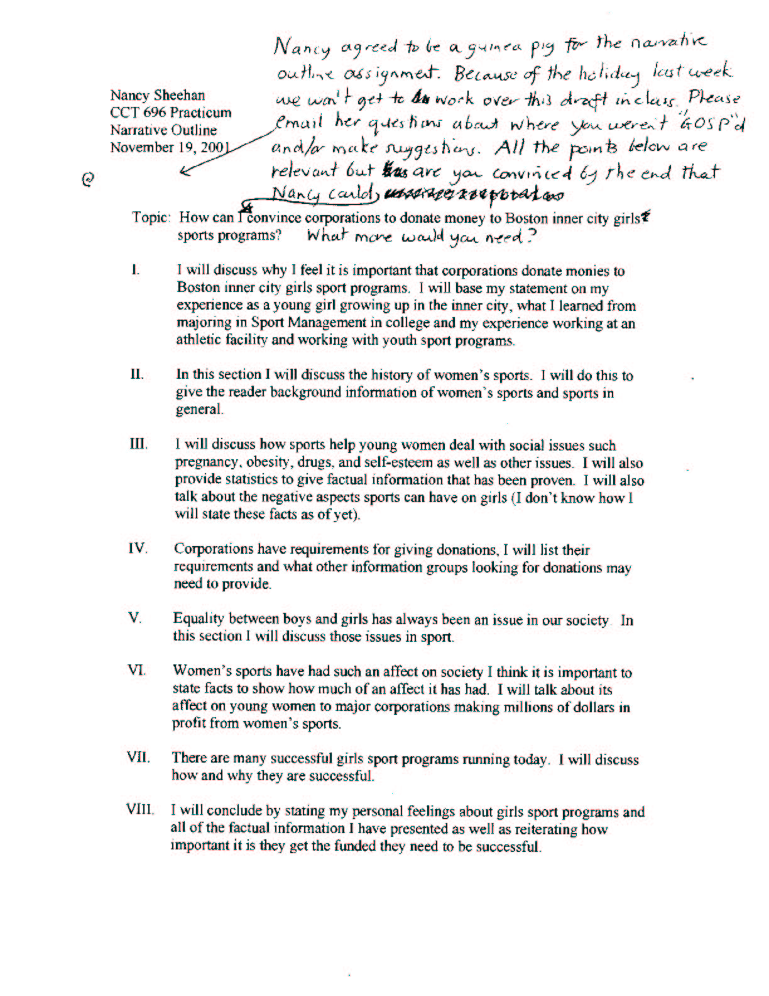
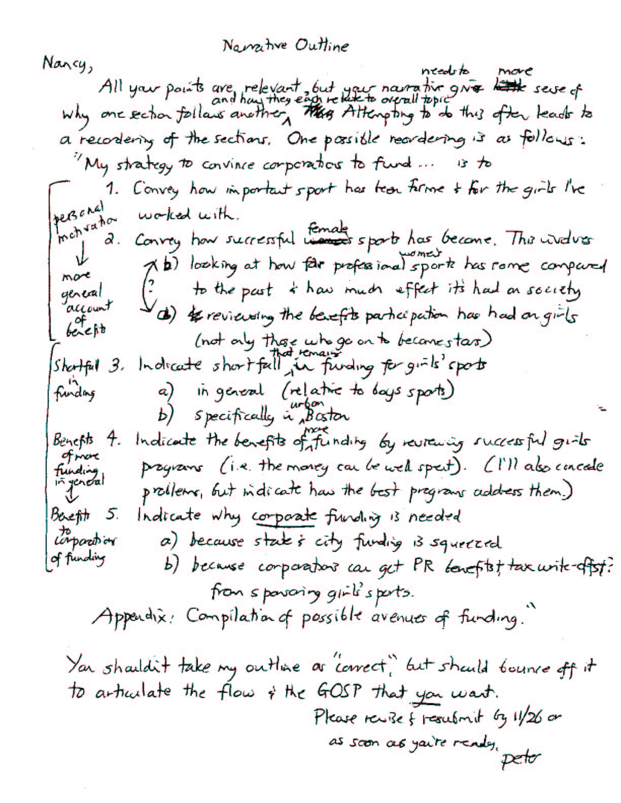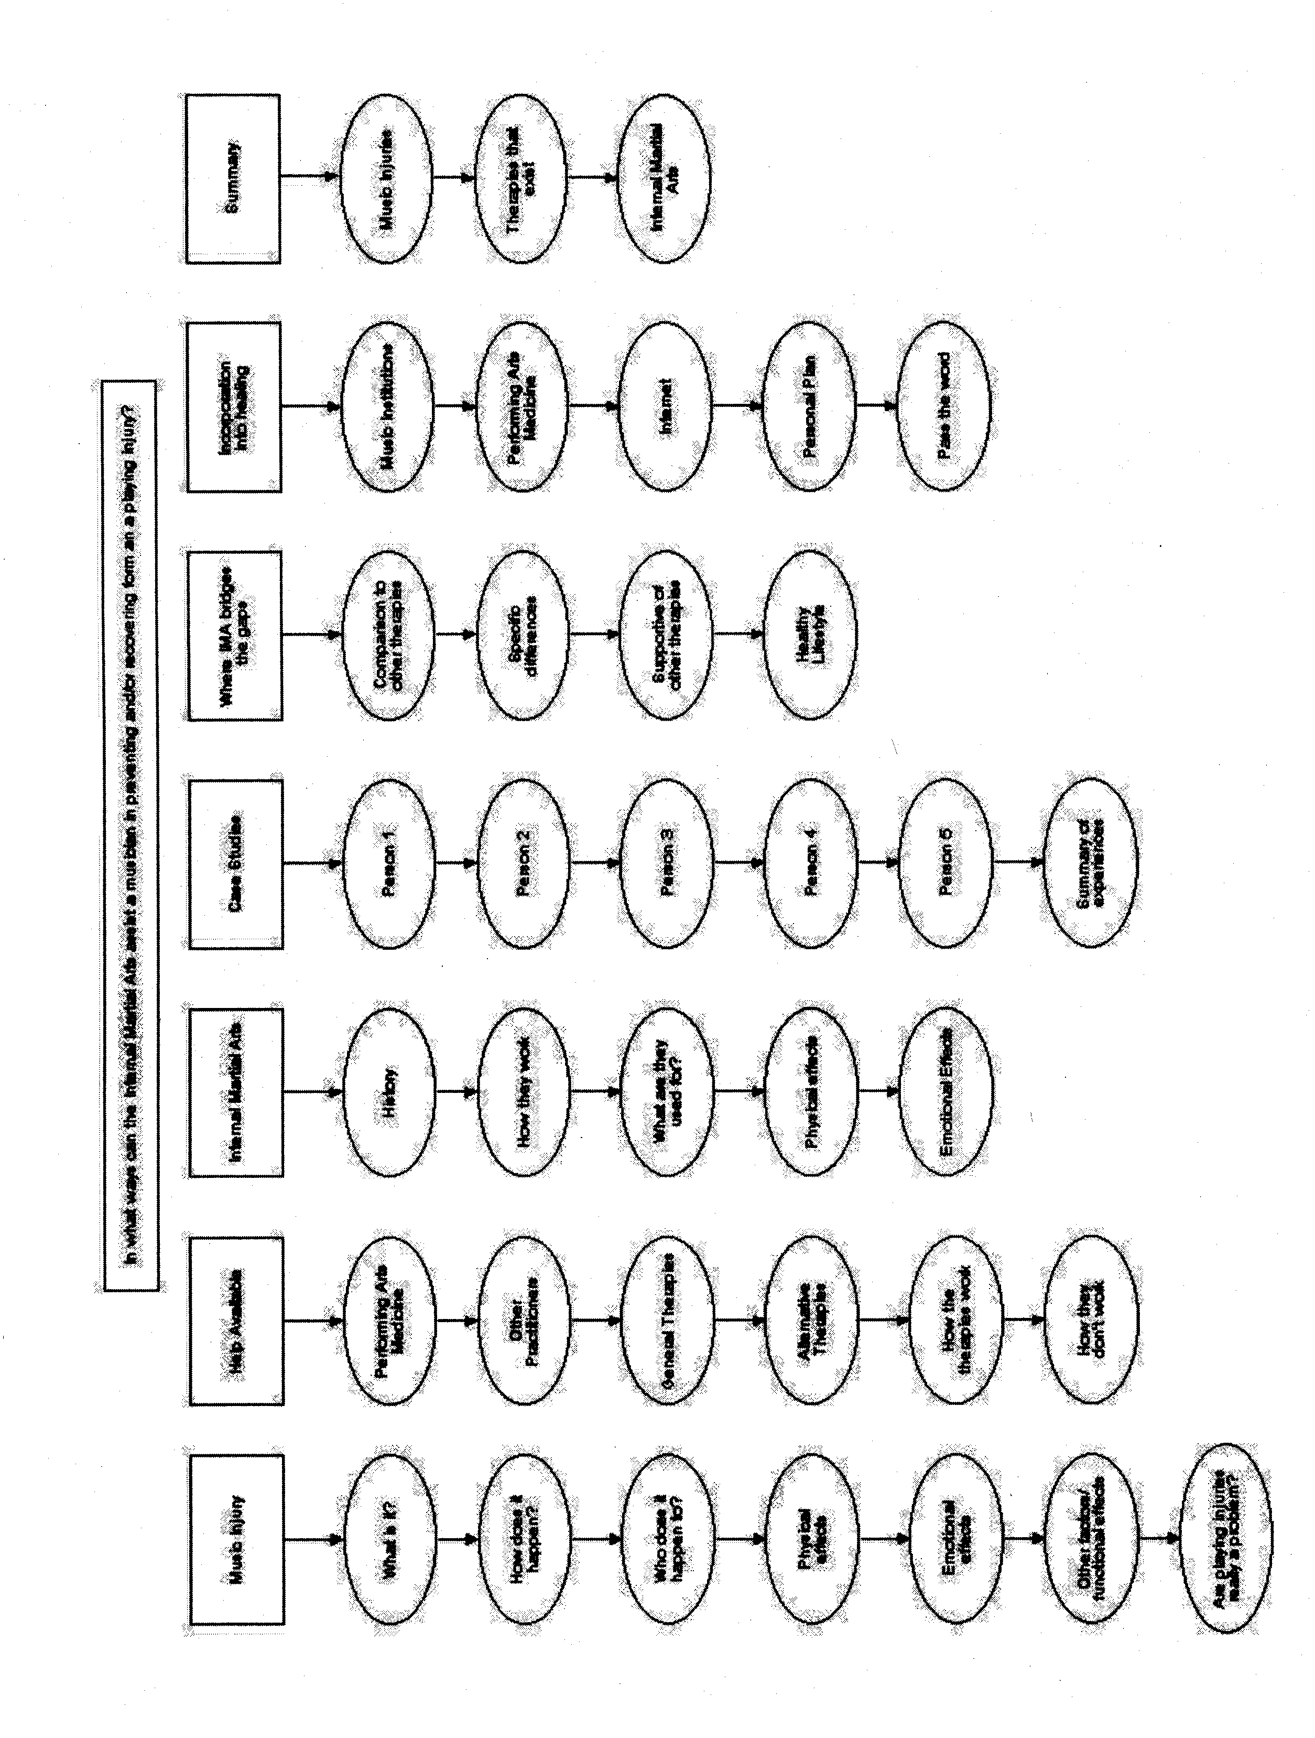
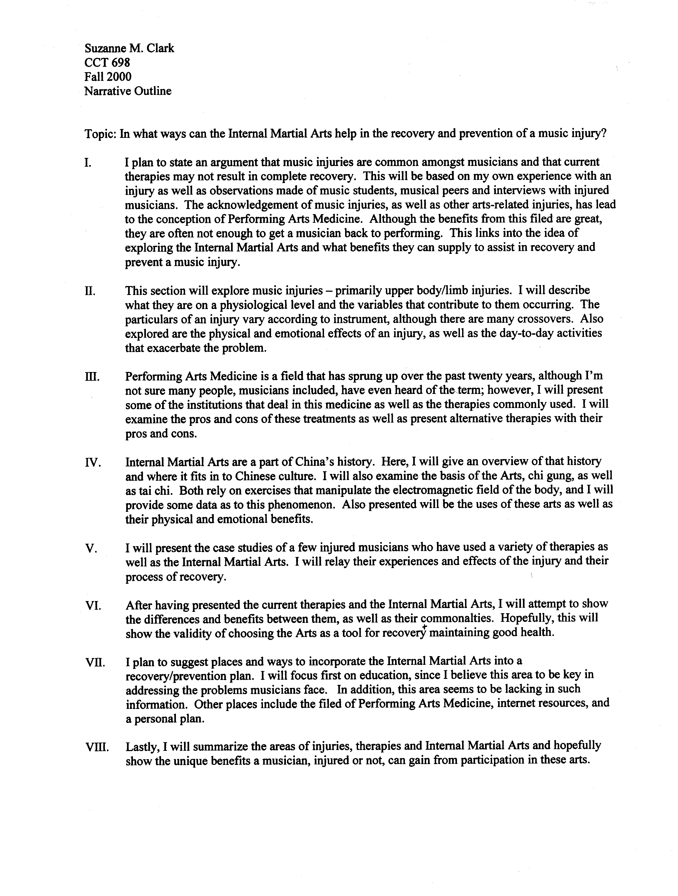
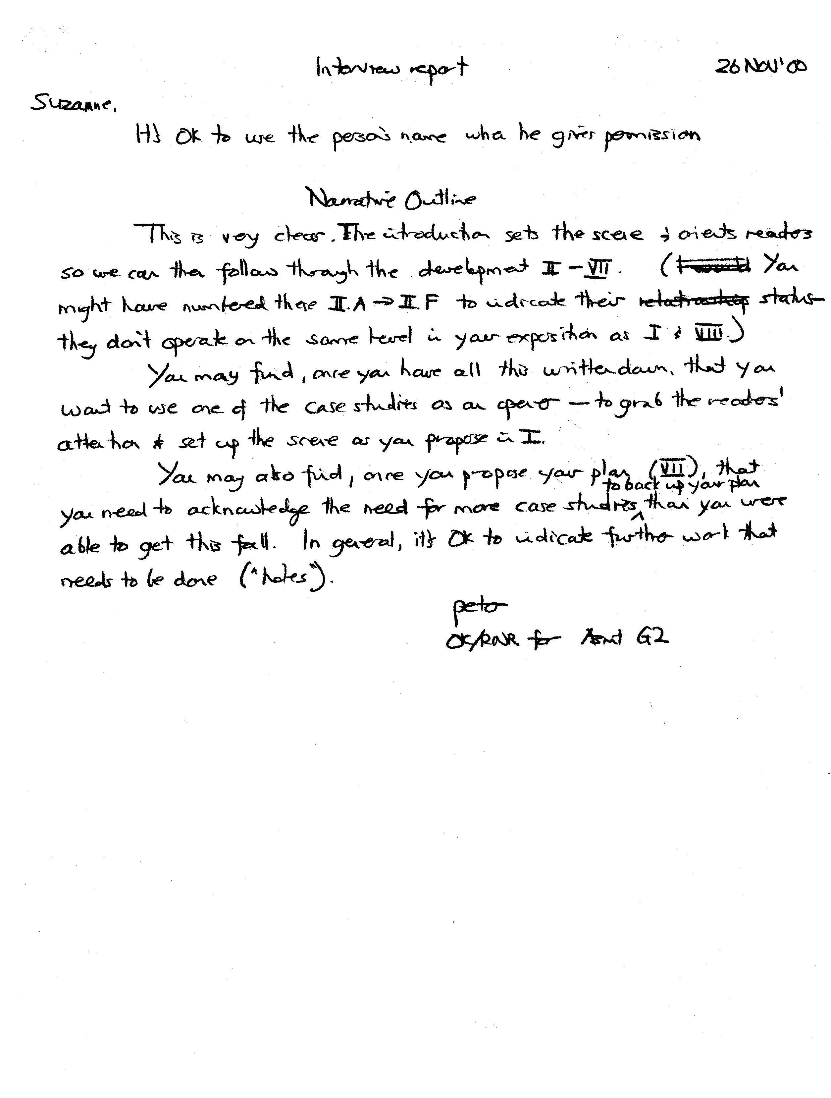 The first piece of my narrative outline was based on the Title Slide from the presentation. I made a note that I had to explain the background information about the context for the Music in History project which means describing the History course, the Adult Diploma Program and the students in it.

Expanding on this comment gave rise to a short outline designed to provide this background, which was:
- Educational Context of the ADP program and its students
  - Importance of multiple payoffs: pervasive skills
  - Social engagement
- Specific Context of the ADP History Course

However, I wanted to Grab the reader, stimulate their thinking about possibilities and begin to Orient them to the path of the paper, so I didn’t want to just explain the context of the ADP and History course first. The Grabber from the presentation was my own personal use of Herbert Russcol as a source of educational enrichment. I didn’t want to use that as the entry-way into my written project and now I understand the reason for this. My anticipated Audience which was an unconscious choice that I hadn’t clarified to myself. It really hit me in class on the 9th that I had lost touch with the Subject, Audience, Purpose trichotomy. My Audience for the presentation of work in progress was clear-cut; the Practicum class itself. And, the Purpose of the presentation was to “collect gems” so everything about the presentation was geared to that end.

My intended Audience for my written paper best defined as Teachers of Adults in High School level programs, especially involving ESL learners; in other words, I imagine the Audience as the teachers I work with and the extended community of similar people who share pedagogical techniques, including Workplace Education, Adult Basic Education, and other forms of High School programs for adults.

The Purpose of my written project is also different than the oral presentation. The section of my rough draft introduction stating the two outcomes makes this Purpose clear.

In any case, for my paper’s introduction, I wanted to Grab the Audience with a direct example of how historically rich and educationally stimulating a song can be, especially one that has gained recent currency. I wanted the Audience to get a preliminary sense of “look at how many ways there are to explore this one song!”, “look how the music is being connected outside of music proper” (the NIEHS website), and finally “look at how the music helps to break through barriers for non-traditional students” (the quote from the special educator from the NIEHS website). Plus, it IS personal for me in that this particular song helped to get the ball rolling for tracking down music and playing it in class for ESL students.

I’ve been working on meshing the multiple outlines that I’ve generated at various stages of the course. The Annotated Outline that stemmed from the presentation provides the framework for section 2 below which was not included in my rough draft. However, I had not done an annotated outline directly for the first section of the paper. Rather, I was working from the brief outline specified above. After the fact, I did the reverse outline process on what I had written (see attachment). This was helpful at making the logic of my approach to the Introduction and Background Information clear. Further, doing this outline and expanding on the paragraph in the rough draft that articulated the path of discussion led me to an overview outline that integrates the sections of my paper more clearly.

Path of Discussion (expanded from rough draft and numbered)
- First, we will review background regarding the specific educational context comprising the History Course of the Adult Diploma Program. Emerging from this discussion is a conception of levels of engagement on two scales: social interaction and information access.
- Then, we will proceed to a consideration of paradigmatic sources that inform and motivate the features of the emerging general framework. This discussion involves a reflection upon the sources of my own practice of music collection as a way to articulate the features of activities that promote greater degrees of student engagement in the collecting and sharing of information. (Use Oral Presentation Annotated Outline)
- Finally, we will appraise lesson plans and student project guidelines that are designed to realize the educational potential of using music in this context.

Overview Outline
- Review Context to clarify goals
- Consider paradigmatic sources to inform and motivate framework
- Actual Lesson plans and definition of database system for collecting
- Future Directions
  - Depth of inquiry
  - Extension to other media

