E. Design of research
• Two pages on Strategic Planning Process
• Clustering of postits & resulting thoughts about directions ahead
• Example of product of vision stage of SPP
• One student's very focused research design (plus two pages of visioning that project)
• Another student’s brief research design
• One student's composite of arguments and visioning leading to a brief timetable
• One student's compilation of everything behind and ahead for their project

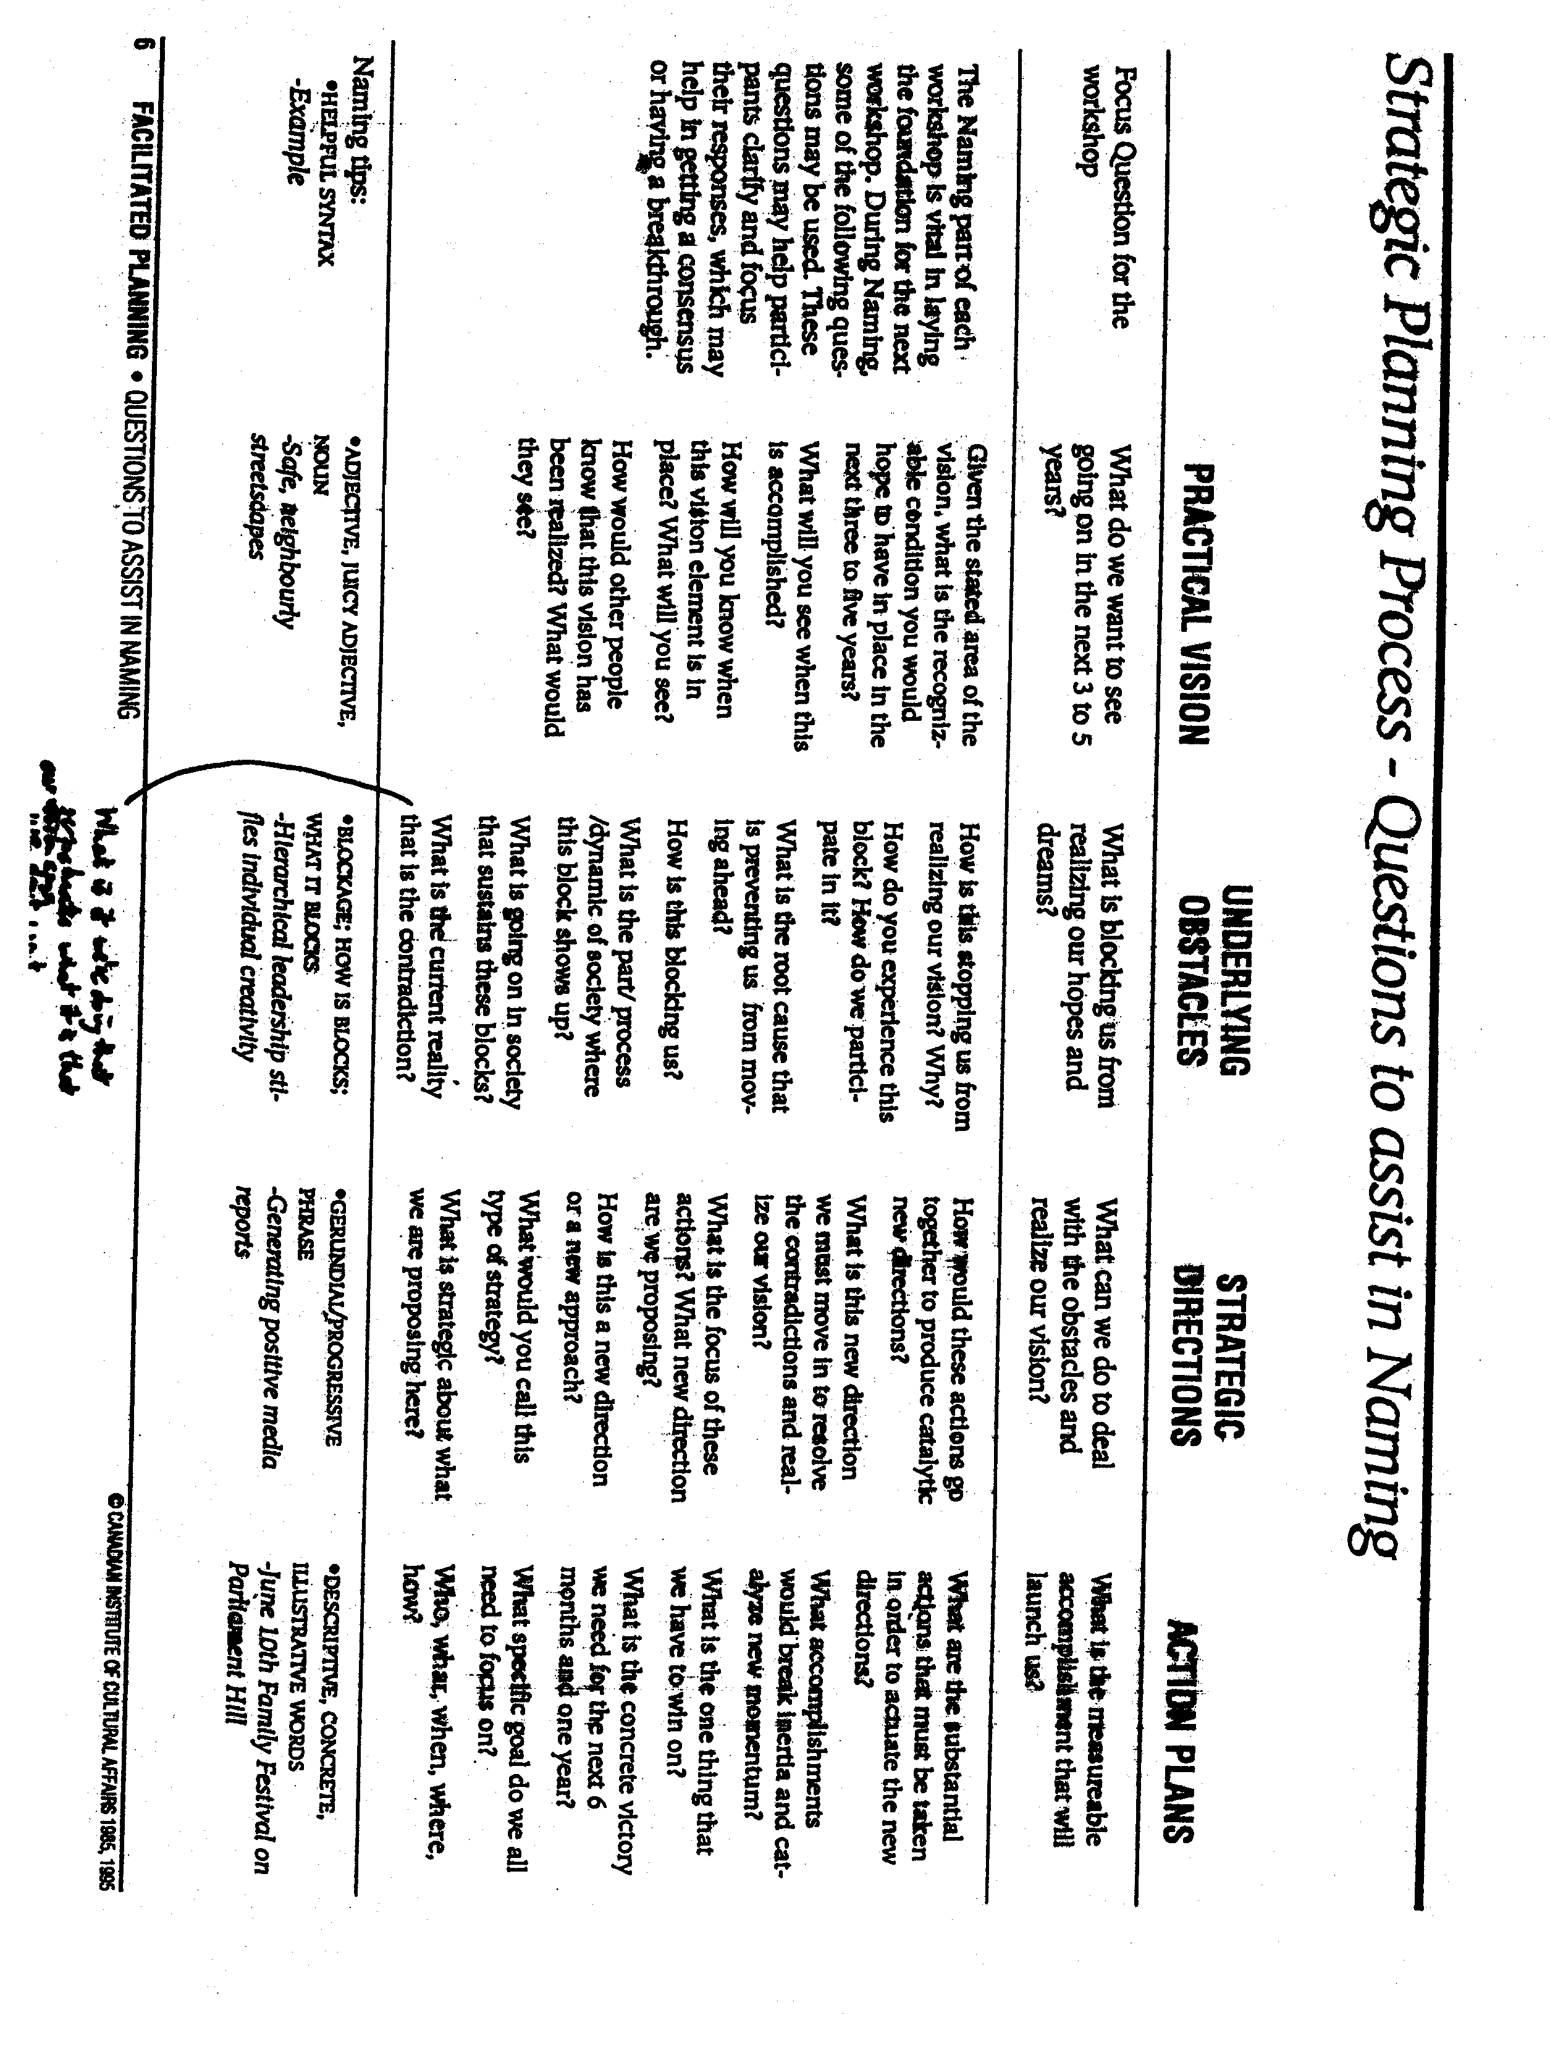
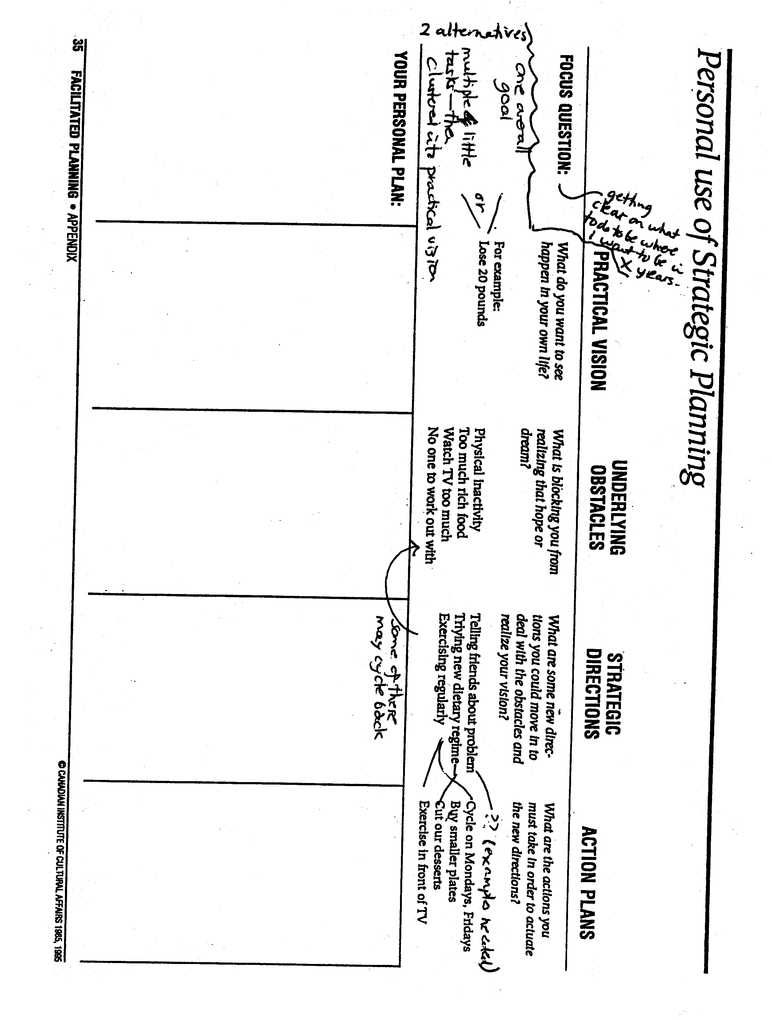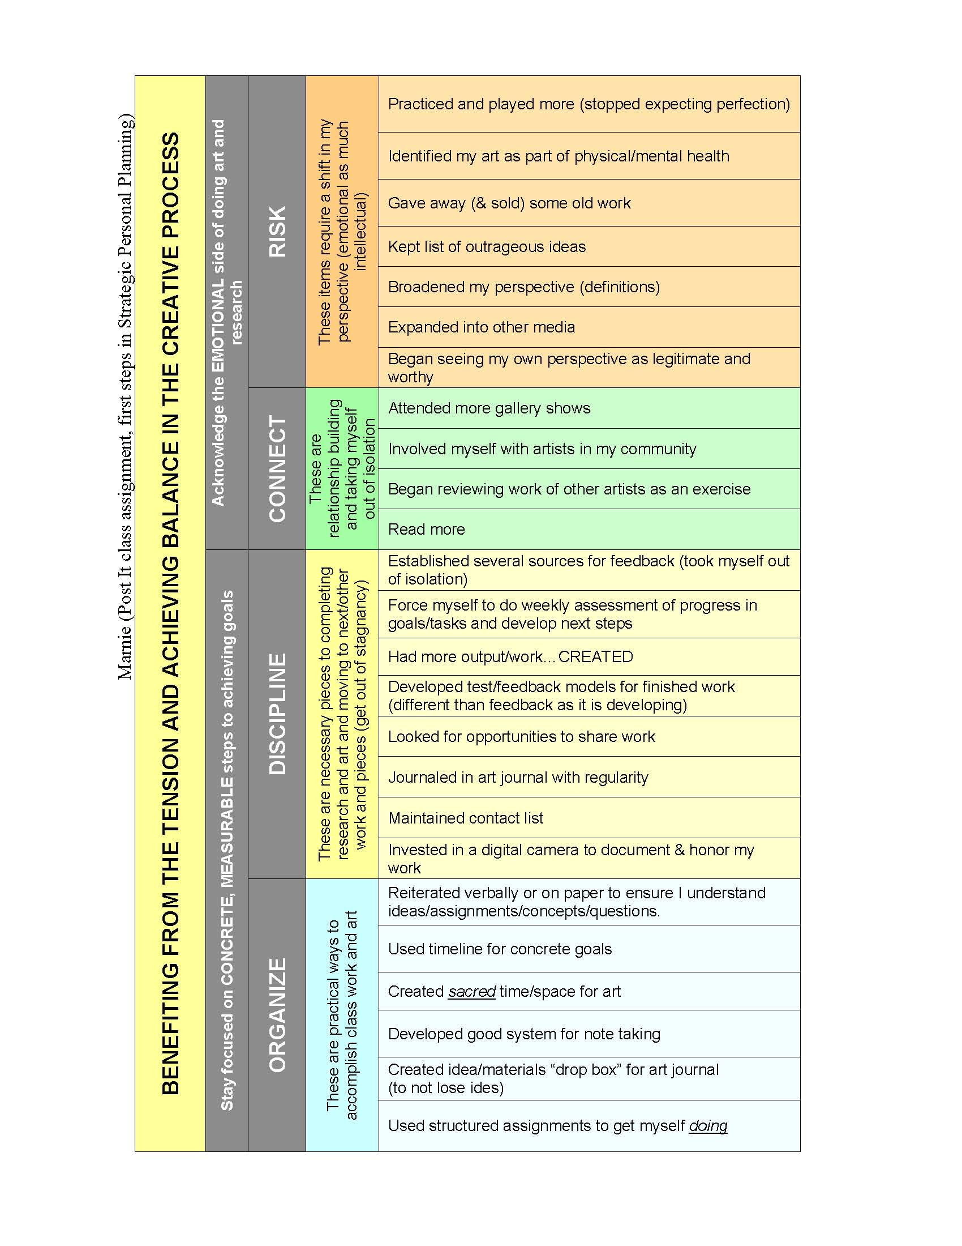
Marnie Jain, October 23, 2006
Personal Strategic Planning Process
From the post-its, I have come to 4 verbs, risk, organize, connect, discipline
I know I have done this exercise honestly as there are all things that I do struggle with, though I can do each well if I make the effort. So now these are to become a part of my Strategic Personal Planning Process.
I have gotten a little lost at this point because I don’t see my project in this as clearly as I believe I should. I really did envision that I had already completed the class and accomplished my goals and so the post-its were written in the past tense. Then I grouped them easily….as I felt there were clear distinctions, yet some overlap.

RISK
Some had to do with a shift in my perspective (that is required in order to complete this project). One is to give away and sell some old work. This is not directly related, but I hold onto what I have done tightly and in some ways it prevents me from moving forward with new work, and sometimes it keeps me from doing different work. Another was seeing my own perspective as legitimate and worthy. This goes right to the heart of my frustration in not finding articles about my topic. My tendency of thought is that if there are no articles on this, then I must be wrong or I must abandon this project. I need to shift my thinking to accommodate the possibility that I may be asking completely new questions and/or bringing new insight to the existence conversation and research on interactive art. I categorized these two and several others (keep a list of outrageous ideas, expand into other media, stop expecting perfect pieces and play more, see the connection between my physical and mental health and my art) under the verb RISK. I need to take more risks, and letting go of protective, tight ways of thinking is one of the highest risks.

ORGANIZE
This verb came from post-its such as “create sacred time and space for art”, “reiterate verbally on paper to ensure I understand ideas/assignments/concepts/questions”, “create idea/materials ‘drop-box’ for later use with art journal”. I saw these all as practical ways to accomplish class work on the project as well as art work, art work which feels like a necessary corollary to the research. My questions are generated through work and possibly some may get answered this way. These are ways for me to not lose thoughts because I do multitask and I do have a lot of pieces moving at one time in my life right now. It is also important because this is where I am intentional. For example, if I identify that my studio space layout can be a barrier to my work, and then make choices for a desired outcome, then test the use of my space reorganized, then makes further adjustments, this is choice accompanied with thought. I need to do the same thing with the pieces I create, and with my project as I proceed.

CONNECT
The connecting post-its are all about relationship building and taking myself out of isolation. My isolation is part intentional, but largely it is about self-doubt and fear. I wrote “read more”. How will this help me? I do not believe that my research and my evolution as an artist, an interactive artist, a student, a person or anything will happen by reading obviously related material alone. It is the connecting of seemingly disparate ideas that generates creativity. Kristen has told me that I need to read Venus and Adonis. She believes it will help my project. Reading is a way of connecting to the larger world of ideas and culture and so this is key. I also wrote “attend more gallery shows of current artists”, “involve myself with artists in my community”, and “begin reviewing the work of other artists as an exercise”. The ladder ties to one of Peter’s directions from today’s meeting, that I consider reviewing several interactive works. I have been a little lax about connecting to people as I need for this project because I have always felt “less” in the art community and my old lack of confidence rushes to the surface. Frankly I feel ignorant and almost like I don’t have any right or place even asking these questions. Connecting, forcing myself to connect, will enable me to practice comfort and eventually see what I know (intellectually) to be true, which is that I have no more or less right to be asking these questions….AND ANSWERING THEM…than anybody else.

DISCIPLINE
Some post-its in this category overlapped with relationship building (CONNECT). For example, “look for opportunities to share work”, maintain list of artists for possible collaboration”, and “establish sources (people) for feedback”. But I put these under discipline rather than connect because the others are more reflective and social while these are concrete steps in propelling my work. In this category I also had, “force myself to do weekly assessment of what I have done and what I need to still do”, “journal in art journal with regularity”, “develop models/means of feedback for finished work (different than feedback as it is developing)”, “invest in a digital camera to document and honor work (in progress and final work)”, and “output more”. I can readily apply many of these to both creating my art and proceeding with my research project. And “output more” really came remembering that creativity and critical thinking requires an initial flood of unedited ideas. I can always select later. This is in a way what I am doing now. Everything in the discipline category are necessary pieces to generating, completing and moving on, and so avoiding stagnancy.

And I still am unsure if I did this assignment right so far, but I think the post-its do have meaning and use or they would not have been generated by my thinking.
