CCT698 Practicum
PHASES OF RESEARCH & ENGAGEMENT
Examples of Student work from previous years

B. Background information
• One student's reflection on his resistance to finding out what others have done
• Resources for reminding you to acknowledge intellectual debts
• First page of a well chosen review article for a project on teaching creativity
• Four examples of "sense-making" responses to readings
• One example of reflection on key article
• Xerox of 2 pages from PT's notebook to illustrate an active "dialogue" with what you're reading
• Three reports of initial meetings with informants
• An email couched as a request for an interview (phase F), but really trying to find out about "what others have done that informs and connects with [her] project"
• Seven examples of annotated bibliographies—the fourth also includes a revised thesis question and intro to his project

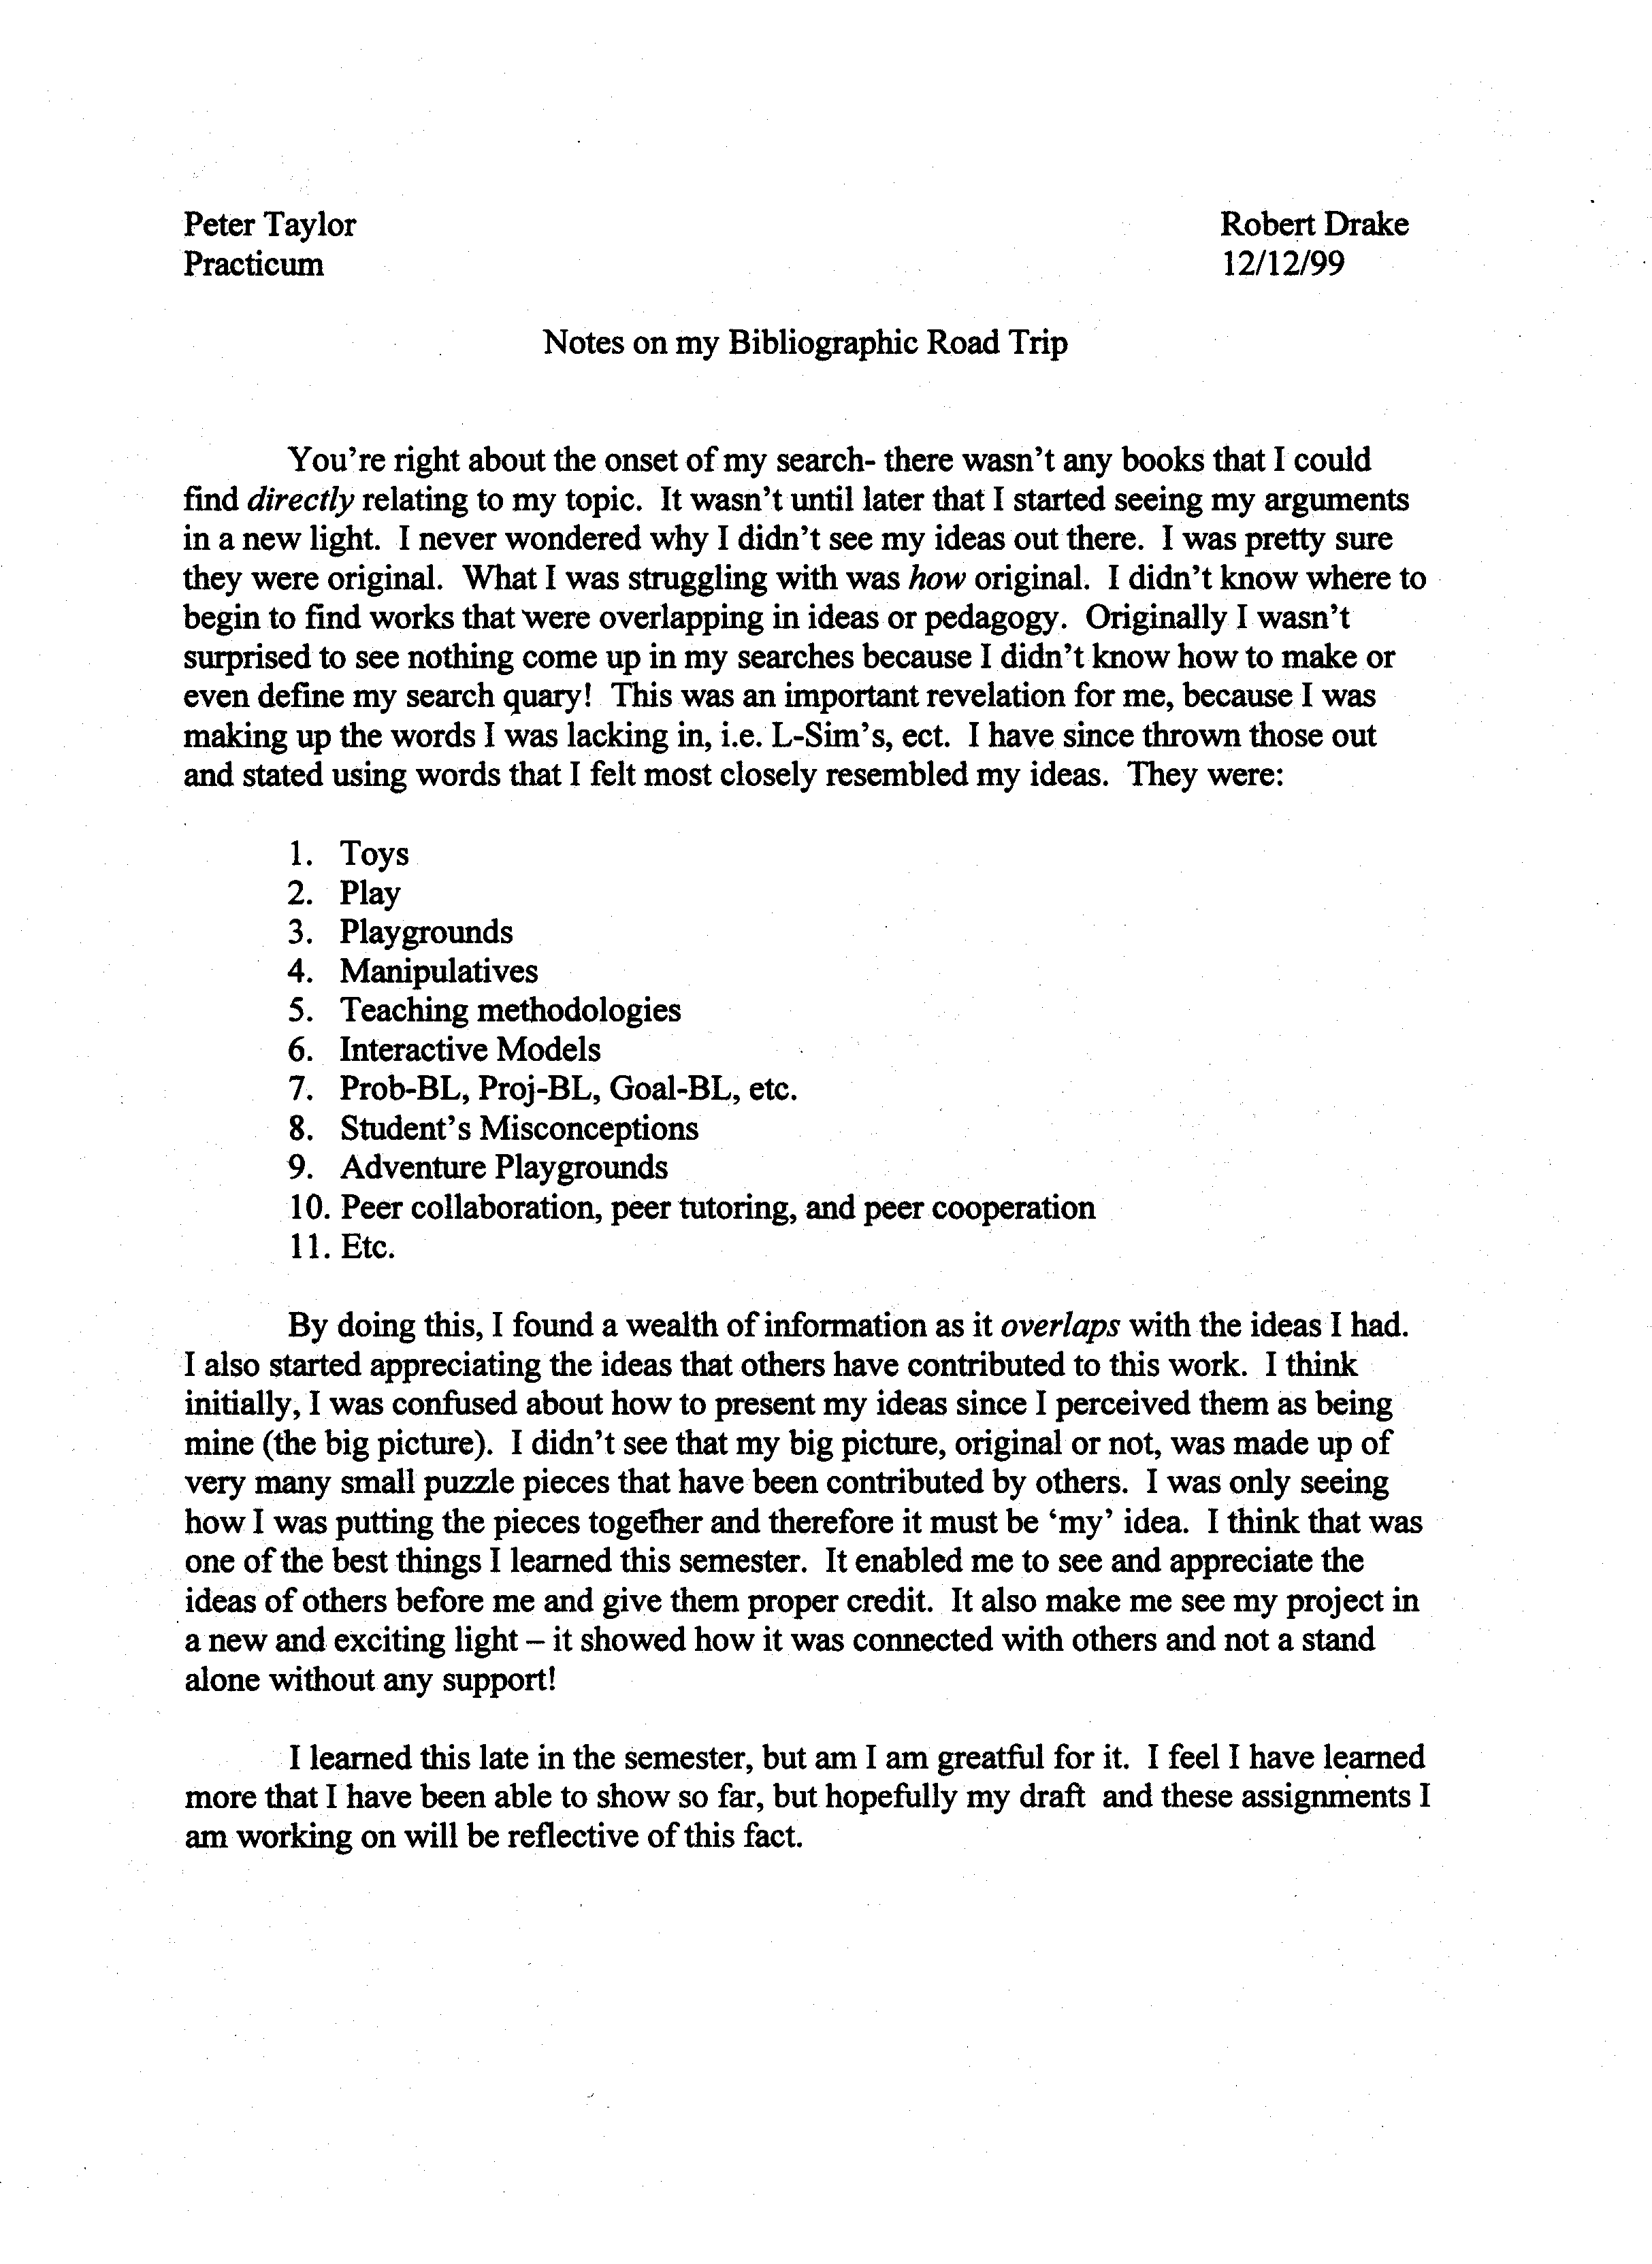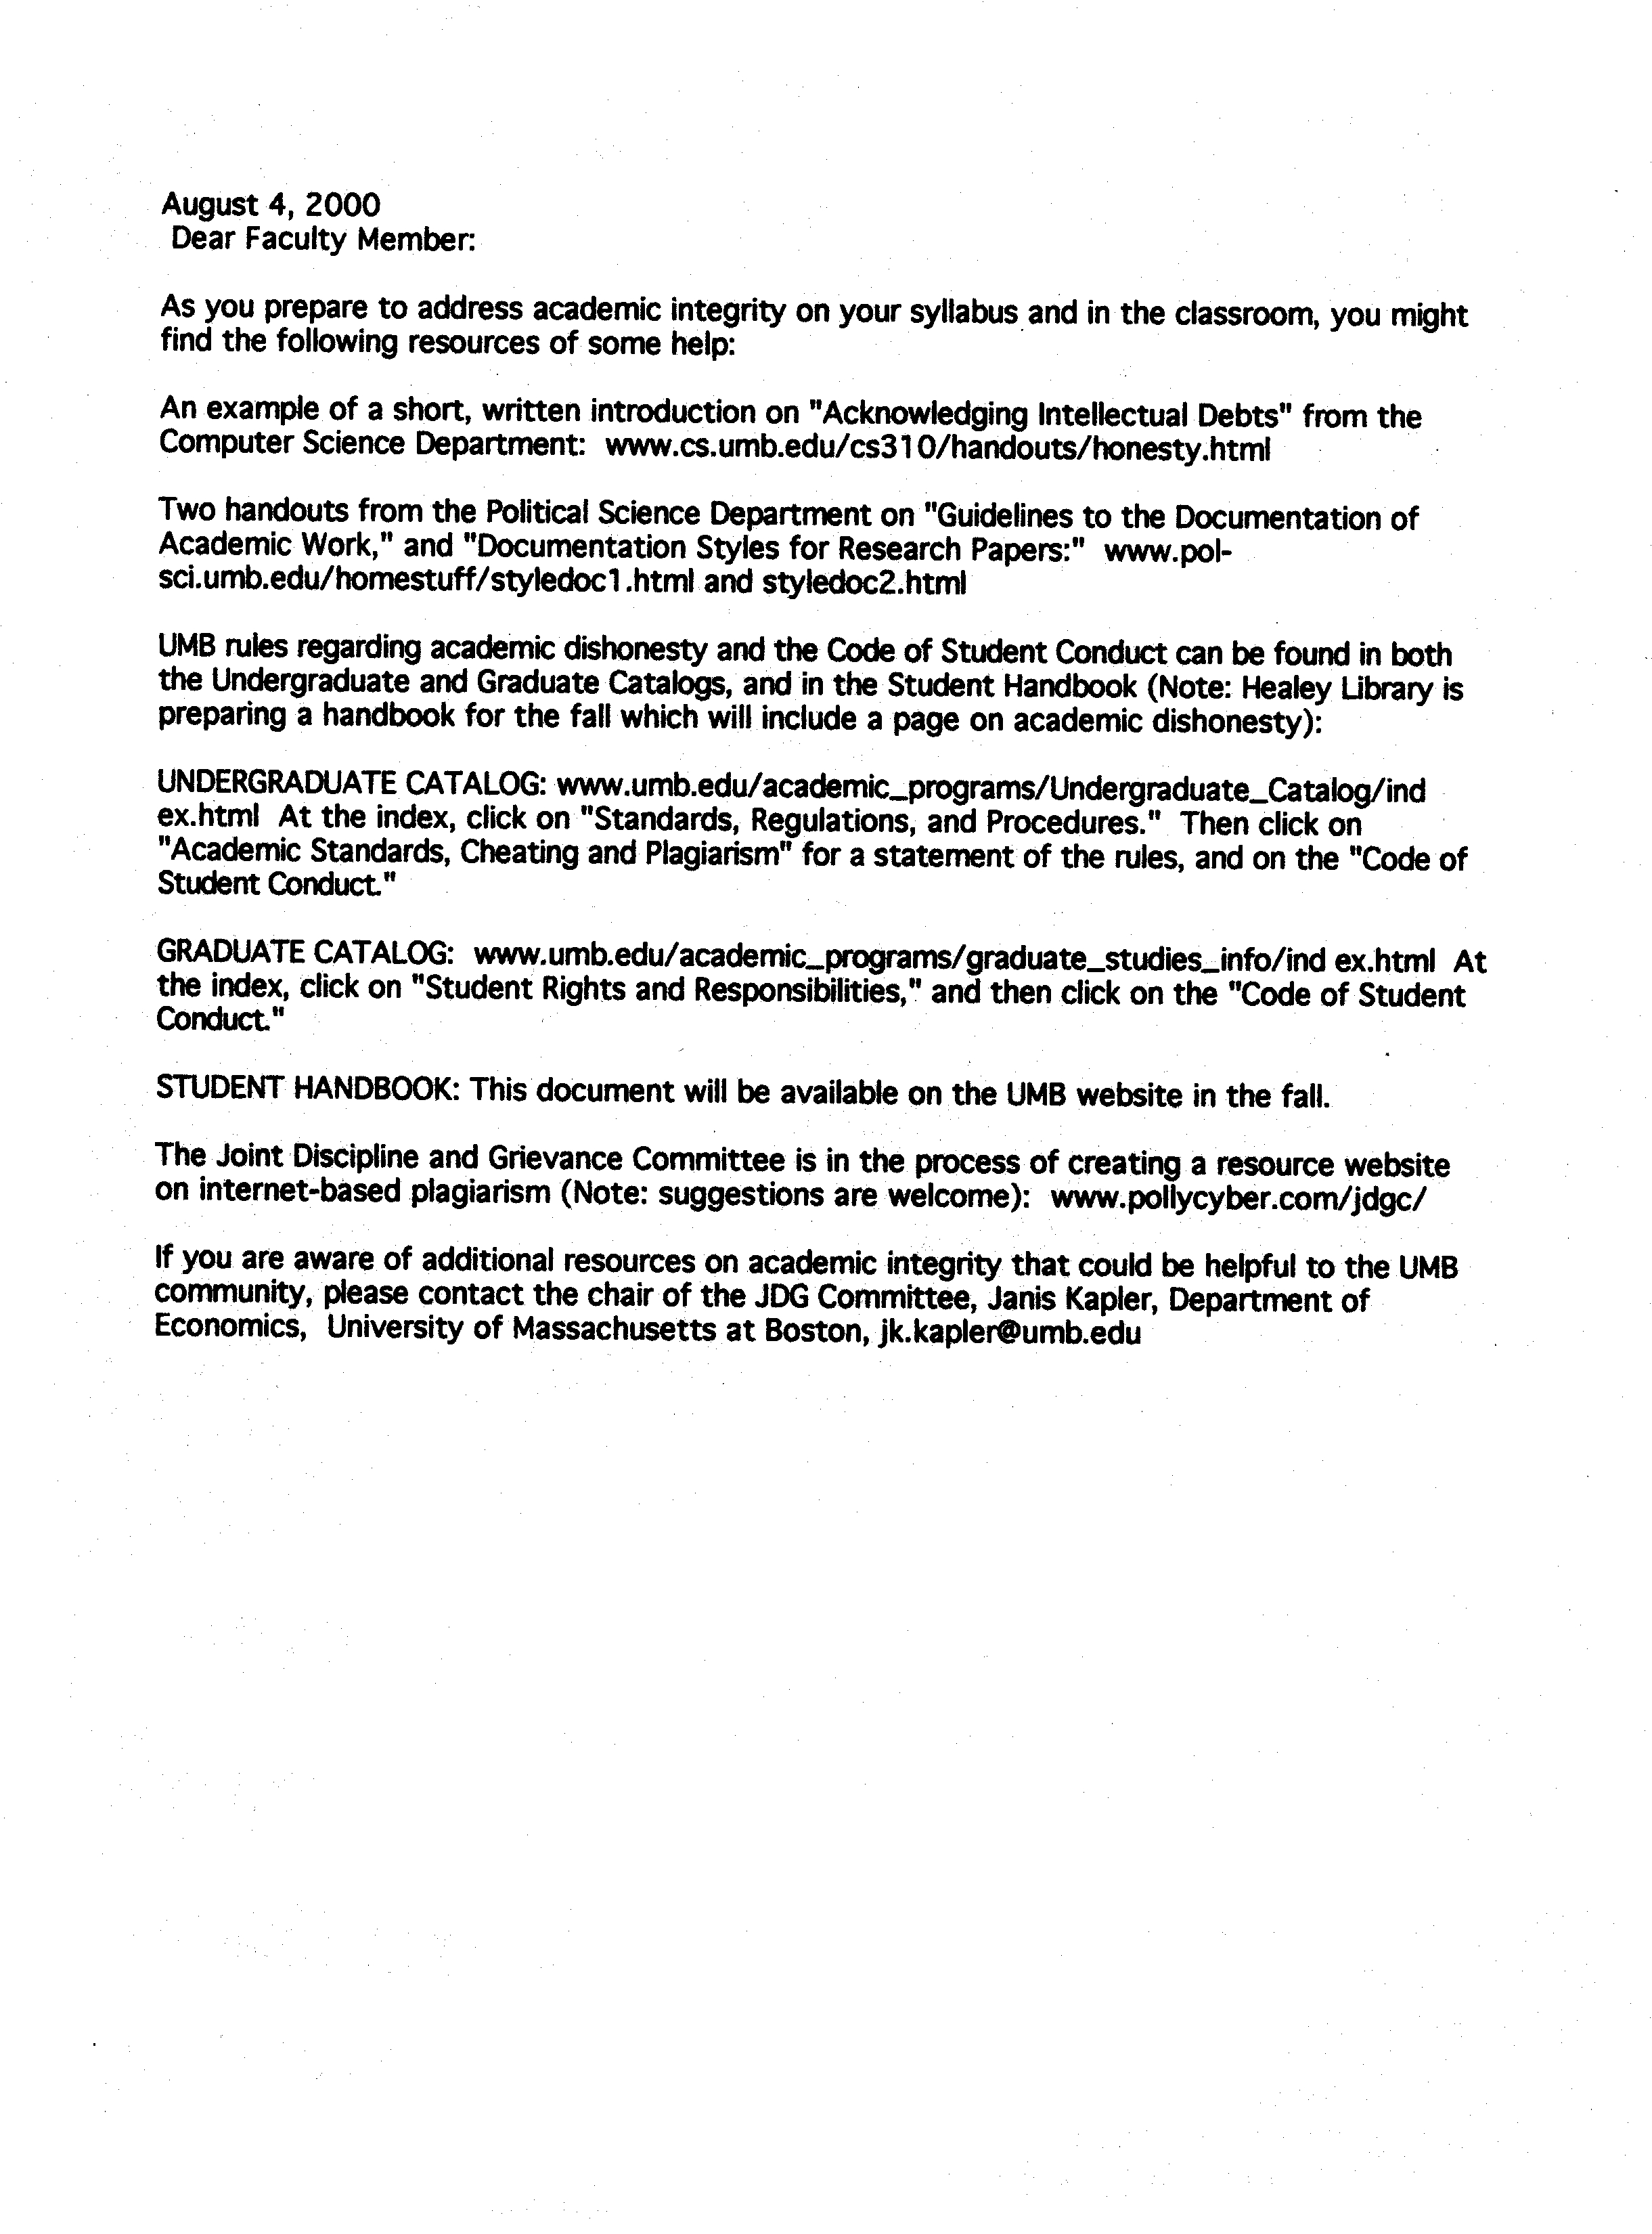
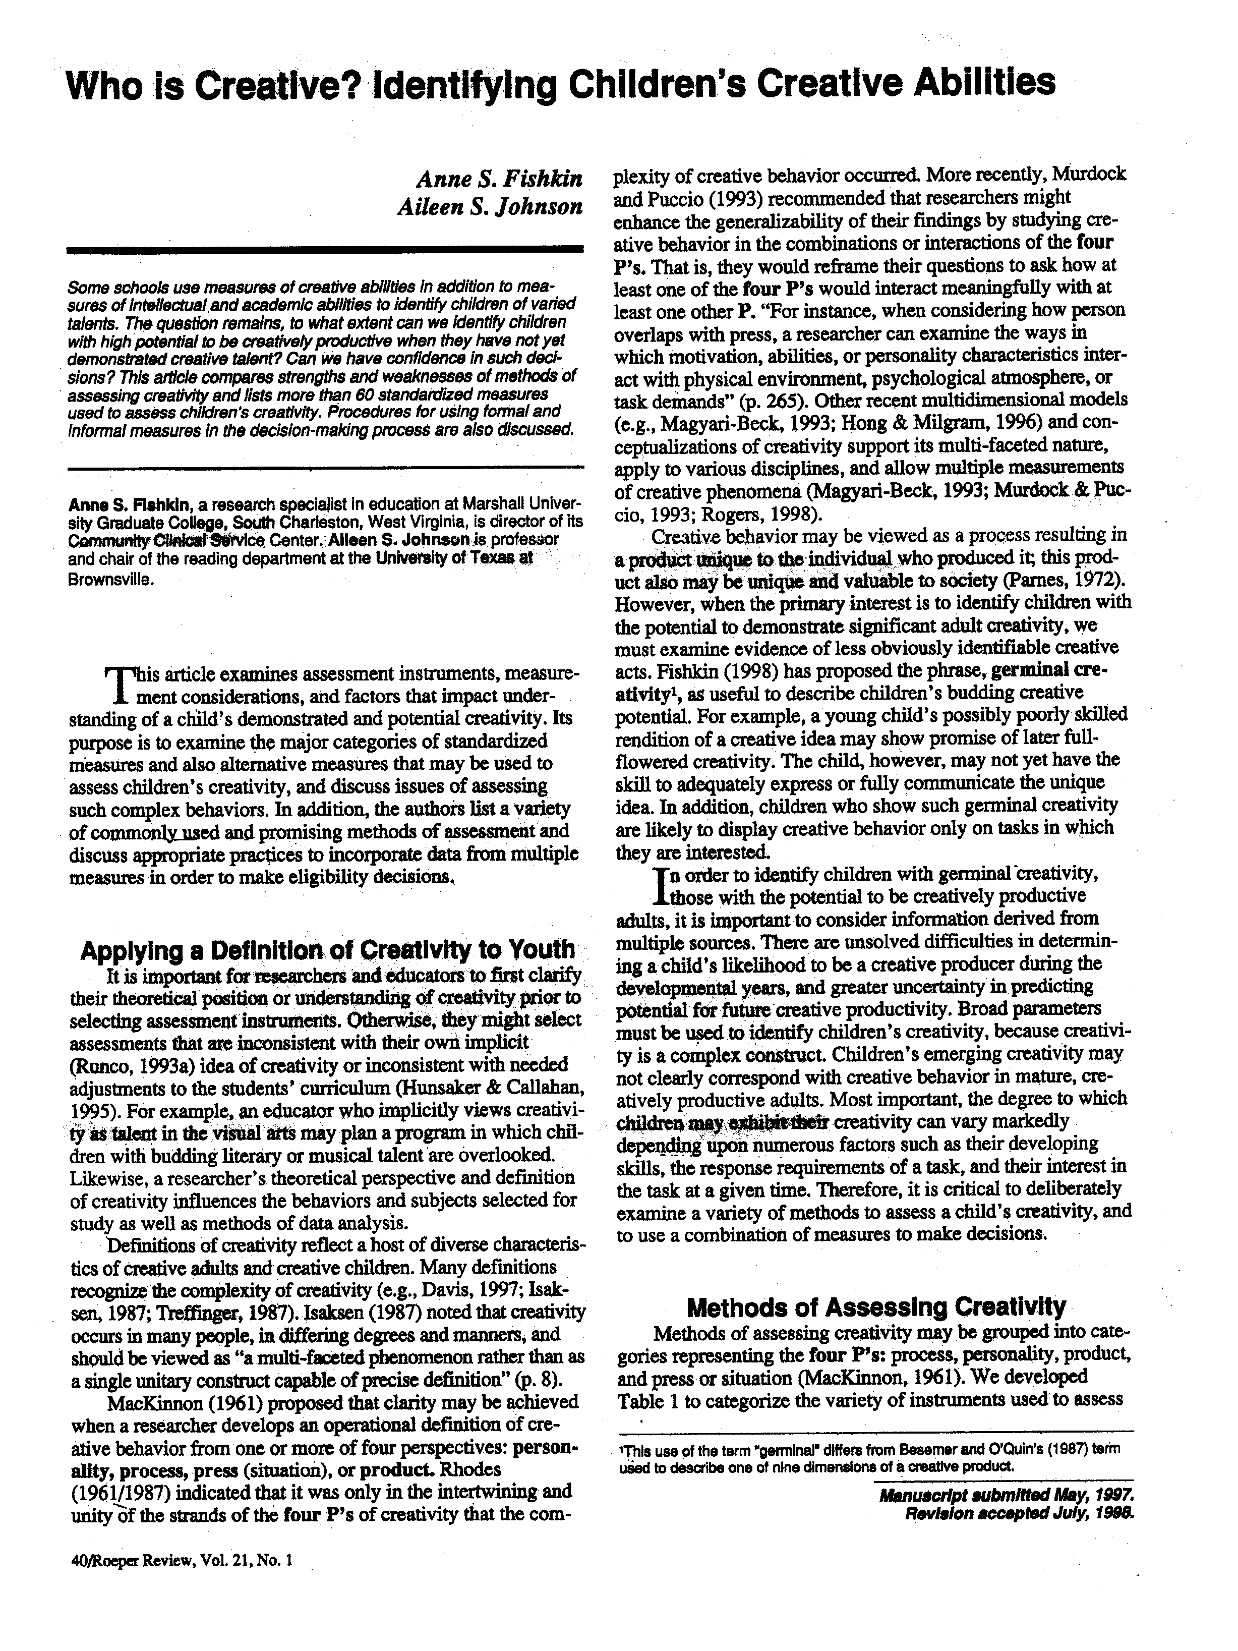
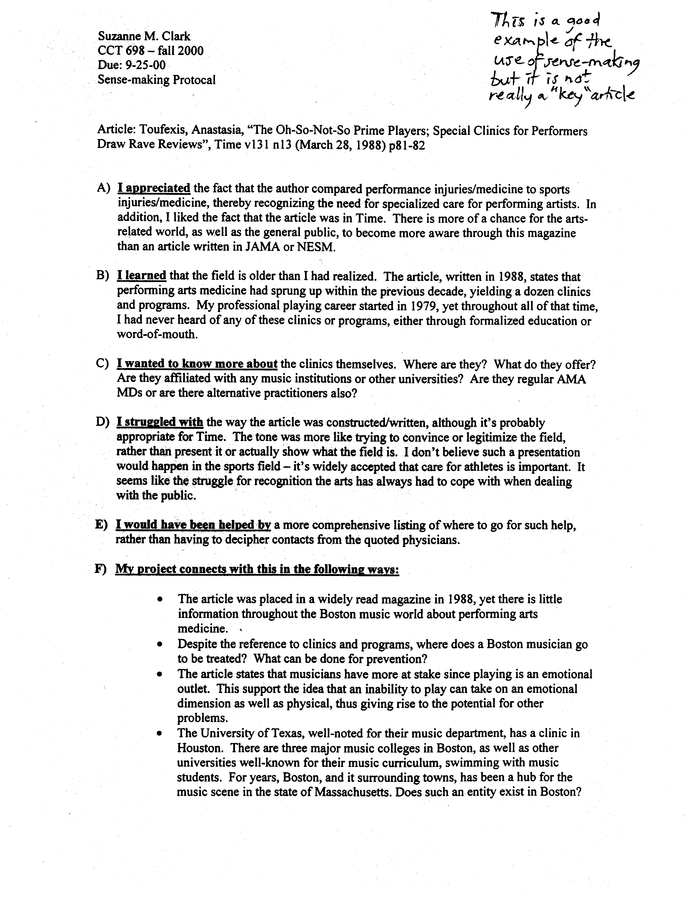
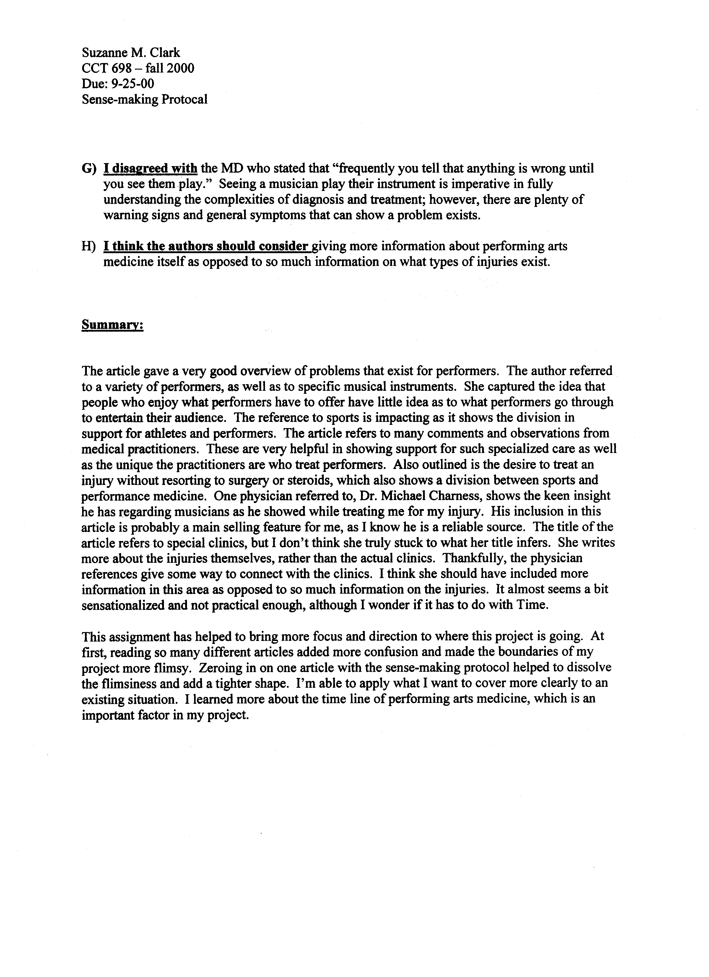
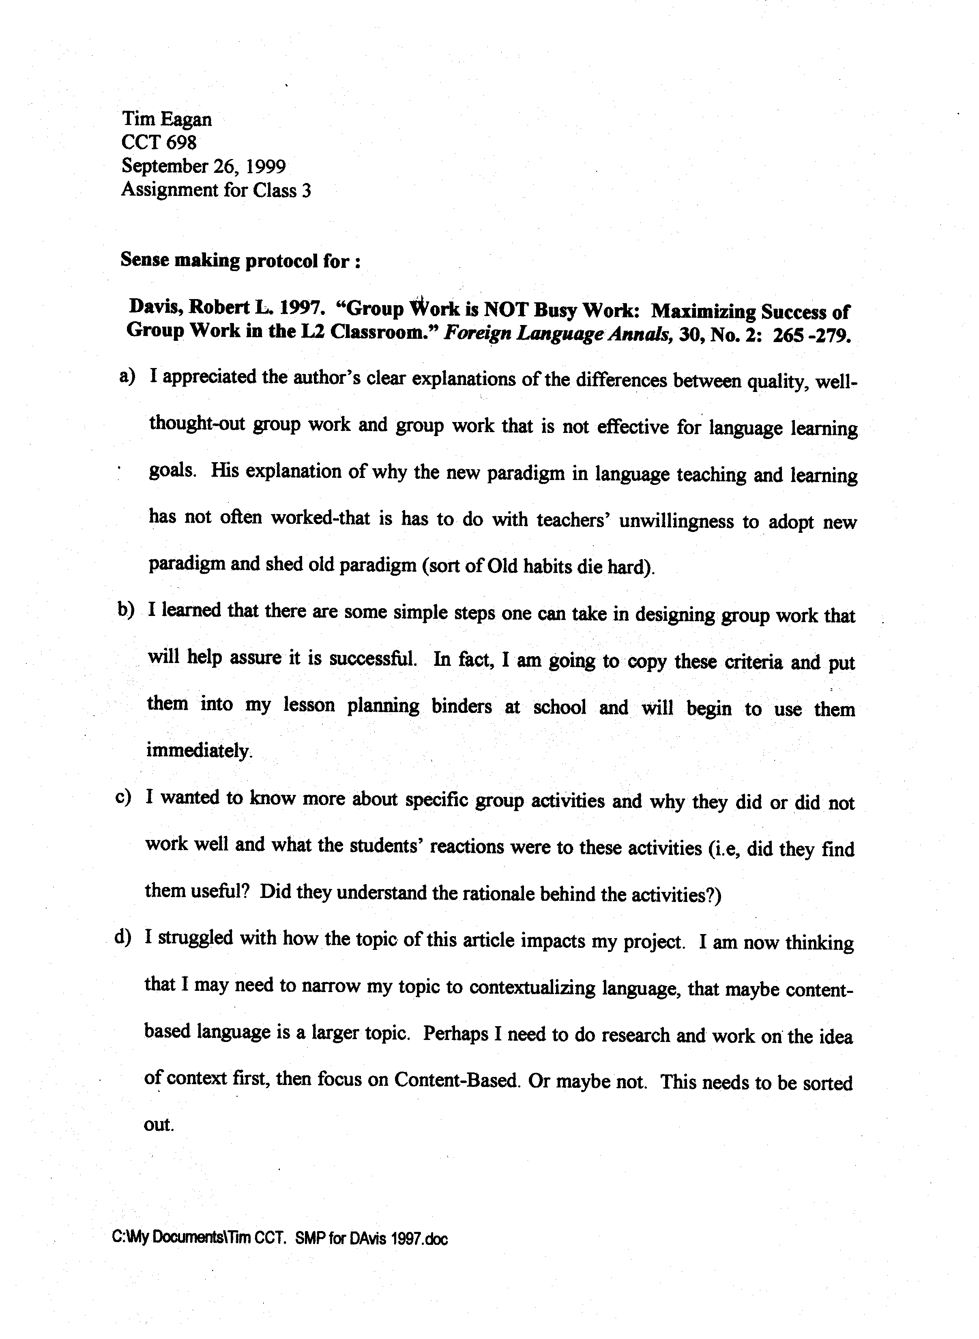
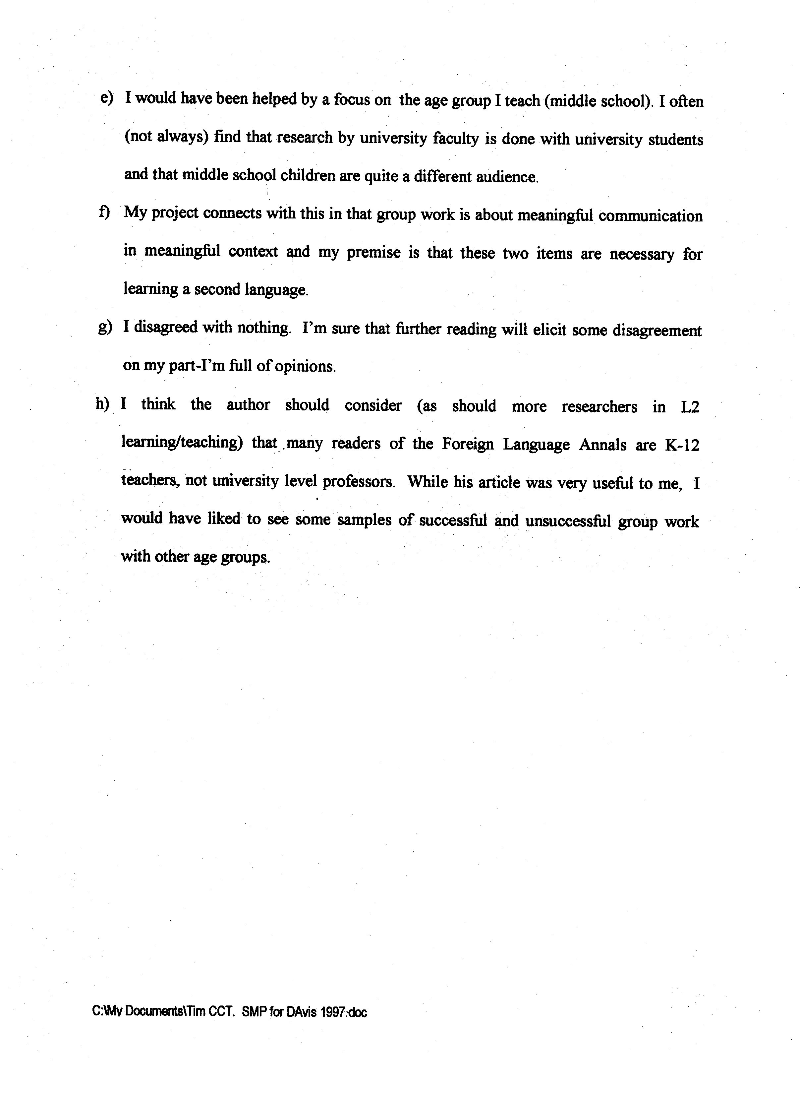
Sheryl Savage
Practicum CCT 698
Professor Peter Taylor
September 25, 2006
Assignment B1: Key Article

Article: Romero, Eric J. and Cruthirds, Kevin W.,” The Use of Humor in the Workplace,” Academy of Management Perspectives, Volume 20, Issue 2, (May 2006) p58-69

Sense-Making:

- I appreciated the authors’ thoughts that concisely stated the same views I have pertaining to humor having a serious impact in the work environment and in the culture of the organization.
- I learned that humor has many positive sides that can lead to better communication and work production as well as comfort level for colleagues.
- I wanted to know more about the different styles of humor that were identified in this article as well as the Organizational Humor Model that was shown. I also wanted to identify which of the many references listed could be crucial in my continuing work.
- I struggled with the idea of possible negative effects of humor as being called the “double-edged sword.”
- I would have been helped by more charts and diagrams.
- My project connects with this in the following ways:
- The article clearly validates my initial thoughts on humor in the workplace as a tool for creative thinking and greater collaboration.
- The article further defines my thoughts on the different types of humor that can be incorporated into the workplace setting as a benefit to the bottom line of the company or organization.
- The article specifically lists creativity and its link to humor as proven in various literature and past research.
- The article discusses the power of humor in leadership of an organization.
- The article has an excellent discussion on how to integrate humor into an organization.
- The article has a wealth of references in two full pages of authors and articles.
g) I disagreed with nothing in the article thus far. I will read it in more depth and
consider all statements,
h) I think the authors should consider writing a second follow up article with
additional information from their ongoing research.
Kathleen Leavitt
September 30, 2006
CCT 698
Sense-making

Article: Porto, G. & Lauve, R., “Disruptive Clinician Behavior: A Persistent Threat to Patient Safety”, Patient Safety and Quality Healthcare, (2006, July/August).

I appreciated the degree to which the authors described the interpretation of disruptive behavior and the fact that physicians are the worst offenders. This is related to their positions of power within the institution or organization.

I learned that disruptive clinicians not only has impact upon patient safety, productiveness of a patient care area, nurse retention, but that administrative and material resources devoted to addressing this issue can be a financial burden.

I wanted to know more about institutions that are currently addressing this problem such as adopting a code of conduct and enforcing compliance. I also am curious about the staff that comes forward to disclose their experience with a disruptive colleague and their experience with the person after the episode.

I struggle with the reality of this issue everyday and the negative effects that result from these interactions. The article made tackling the issue seem relatively easy and I find that I am offended by that. I have difficulty envisioning a code of conduct being enforced with some of the physicians who are able to get their way by bullying and intimidation. It is due to this struggle that I am researching this topic and am focused on identifying methods to counteract it in my workplace environment.

I would have been helped by more information that would encourage people to hold others accountable for their bad behavior and come forward to the leadership, administrative groups within their institution regarding disruptive behavior. This topic should be expounded upon for the purpose of supporting people to share their experiences.

My project connects with this because my staff works very closely with a number of physicians who can be physically and verbally abusive and intimidating. At times it is directed to the surgical fellows and not the nursing staff but still it effects all who are present in the specific OR providing patient care. This situation does not allow people who are highly skilled and proficient in their area perform to their best ability. Instead, these occurrences create an environment where the priority becomes saving your own hide and becoming one with the OR wall so that you do not become the target of the tirade.

I disagreed with the simplicity in which the advice is given for organizations to handle this issue. In the article it was clearly stated that some physicians who practice this behavior succeed in obtaining their requests because of the behavior. This can be interpreted as a reward and in my workplace I have had physicians who practice the behavior tell me that they will continue to behave in this fashion because it works. The problem is much more complex and requires a great deal of support in order for change to occur.

I think the author should consider providing information about institutions that are strictly enforcing this code and what the results have been and also how the whistle blowers have been treated.

Summary: The article provided, in detail, summary and facts to support the issue that I am intent on addressing. The impact that the behavior has, not only on patients, but also t on financial and teamwork matters represents the magnitude of the problem and the need for it to be acknowledged and consequences to those who partake in this behavior. The description of disruptive behavior is excellent as it defines clearly what is not acceptable and does not provide for exceptions. Sometimes bad behavior is excused because the physician is under much stress or the surgical procedure is deemed to be very complex. These situations demand the team work and function as a cohesive group and are allowed to perform to their best ability in order to meet the goal of providing the best care possible for the patient.
The authors provide a thorough plan and approach for dealing with and stopping disruptive behavior. Many important points are presented in their article as to reasons that the physicians are allowed to continue. These observations I found to be very helpful and coincide with situations I see in the workplace on a continuous basis.

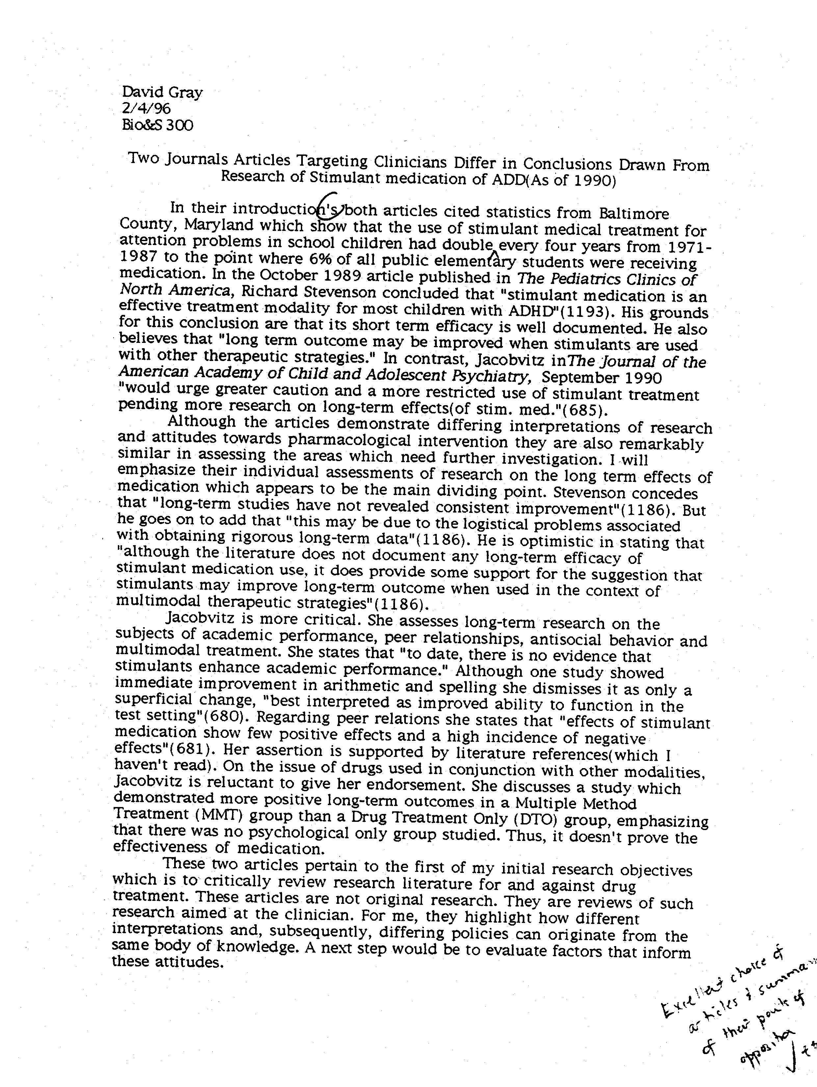
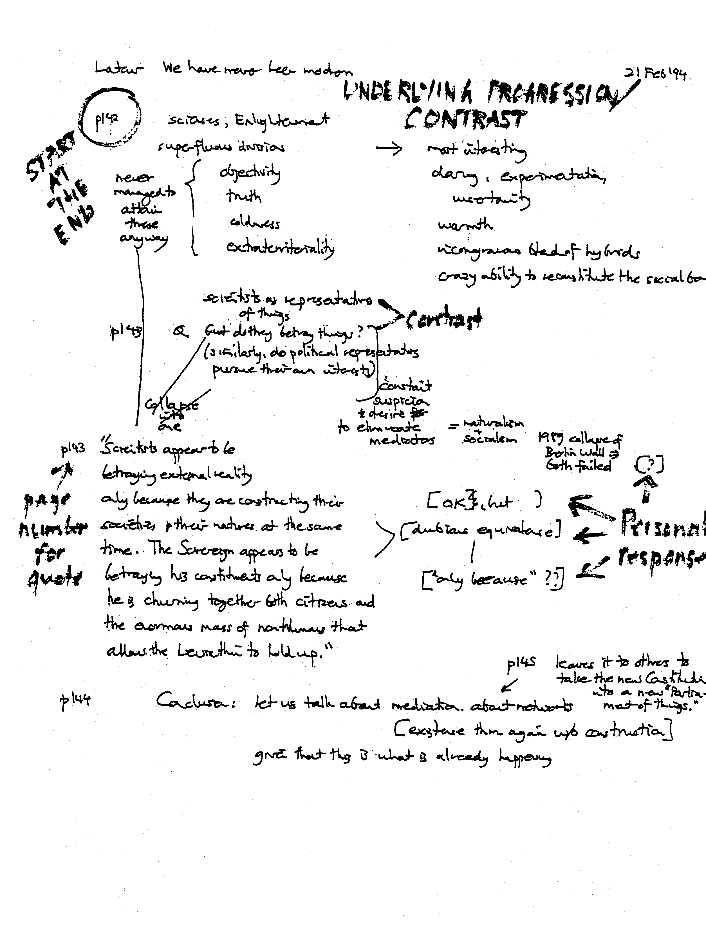
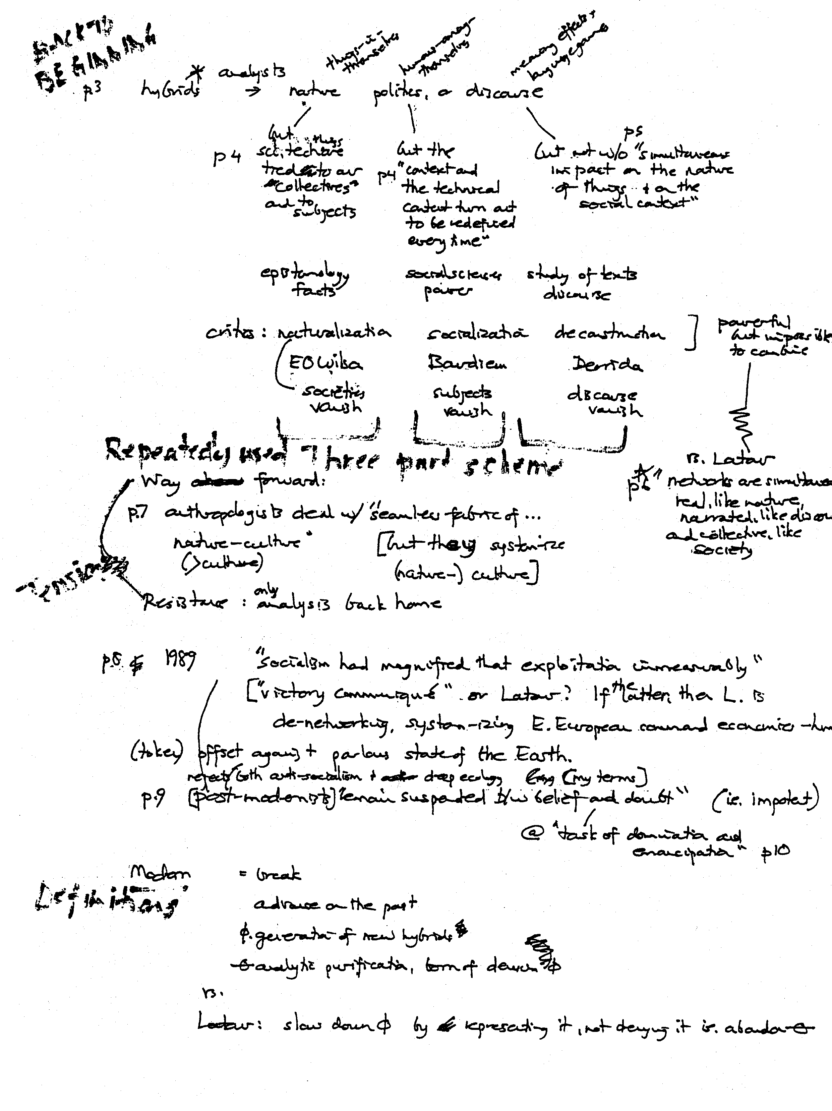
Initial Informant
Ivy Frances
CCT 698

Informant: Susan Butler
October 19, 2003

Susan gave me three resources that I will follow up on: The Photographic Resource Center in Kenmore Square has a very large inventory of books and other materials where I could spend several days, weeks or years exploring their materials! She also said Double Take Magazine would be a good resource for the kinds of philosophy questions I was exploring about photography. As I explained further about my project she explained that, a photography book about a Fishing Community in Maine by Olive Pierce kept coming to her mind, so I will try and find this book.

Susan also gave me some key advice and pieces of wisdom that I want to keep in the front of my mind during this project:

- It is about the practice of staying open – put yourself in position

- It is very frightening

- Let it be what it is

- Make sure you dialogue with yourself afterwards

- Invent as you go along

- What will be in the frame or not

- Shed false expectations

- Give yourself maximum permission to be expressive

- Find out what part of the photograph is important – abstract, their view, your view

- Think of it as a journey, not a book for publication

- Don’t worry about the product – follow your heart

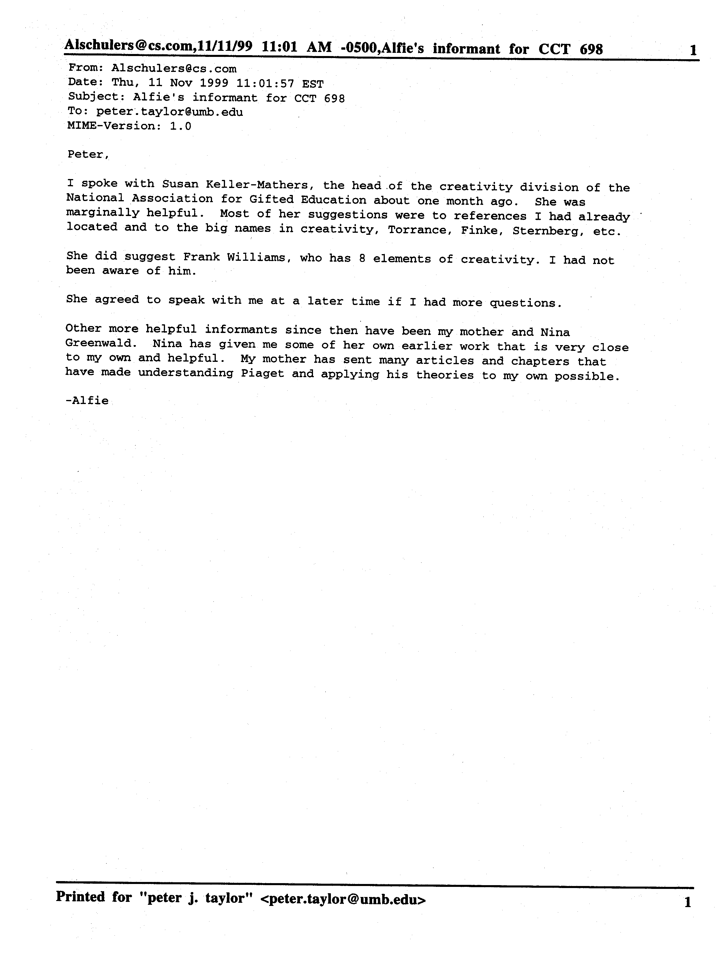
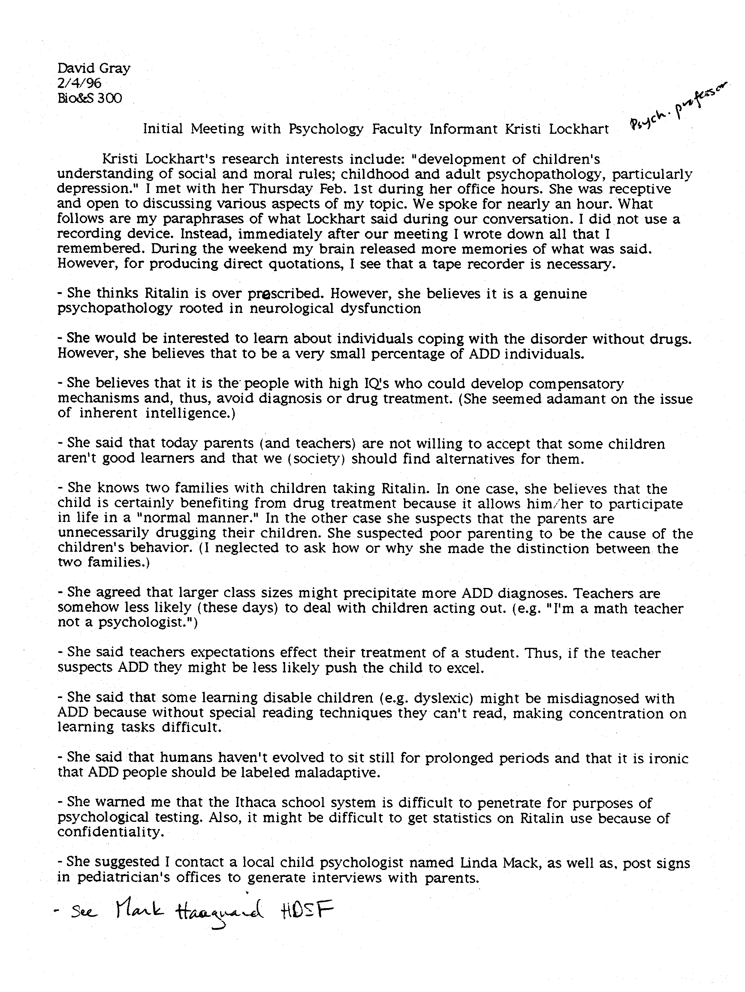
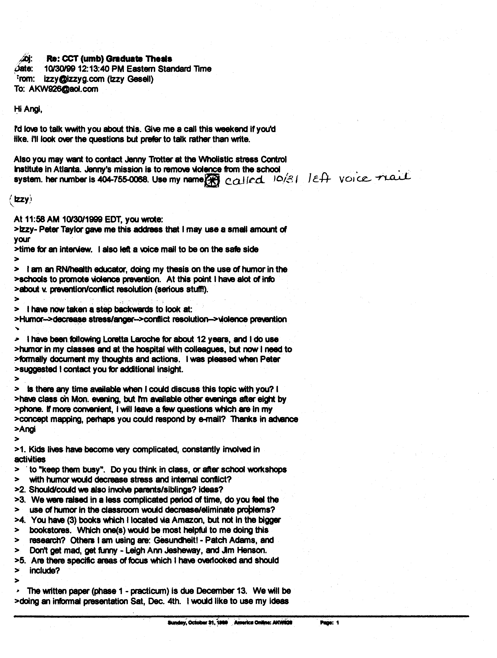
Jeanne Hammond
Assignment B3
October 20, 2002

Annotated Bibliography

Guiding Question:
What can I learn about developing a climate for teamwork to enhance job satisfaction, improve unit morale, and decrease staff turnover through review of current literature and observation of related efforts?

Cox, K.B. (2001). The Effects of Unit Morale and Interpersonal Relations on Conflict in the Nursing Unit. Journal of Advanced Nursing, 35 (1) 17-25.
Greater unit morale and better interpersonal relations were associated with lower intragroup conflict and less anticipated turnover. Nurse managers need to promote an environment that supports a team-oriented culture by encouraging collaboration and collegiality, while minimizing the conditions for conflict. Nursing is teamwork, therefore nurses need to learn to be effective team players. Developing as a team player needs to begin during basic nursing education

Fawcett, D.L. (2002). Mentoring: What It Is and How to Make It Work. Association of Operating Room Nurses Journal, 75(5) 950-955.
A mentor is a role model for a new nurse that provides a nurturing environment to help the new nurse grow professionally. The responsibilities of a mentor include knowing the mentee, able to communicate openly with the mentee, communicating standards of practice, and assist in the socialization of new nurses to the unit. A mentor is a friend, teacher, advocate and confidant. The relationship is built on trust. Whether a mentor or not, every nurse on the unit is responsible for the success of a new nurse. They are responsible for teaching new skills or accepting a new staff member as part of the team.

Fullam, C., Lando, A.R., Johansen, M.L., Reyes, A., & Szaloczy, D.M. (1998). The Triad of Empowerment: Leadership, Environment, and Professional Traits. Nursing Economics, 16 (5) 254-259.
Empowerment is moving decision making down to the lowest level where competent decisions can be made. In the hospital setting it would be at the unit staff level. Empowerment is a process that includes the professional nurse, a supportive environment and transformational leadership. It is an environment in which there is mutual trust, respect and autonomy. Developing an empowered staff is a win-win situation for all involved including the leadership team, nursing staff and institution. Empowerment results in increased employee satisfaction.

Hetherington, L.T. (1998). Becoming Involved: The Nurse Leader’s Role in Encouraging Teamwork. Nursing AdministrationQuarterly, (Fall), 29-37.
The benefits of effective teamwork include a shared vision of patient care and unit practice, enhanced professional relationships amongst caregivers, increased unit morale and reduced staff burnout. The manager can help promote job satisfaction by promoting joy in the work we do. Job satisfaction and joy in work is related to involvement. Meaningful involvement will encourage staff to participate in professional development committees and unit based projects. The nurse manger can lead by role modeling.

Katzenbach, J.R. & Smith, D.K. (1999). The Wisdom of Teams: Creating the High-Performance Organization. New York: HarperBusiness Book.

Mills, A.C. & Blaesing, S.L. (2000). A Lesson from the Last Nursing Shortage: The Influence of Work Values on Career Satisfaction with Nursing. Journal of Nursing Administration, 30 (6), 309-315.
As another nursing shortage looms over healthcare, the reasons that nurses chose nursing as a profession and would they encourage others to enter the profession are explored in this research article. Concerning is the dissatisfaction of nurses with their career, to the extent they would not encourage others to enter the profession nor would they chose nursing as a profession if they had the chance to do it over again. A lesson learned from the last nursing shortage is nursing cannot respond to financial pressures to reorganize nursing activities that would alter nurses core work values which include the rewards in the nurse-patient relationship.

Roman, M. (2001). Mentors, Mentoring. MedSurg Nursing, 4 (2) 57-58.
Mentoring is a nurturing relationship. Mentoring helps new nurses to grow professionally by providing knowledge, advice and emotional support. “Novice nurses today still seem most frustrated by the lack and care of concern they are shown by staff nurses, their peers and colleagues. It has been said “Nurses eat their young.” Why don’t we nurture our young and watch them grow?

Roman, M. (2001). Teams, Teammates, and Team Building. MedSurg Nursing, 10 (4) 161-163.
“Current staff on a unit plays a major role in minimizing turnover.” “When a nurse fails to succeed on the unit, it’s because the current staff failed that person.” There are tips to enhance positive relationships among staff. It is everyone’s responsibility to encourage new staff and provide positive feedback to increase confidence and self-esteem. Mentoring and providing corrective feedback can help guide practice and help achieve self-efficacy.

Senge, P., Kleiner, A., Roberts,C., Ross,R., & Smith, B. (1994). The Fifth Discipline: Strategies and Tools for Building a Learning Organization. New York: Doubleday.
Chapters Shared Visions and Team Learning will be read and added to this annotated bibliography.

Senge, P., Kleiner, A., Roberts,C., Ross,R., & Smith, B. (1994). The Fifth Discipline Fieldbook: Strategies and Tools for Building a Learning Organization. New York: Doubleday.
Chapters Shared Visions, Team Learning and Arenas of Practice will be read and added to this annotated bibliography.

Watson, D.S. (2002). The Perfect Storm. Association of Operating Room Nurses Journal 75 (6), 1068-1070.
Factors that contribute to improved staff morale and staff retention are performance recognition, flexible work schedules, empowering staff at the unit level, and time allowed for professional development. We need to promote and celebrate nursing as a profession and create work environments that nurses want to work in. Improvements in the work environment include elimination of mandatory overtime and provision of optimal staffing for acuity.

Wieke, K.L., Prydun, M., & Walsh, T. (2002). What the Emerging Workforce Wants in Its Leaders. Journal of Nursing Sholarship, 3rd Quarter, 283-288.
A phenomenon of 4 generations working together has emerged. Each generation has values and ideals unique to each generation, but is in conflict with the values of other generations. The emerging workforce values flexibility, training, mentoring, money and a balanced home/work life. The emerging and entrenched workforce desire some of the same attributes in leaders, but the emerging workforce prefers more nurturing qualities. Nurse leaders will need to respond to the needs of the generations to develop a cohesive work environment in which everyone’s values are respected.

Zemke, R., Raines, C. & Filipczak, B. (2000). Generations at Work: Managing the clash of Veterans, Boomers, Xers, and Nexters in Your Workplace. New York: Amacon.

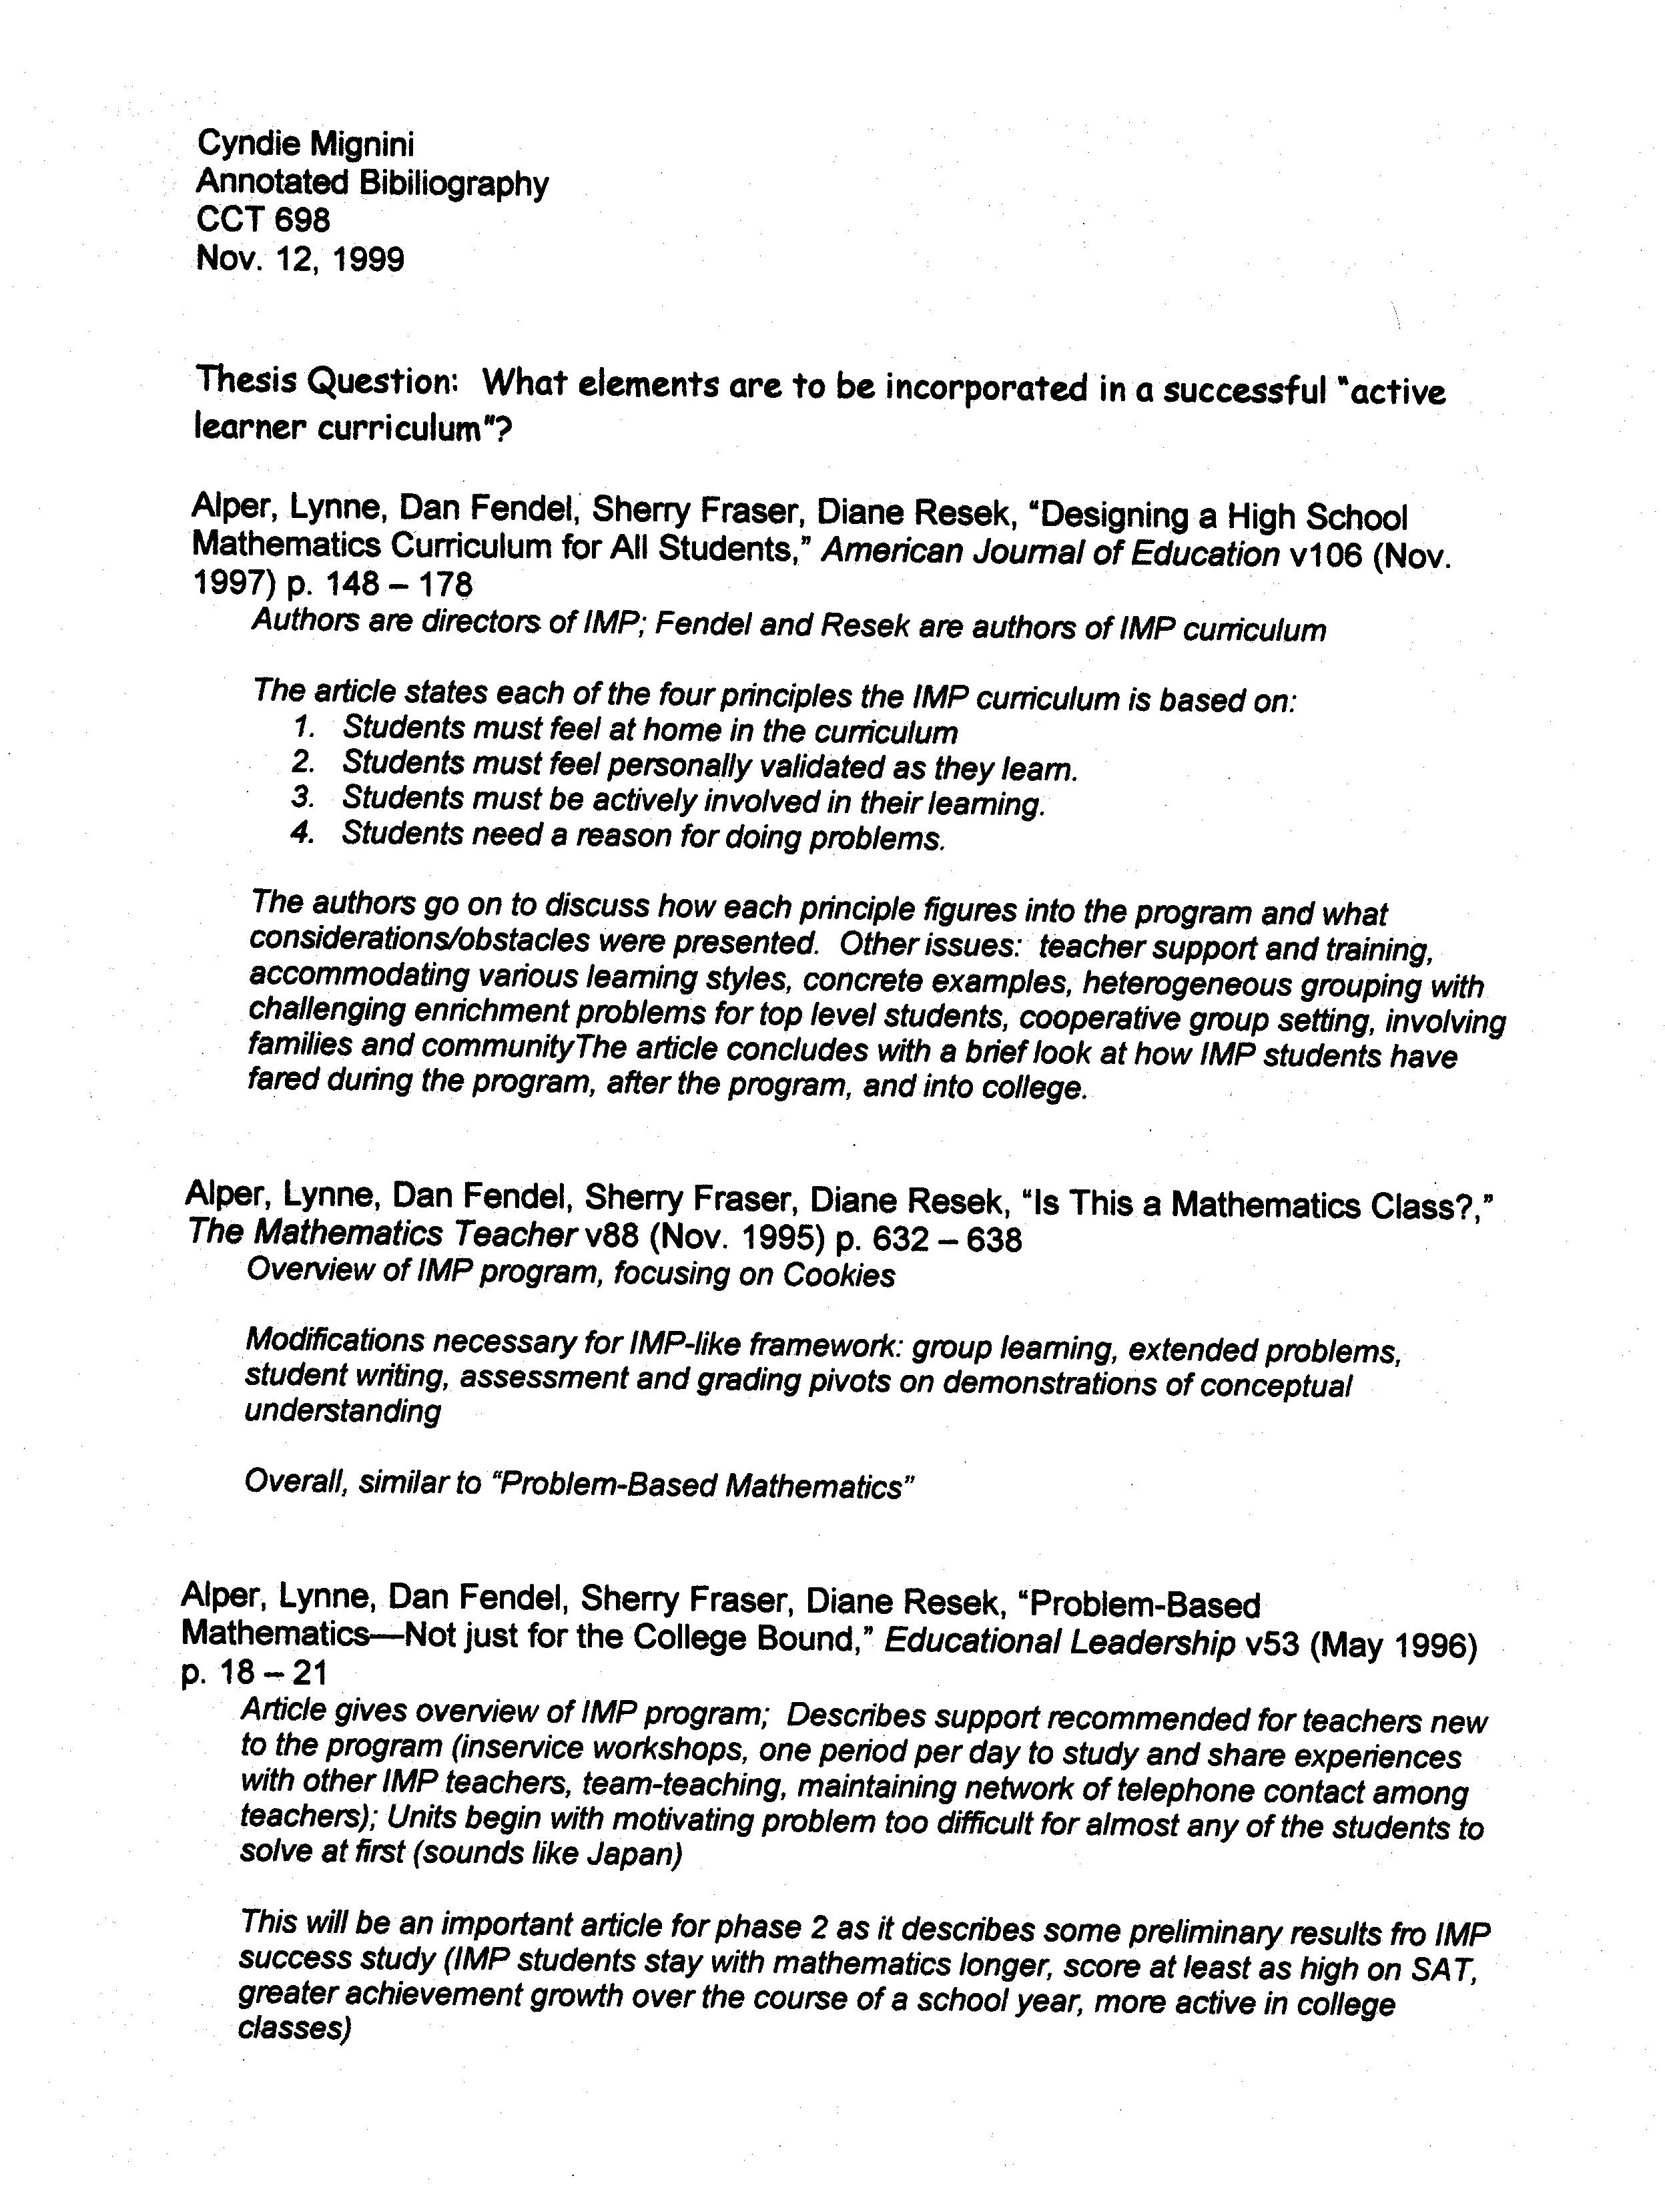
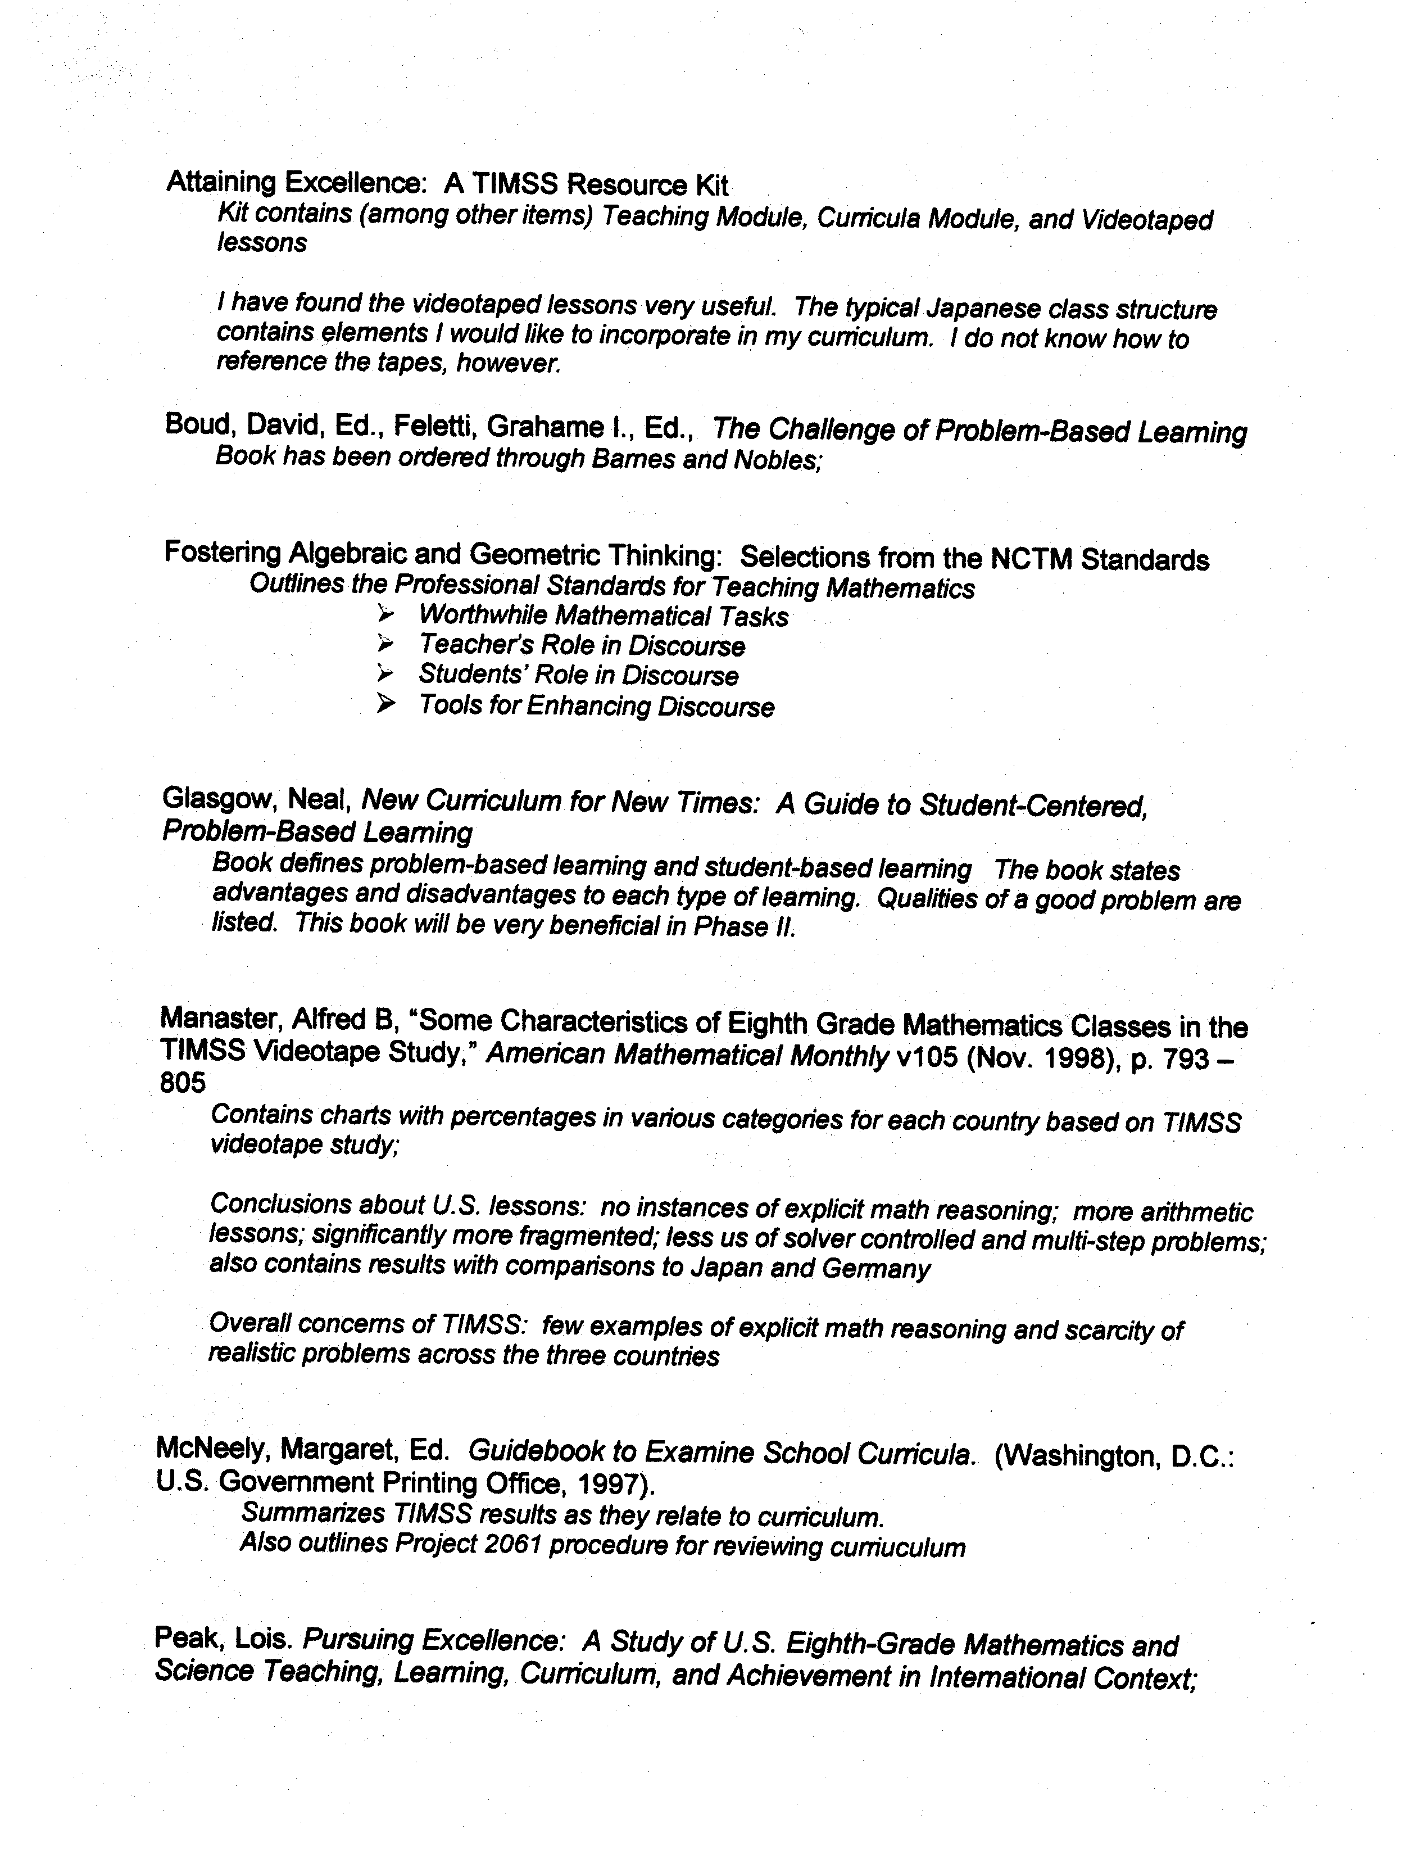

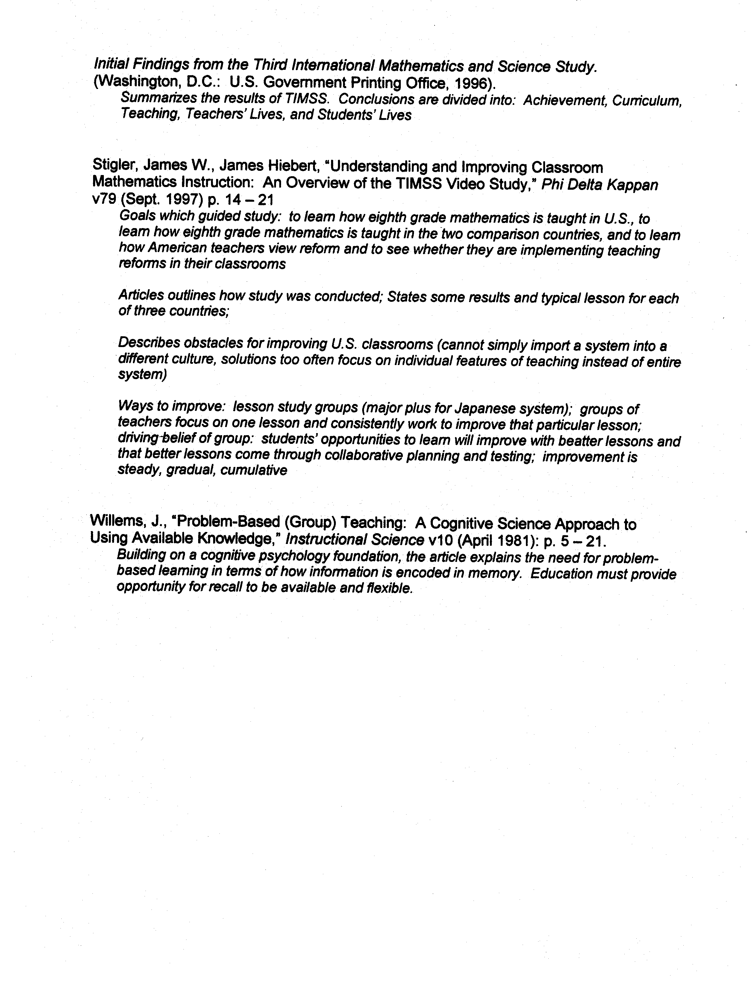
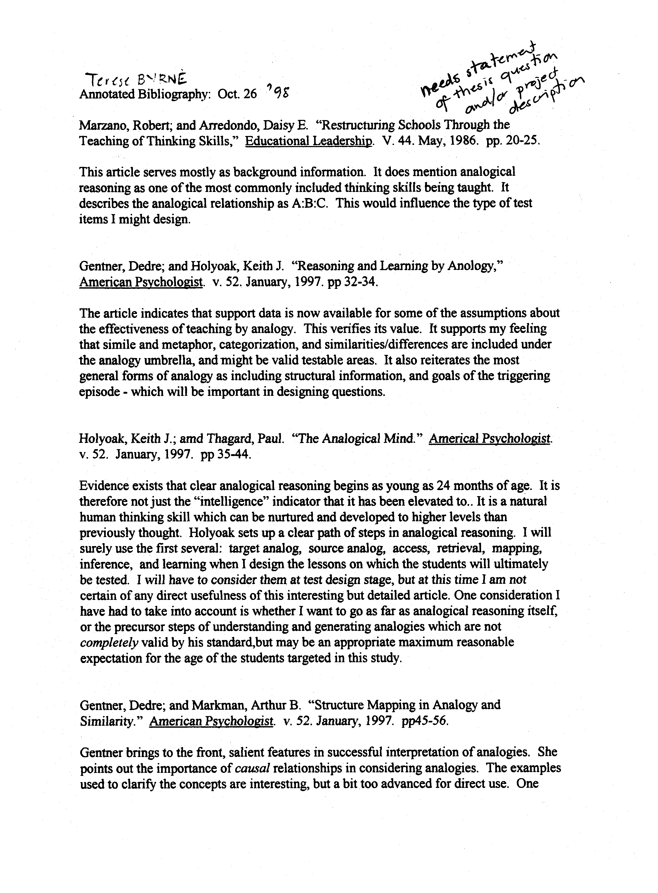
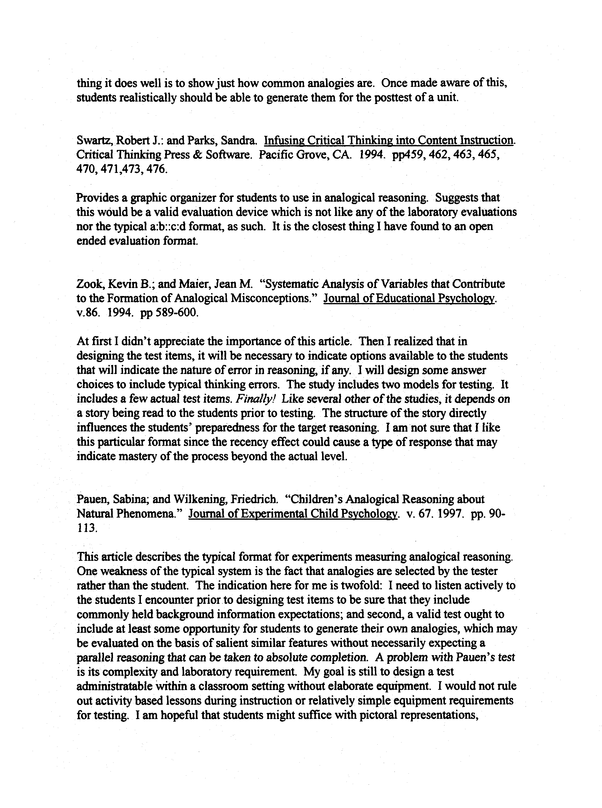


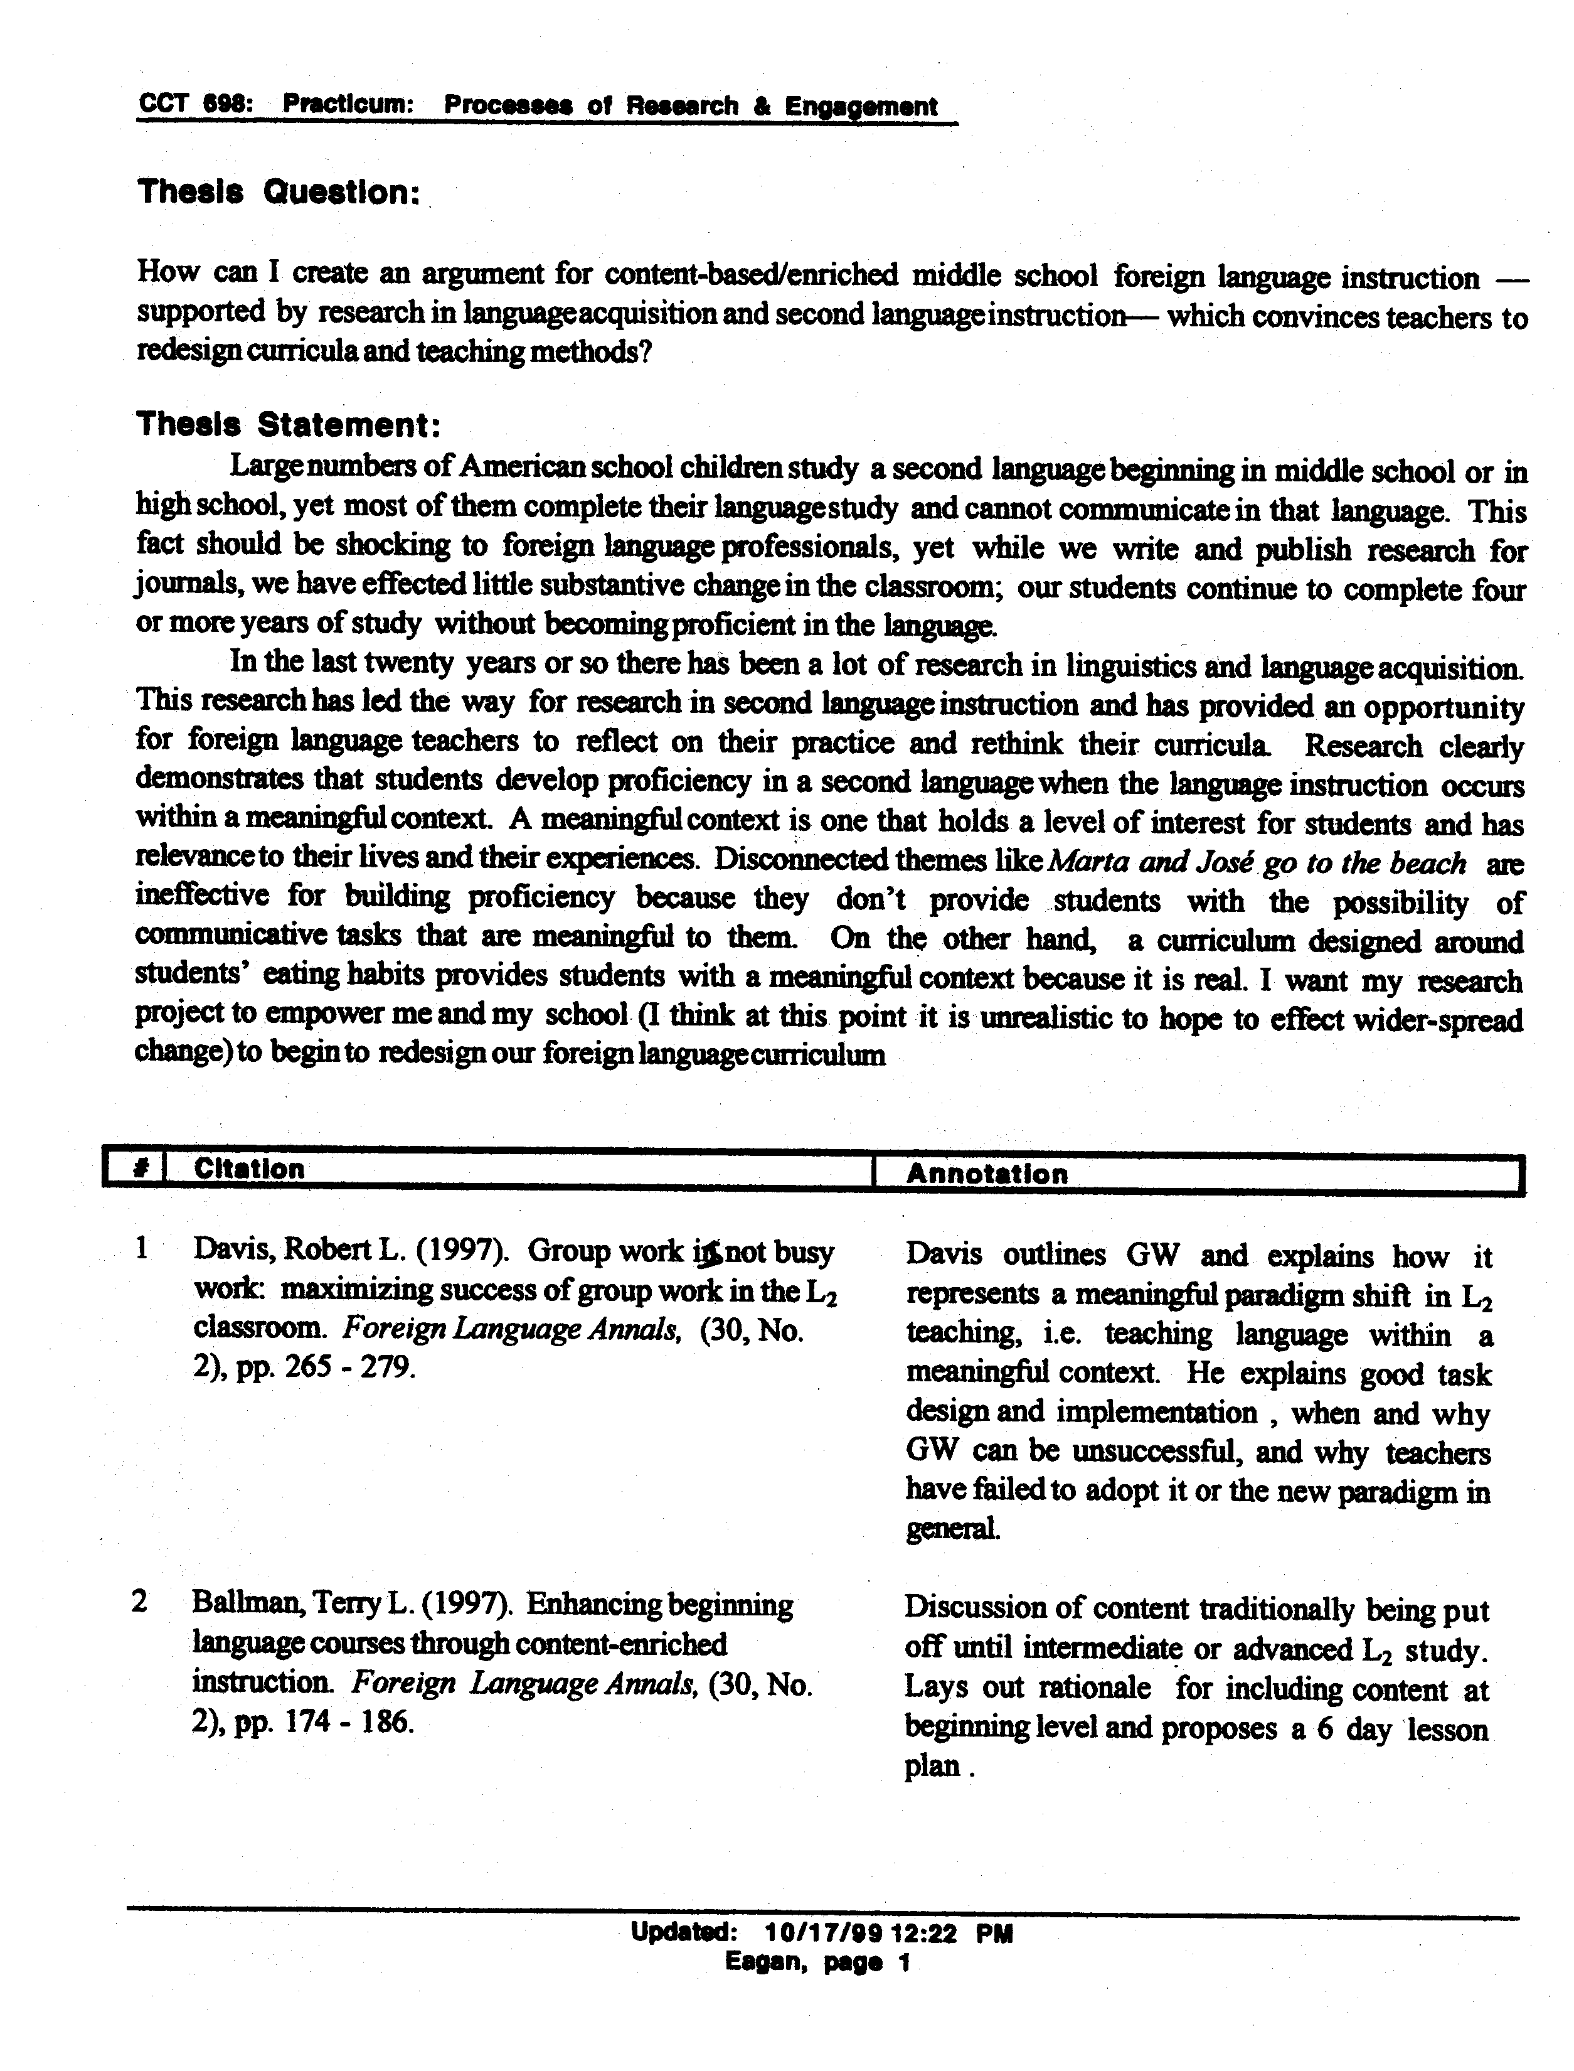
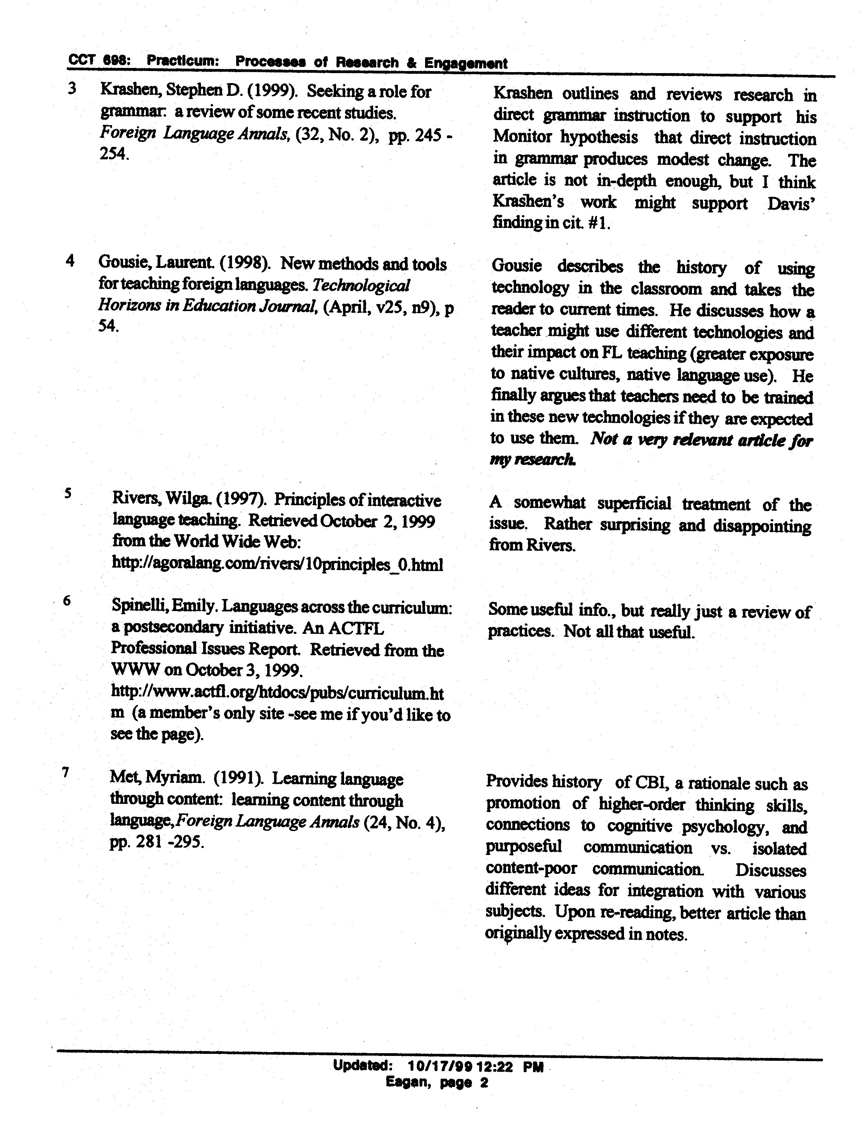
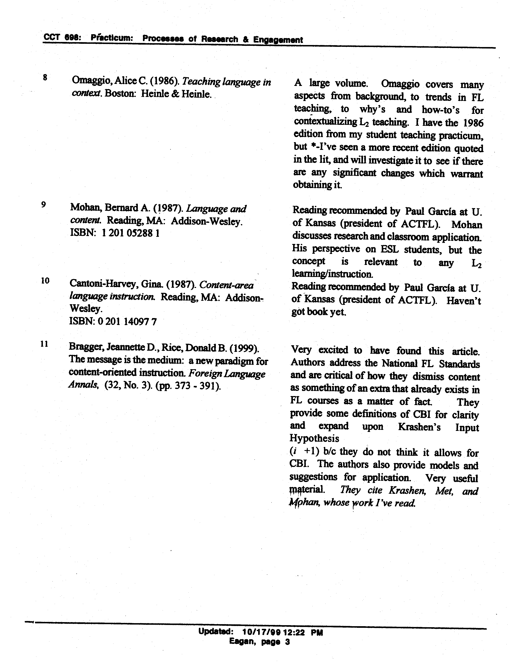

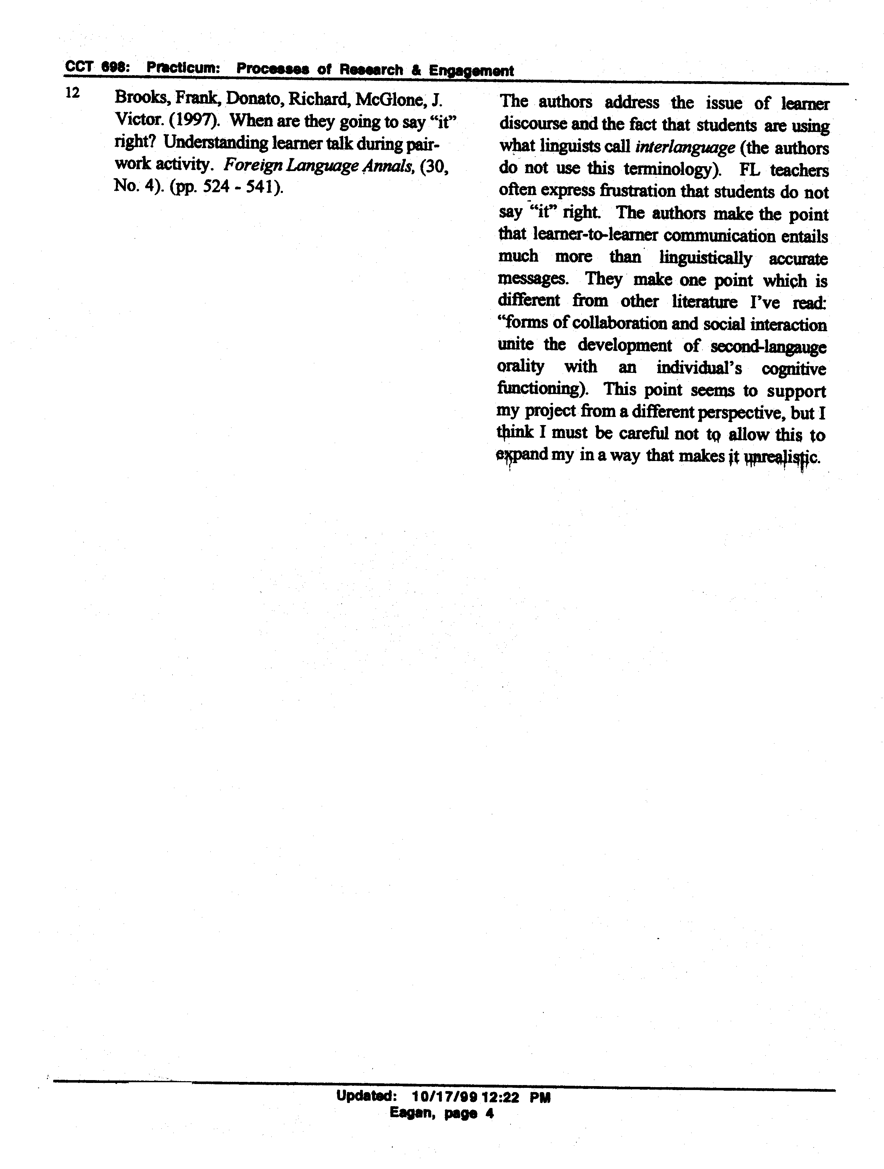

Annotated Bibliography

Guiding Question:
What can I learn about developing a climate for teamwork to enhance job satisfaction, improve unit morale, and decrease staff turnover through review of current literature and observation of related efforts?

Cox, K.B. (2001). The Effects of Unit Morale and Interpersonal Relations on Conflict in the Nursing Unit. Journal of Advanced Nursing, 35 (1) 17-25.
Greater unit morale and better interpersonal relations were associated with lower intragroup conflict and less anticipated turnover. Nurse managers need to promote an environment that supports a team-oriented culture by encouraging collaboration and collegiality, while minimizing the conditions for conflict. Nursing is teamwork, therefore nurses need to learn to be effective team players. Developing as a team player needs to begin during basic nursing education

Fawcett, D.L. (2002). Mentoring: What It Is and How to Make It Work. Association of Operating Room Nurses Journal, 75(5) 950-955.
A mentor is a role model for a new nurse that provides a nurturing environment to help the new nurse grow professionally. The responsibilities of a mentor include knowing the mentee, able to communicate openly with the mentee, communicating standards of practice, and assist in the socialization of new nurses to the unit. A mentor is a friend, teacher, advocate and confidant. The relationship is built on trust. Whether a mentor or not, every nurse on the unit is responsible for the success of a new nurse. They are responsible for teaching new skills or accepting a new staff member as part of the team.

Fullam, C., Lando, A.R., Johansen, M.L., Reyes, A., & Szaloczy, D.M. (1998). The Triad of Empowerment: Leadership, Environment, and Professional Traits. Nursing Economics, 16 (5) 254-259.
Empowerment is moving decision making down to the lowest level where competent decisions can be made. In the hospital setting it would be at the unit staff level. Empowerment is a process that includes the professional nurse, a supportive environment and transformational leadership. It is an environment in which there is mutual trust, respect and autonomy. Developing an empowered staff is a win-win situation for all involved including the leadership team, nursing staff and institution. Empowerment results in increased employee satisfaction.

Hetherington, L.T. (1998). Becoming Involved: The Nurse Leader’s Role in Encouraging Teamwork. Nursing AdministrationQuarterly, (Fall), 29-37.
The benefits of effective teamwork include a shared vision of patient care and unit practice, enhanced professional relationships amongst caregivers, increased unit morale and reduced staff burnout. The manager can help promote job satisfaction by promoting joy in the work we do. Job satisfaction and joy in work is related to involvement. Meaningful involvement will encourage staff to participate in professional development committees and unit based projects. The nurse manger can lead by role modeling.

Katzenbach, J.R. & Smith, D.K. (1999). The Wisdom of Teams: Creating the High-Performance Organization. New York: HarperBusiness Book.

Mills, A.C. & Blaesing, S.L. (2000). A Lesson from the Last Nursing Shortage: The Influence of Work Values on Career Satisfaction with Nursing. Journal of Nursing Administration, 30 (6), 309-315.
As another nursing shortage looms over healthcare, the reasons that nurses chose nursing as a profession and would they encourage others to enter the profession are explored in this research article. Concerning is the dissatisfaction of nurses with their career, to the extent they would not encourage others to enter the profession nor would they chose nursing as a profession if they had the chance to do it over again. A lesson learned from the last nursing shortage is nursing cannot respond to financial pressures to reorganize nursing activities that would alter nurses core work values which include the rewards in the nurse-patient relationship.

Roman, M. (2001). Mentors, Mentoring. MedSurg Nursing, 4 (2) 57-58.
Mentoring is a nurturing relationship. Mentoring helps new nurses to grow professionally by providing knowledge, advice and emotional support. “Novice nurses today still seem most frustrated by the lack and care of concern they are shown by staff nurses, their peers and colleagues. It has been said “Nurses eat their young.” Why don’t we nurture our young and watch them grow?

Roman, M. (2001). Teams, Teammates, and Team Building. MedSurg Nursing, 10 (4) 161-163.
“Current staff on a unit plays a major role in minimizing turnover.” “When a nurse fails to succeed on the unit, it’s because the current staff failed that person.” There are tips to enhance positive relationships among staff. It is everyone’s responsibility to encourage new staff and provide positive feedback to increase confidence and self-esteem. Mentoring and providing corrective feedback can help guide practice and help achieve self-efficacy.

Senge, P., Kleiner, A., Roberts,C., Ross,R., & Smith, B. (1994). The Fifth Discipline: Strategies and Tools for Building a Learning Organization. New York: Doubleday.
Chapters Shared Visions and Team Learning will be read and added to this annotated bibliography.

Senge, P., Kleiner, A., Roberts,C., Ross,R., & Smith, B. (1994). The Fifth Discipline Fieldbook: Strategies and Tools for Building a Learning Organization. New York: Doubleday.
Chapters Shared Visions, Team Learning and Arenas of Practice will be read and added to this annotated bibliography.

Watson, D.S. (2002). The Perfect Storm. Association of Operating Room Nurses Journal 75 (6), 1068-1070.
Factors that contribute to improved staff morale and staff retention are performance recognition, flexible work schedules, empowering staff at the unit level, and time allowed for professional development. We need to promote and celebrate nursing as a profession and create work environments that nurses want to work in. Improvements in the work environment include elimination of mandatory overtime and provision of optimal staffing for acuity.

Wieke, K.L., Prydun, M., & Walsh, T. (2002). What the Emerging Workforce Wants in Its Leaders. Journal of Nursing Sholarship, 3rd Quarter, 283-288.
A phenomenon of 4 generations working together has emerged. Each generation has values and ideals unique to each generation, but is in conflict with the values of other generations. The emerging workforce values flexibility, training, mentoring, money and a balanced home/work life. The emerging and entrenched workforce desire some of the same attributes in leaders, but the emerging workforce prefers more nurturing qualities. Nurse leaders will need to respond to the needs of the generations to develop a cohesive work environment in which everyone’s values are respected.

Zemke, R., Raines, C. & Filipczak, B. (2000). Generations at Work: Managing the clash of Veterans, Boomers, Xers, and Nexters in Your Workplace. New York: Amacon.
