CCT698 Practicum
PHASES OF RESEARCH & ENGAGEMENT
Examples of Student work from previous years

A. Overall vision
• Six examples of project descriptions. Note: These are revised versions—Expect your initial version to need revision.
Rob Norris
Practicum
September 22

Revised project thesis question and description

Researchable Question: What does it mean to have found your personal center of imagination and what can be done to facilitate maintaining this type of mindset?

This summer I devoted my free time to creative writing. It was a struggle from the beginning to the end. Wrestling with plots, characters, details, questions, perspectives, and techniques made creative writing an endeavor more difficult than I had expected. But towards the end of the summer I felt like I made a breakthrough: I found my center of imagination and words began to flow easily. The words were flashing across my laptop, images flashing in my mind’s eye, scenes acted out in my head. As I sat in front of my laptop during these sessions I felt like I was beside myself. I was speaking in a voice that had been silenced long ago by external forces. The experience of letting out this creative capability was invigorating and rather emotional. It is this feeling, this moment of epiphany, this inspiration, this “being in the zone” is what I wish to center my initial project inquiry around:

- What is this experience all about?
- What are its effects on the person and his or her work?
- What can be done to stay in this center of imagination?

In my initial research I have found sparse information directly addressing this topic. It’s strange, in my opinion, that such a profound part of an artist’s experience has not been individually focused upon more. There is a massive potential of insight to be gained regarding the nature of creativity within this question. And since this has not been studied in detail I feel like I have something to contribute. Very exciting.
One of the few figures who has dedicated much study on this specific aspect of creativity is Gaston Bachelard. He was a French scientist turned philosopher from the nineteenth/twentieth century. His ideas are significant because he based many of his ideas on human perception upon the powers of imagination. Bachelard also acknowledged the significant input emotions have on human perception.
I intend to further study Bachelard’s ideas as a beginning to my own inquiry into the topic. I will also be looking for more thought on the topic, allowing my question to morph when necessary.

AUDIENCE OF MY INQUIRY:
Those people who are frustrated while attempting to be fully invested in the creative process. My audience is whoever have tried but failed to maintain focus on being a creative person. The range of demographics will be broad because I believe the appeal of creativity is universal among all positions in life.

PURPOSE OF MY INQUIRY:
Personally—so I can be a more fluid creative writer and so I can maintain a more creative persective on my life and work.
Generally—to provide more public knowledge over the creative process and its beneficial effects on a person's psyche and their work.

Tim Eagan Revised: 10/9/99 12:19 PM

Thesis Question & Statement:

How can I create an argument for content-based/enriched middle school foreign language instruction—supported by research in language acquisition and second language instruction—which convinces teachers to redesign curricula and teaching methods?

Statement:

Large numbers of American school children study a second language beginning in middle school or in high school, yet most of them complete their language study and cannot communicate in that language. This fact should be shocking to foreign language professionals, yet while we write and publish research for journals, we have effected little substantive change in the classroom; our students continue to complete four or more years of study without becoming proficient in the language.
In the last twenty years or so there has been a lot of research in linguistics and language acquisition. This research has led the way for research in second language instruction and has provided an opportunity for foreign language teachers to reflect on their practice and rethink their curricula. Research clearly demonstrates that students develop proficiency in a second language when the language instruction occurs within a meaningful context. A meaningful context is one that holds a level of interest for students and has relevance to their lives and their experiences. Disconnected themes like Marta and Jose go to the beach are ineffective for building proficiency because they don't provide students with the possibility of communicative tasks that are meaningful to them. On the other hand, a curriculum designed around students' eating habits provides students with a meaningful context because it is real. I want my research project to empower me and my school (I think at this point it is unrealistic to hope to effect wider-spread change) to begin to redesign our foreign language curriculum.

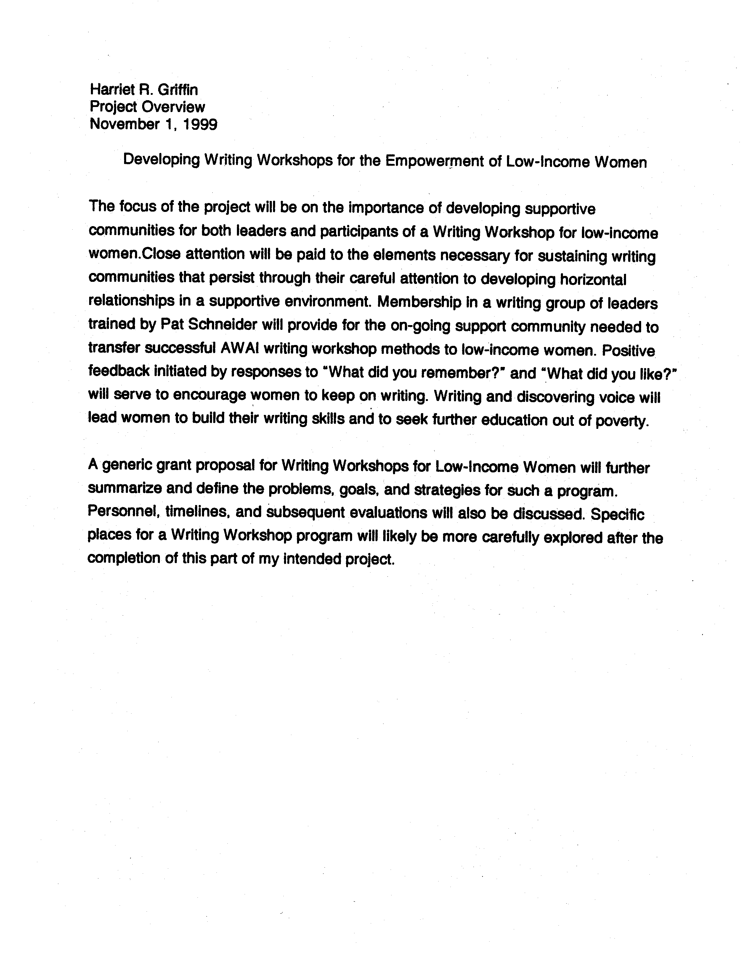
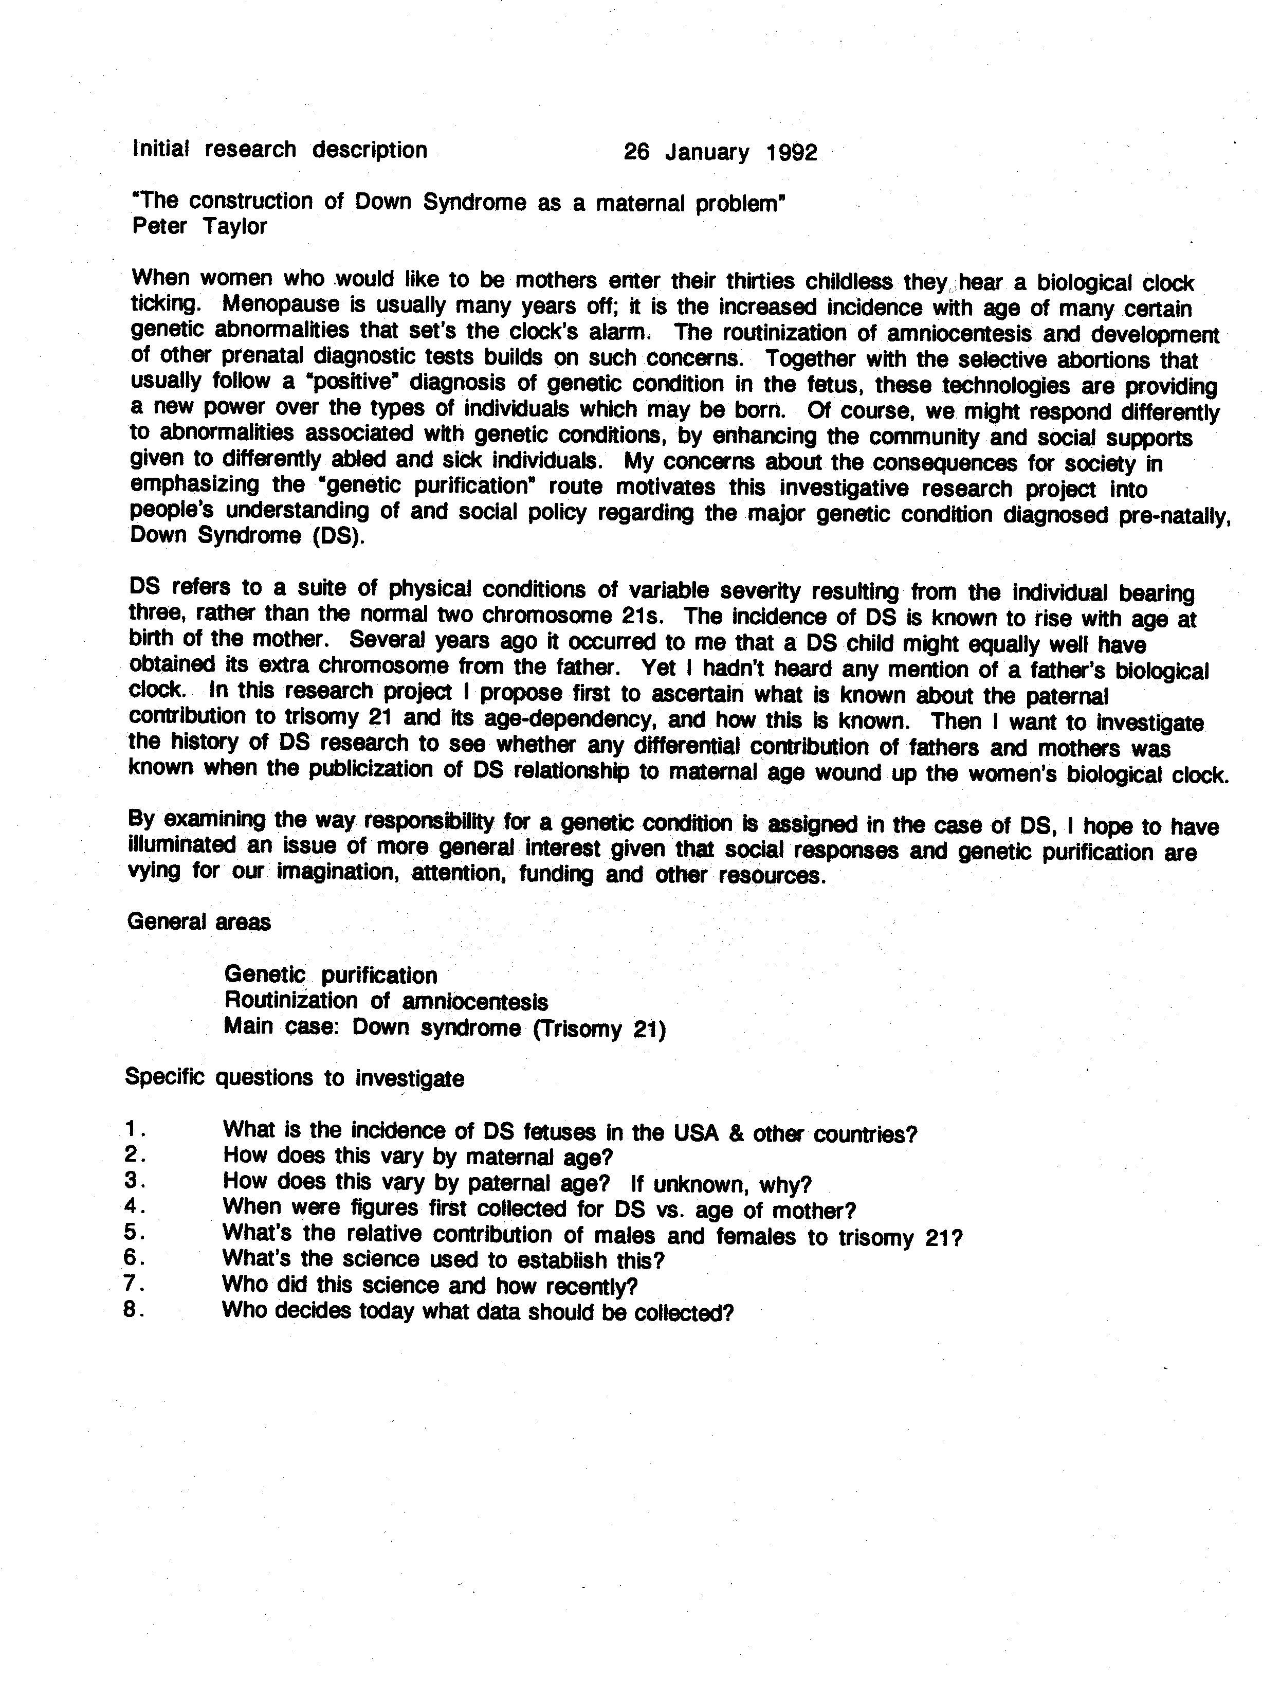
Suzanne M. Clark
CCT 698 - fall 2000
Due: 10-2
Revision
Thesis Question:
Can the Asian healing arts of tai chi, chi gung and ba gua play a role in
performing arts medicine as therapy for a musician's recovery from an
overuse injury and/or be used for prevention of such injuries?
Thesis Statement:
Performing arts medicine has developed in recent years as an answer to the
unrelenting injuries that musicians face. Across the globe, various
institutions have formed organized networks for distribution of information
to musicians and the professionals who treat them. Related clinics and
practitioners provide specialized services, such as nutritional therapy,
neurological assessment and testing, acupuncture, laser therapy,
homeopathy, muscular therapy, physical therapy, and chiropractic care as
treatment for playing injuries.
Despite the services available, many musicians do not recover fully, and
some not at all, from their debilitating injury. Unfortunately, overuse
injuries not only interrupt or even displace a career, but often they
inhibit everyday life due to their penetrating and relentless nature.
Simple tasks like combing one's hair, washing dishes, taking out the
garbage, buttoning shirts, or picking up a child are no longer within an
injured person's ability. Since many musicians feel their playing is their
"true voice", the sudden onset of musical speechlessness can be disturbing
on a deeper level. The loss of one's career, autonomy and emotional
expression can be devastating.
Since the available treatments may not cure the problem, perhaps one needs
to consider a different approach to healing. In China, the Asian healing
arts are used as prevention and treatment for serious diseases, such as
cancer and arthritis. How do these therapies work and could they fill in
the gaps that Western medicine and alternative therapies have not been able
to fill? My project will look at the healing arts on a physiological level
as well as emotional, mental and spiritual. They will be viewed not only
in contrast to the therapies used in performing arts medicine for healing
overuse injuries, but also as a foundation to support and enhance those
therapies. Perhaps the missing link between a limited, painful music
career and its restoration will be found.
Rob Norris
Practicum
September 22

Revised project thesis question and description

Researchable Question: What does it mean to have found your personal center of imagination and what can be done to facilitate maintaining this type of mindset?

This summer I devoted my free time to creative writing. It was a struggle from the beginning to the end. Wrestling with plots, characters, details, questions, perspectives, and techniques made creative writing an endeavor more difficult than I had expected. But towards the end of the summer I felt like I made a breakthrough: I found my center of imagination and words began to flow easily. The words were flashing across my laptop, images flashing in my mind’s eye, scenes acted out in my head. As I sat in front of my laptop during these sessions I felt like I was beside myself. I was speaking in a voice that had been silenced long ago by external forces. The experience of letting out this creative capability was invigorating and rather emotional. It is this feeling, this moment of epiphany, this inspiration, this “being in the zone” is what I wish to center my initial project inquiry around:

- What is this experience all about?
- What are its effects on the person and his or her work?
- What can be done to stay in this center of imagination?

In my initial research I have found sparse information directly addressing this topic. It’s strange, in my opinion, that such a profound part of an artist’s experience has not been individually focused upon more. There is a massive potential of insight to be gained regarding the nature of creativity within this question. And since this has not been studied in detail I feel like I have something to contribute. Very exciting.
One of the few figures who has dedicated much study on this specific aspect of creativity is Gaston Bachelard. He was a French scientist turned philosopher from the nineteenth/twentieth century. His ideas are significant because he based many of his ideas on human perception upon the powers of imagination. Bachelard also acknowledged the significant input emotions have on human perception.
I intend to further study Bachelard’s ideas as a beginning to my own inquiry into the topic. I will also be looking for more thought on the topic, allowing my question to morph when necessary.

AUDIENCE OF MY INQUIRY:
Those people who are frustrated while attempting to be fully invested in the creative process. My audience is whoever have tried but failed to maintain focus on being a creative person. The range of demographics will be broad because I believe the appeal of creativity is universal among all positions in life.

PURPOSE OF MY INQUIRY:
Personally—so I can be a more fluid creative writer and so I can maintain a more creative persective on my life and work.
Generally—to provide more public knowledge over the creative process and its beneficial effects on a person's psyche and their work.

