Virginia de la Garza
December 2007
Process of Research and Engagement
Final Paper

Steps Needed to Become Someone Who Fosters Intellectual Perseverance
We are constant learners; it’s our nature to be so. Some people think that learning is easy and some others find it to be very hard. Some students get actively engaged in their learning goals or thinking processes and constantly look for answers or solutions, whereas others, have to hassle finding out ways to achieve their learning goals.
The following questions arose when analyzing and thinking about the learner’s commitment or the lack of it, when studying. What are the characteristics of an effective critical thinking learner? What makes a person be engaged in achieving a learning goal even when that means dealing with a great amount of effort, confusion, or even frustration? Does it have to do with the learners’ motivation and/or with their sets of mental tools? Are students conscious of the mental tools they posses and the way to use them? Can the ability to achieve learning objectives in difficult scenarios be taught? Have we been taught to overcome obstacles when trying to accomplish a learning objective? Does the educational system, the teacher, the student, society, or the media, play a role on influencing one’s way of approaching problem solving? What makes one be able to beat personal limits, or on the contrary, what makes us step away from our goal?
This paper is the first part of a deeper study around this topic. Several of the questions previously posed will be explored. The main objective of this study is to look for the understanding of the mental processes that accompany a person who tries to learn in spite of difficulties, and consequently searches for the steps needed to become a person who fosters Intellectual Perseverance in learners.
Elder & Paul, internationally recognized authorities on critical thinking due to their extensive experience and rich contributions to education and the world of thinking skills, designed a diagram with the six stages that all of us go through if we aspire to develop as critical thinkers:
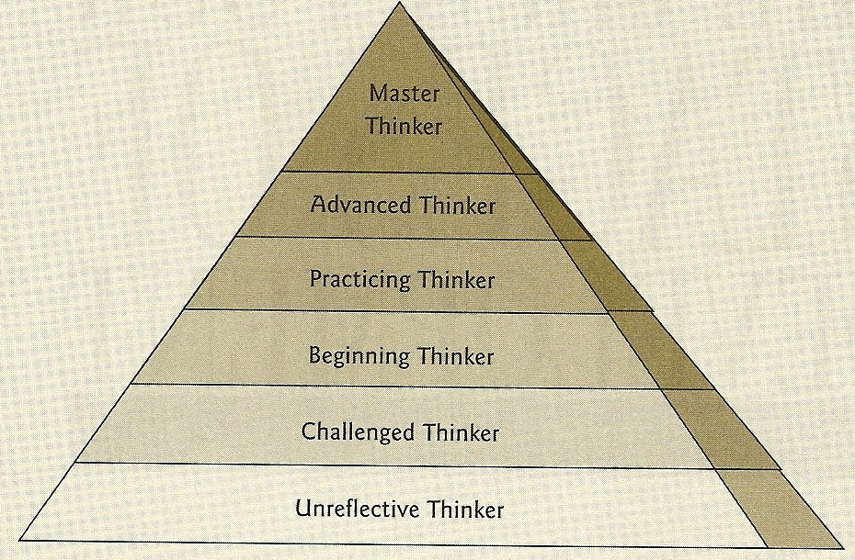
Elder, L., & Paul, R.W. (2002). Critical thinking: Tools for taking charge of your professional and personal life. New York: Prentice Hall.
Elder & Paul (2002) describe each stage in the following way: In stage 1, the Unreflective Thinker is unaware of significant problems in thinking; in stage 2, the Challenged Thinker becomes aware of problems in thinking; in stage 3, the Beginning Thinker tries to improve but without regular practice; in stage 4, the Practicing Thinker recognizes the necessity of regular practice; in stage 5, the Advanced Thinker proceeds in accordance with practice, finally in stage 6, the Master Thinker is skilled and his insightful thinking becomes nature.

In addition, they believe that critical thinkers strive to develop essential traits or characteristics of mind which are perceived as interrelated habits that enable one to open, discipline, and improve mental functioning. (3) The following diagram shows the eight intellectual traits:
TRAITS OF THE DISCIPLINED MIND
Intellectual integrity
Intellectual humility
Intellectual sense of justice
Intellectual perseverance
Intellectual fair-mindedness
Intellectual confidence in reason
Intellectual courage
Intellectual empathy
Intellectual autonomy
Elder, L., & Paul, R.W. (2002). Critical thinking: Tools for taking charge of your professional and personal life. New York: Prentice Hall.

They believe that all of the Traits of the Disciplined Mind can be developed. This paper is based on the analysis of one of those eight interrelated traits of the disciplined mind: Intellectual Perseverance. Paul and Elder (2002) define Intellectual Perseverance as the disposition to work one’s way through intellectual complexities despite frustration inherent in the task. They believe that some intellectual problems are complex and cannot be easily solved but one has intellectual perseverance when one does not give up in the face of intellectual complexity or frustration. In addition, the intellectually perseverant person has a realistic sense of the need to struggle with confusion and unsettled questions over an extended time to achieve understanding or insight.
On the other hand, Paul and Elder (2002) claim that the opposite of Intellectual Perseverance is Intellectual Laziness, which is demonstrated as the tendency to give up quickly when faced with an intellectually challenging task. They believe that people who are intellectually indolent, or lazy, have a low tolerance for intellectual pain or frustration.

In order to better analyze, understand and have a visual representation of the definitions of Intellectual Perseverance and Intellectual Laziness, previously mentioned, the following diagram was designed for this study.
Starting point-Learning
Goal
Sense of
the need
to struggle
with confusion
and unsettled
questions over extended time
Mental
process
continues
Intellectual
Laziness
Deeper
understanding
or insight
Intellectual Perseverance
Intellectual
Complexities

Intellectual pain
or frustration
Mental process stops
Low
tolerance

I don’t think that Intellectual Perseverance and Intellectual Laziness is a matter of motivation. Perseverance, insistence, firmness, decisiveness, persistence, determination, and willpower, are synonyms usually related to motivation. I believe that Intellectual Perseverance and Intellectual Laziness go beyond motivation; it is all about knowing how to learn and preparing the mind for learning by understanding that there are mental processes that give you paths that lead to solutions and that there are other mental processes that block you from seeing or following those paths.
Facing intellectual complexities is a daily occurrence. As a student and as a teacher, there’s a constant need to search for ways to problem solve in order to achieve personal and academic goals. Solving problems is not always simple but nevertheless problems need to be faced. I find this topic fascinating and the way the authors perceive and define Intellectual Perseverance motivates and challenges me to study the topic and do further research in order to understand the thinking processes one goes through when trying to put in practice or develop that trait of mind. I believe that understanding Intellectual Perseverance or what makes a person face a challenge and overcome the obstacles to achieve a goal, is a key component in the learning and teaching process.
I don’t agree with the authors’ way of perceiving the lack of Intellectual Perseverance or as they call it, Intellectual Laziness. The dictionary defines Lazy as disinclined to activity or exertion; not energetic or vigorous; moving slowly; and Indolent is defined as a person who suggests a love of ease and a dislike of movement or activity. (1)
I don’t think that a person who gives up when facing an intellectual obstacle is necessary an intellectually lazy person. The person might face that situation in an energetic and ambitious way but at the same time, have a lack of mental tools to achieve the main objective and I don’t see that as being lazy.
On the other hand, I understand and don’t discard that there are some people who might be lazy thinkers due to the trend of the law of the least effort. I have heard teachers, who work in Mexican universities, claim that some of their students, who seem to be able to be effective thinkers, don’t do their best nor use their maximum effort when solving problems, studying, or learning. Student’s curiosity and thinking skills seem to be decreasing. Those teachers believe that some students nowadays are growing in a culture based on the minimum effort and tend to solve problems or achieve cognitive goals looking for the fastest and easiest ways. It seems that students learn to develop effective strategies that help them cover what is required from the educational system and concentrate on the “product” instead of the learning process. In other words, those students use the most convenient search method or strategy and consequently, the problem solving struggle, the information-seeking, or the intellectual perseverance behavior stops as soon as minimally acceptable results are found. This can be dangerous because students do not develop their cognitive skills like they should and consequently, the curriculum objectives are not reached.
What is the reason of this culture or tendency to evade a problem with the least possible effort? I wonder if this habit of mind related to facing tasks in a superficial or fast way has to do with the lack of metacognition. Are they following this process because they don’t know how to face a problem in a different way?
The definition of Intellectual Perseverance made some questions arise. Those questions are presented in the following diagram:

Sense of
the need
to struggle
with confusion
and unsettled
questions over extended time
Mental process stops
Mental
process
continues
Intellectual
Laziness
Deeper
understanding
or insight
Intellectual Perseverance
Intellectual
Complexities

Intellectual pain
or frustration
Low
tolerance
2. What causes a sense of the need to struggle or the lack of it?
Have mental tools and the ability to solve problems something to do with this?
6. Is this a characteristic, a disposition, a habit, a set of mental tools or an attitude?

3. Are learners aware of their own level of tolerance and the way the manage frustration?

5. Are these traits of mind learned? Who is responsible for this to happen? (Educational system, teachers, students, family, media, peers, groups, etc.)

1. What are the difficulties and/or
obstacles that cause
confusion?

4. Are the learners aware or unaware of their metacognitive levels, mental blocks, and thinking skills? How important is this for learning?

Starting point-Learning
Goal

If Intellectual Perseverance and Intellectual Laziness go beyond motivation and are related to the way each person prepares their mind for learning, analyzing the answers to questions 1, 2, and 3, presented in the diagram, will lead to a better understanding of the way a learner faces a problem or situation. Question 4 is directly associated to Metacognition and I believe that the awareness and use of the metacognitive skills play an essential role in achieving the learning goal or not. Therefore metacognition is seen as the center of the Intellectual Perseverance/Intellectual Laziness thinking process.
Nelson and Narens (1996) believe that metacognition is, literally, thinking about thinking and plays a part in both monitoring and controlling our cognitive functions. Smith et al. (2000) think that the term also addresses the ability to assess our level of knowledge and skill in a given domain. Smith et al (2005) claim that in its monitoring role, metacognition informs us of our knowledge and assesses our performance.
- For example, when you are asked to write an essay as a final project for a class, your metacognitive process reviews the experience you have had writing essays and the information you know about the topic, then it makes a judgment and decides if you are able to do the task or not. Smith et al (2005) believe that throughout the course one takes to achieve the task, the metacognitive processes inform you of your progress and indicate whether you have the ability to complete the task at hand. In addition, they believe that those metacognitive judgments are input to the control activities of metacognition, providing your cognitive processes with the information needed to change and adapt. I believe that some of those judgments can be mistaken due to the lack of awareness of how to control and understand those mental processes. In other words, not everybody has learned or is aware of their metacognitive level or skills. Everson & Tobias, (1998) claims that incompetent individuals lack of metacognition.
- Kruger & Dunning’s (1999) research show that metacognitive judgments are often at odds with reality, and use the term Metacognitive Miscalibration to refer to the disparity between self-assessments and more objective measures of ability and performance. They believe that people differ widely in the knowledge and strategies they apply to approach a problem and have different levels of success. In addition, they claim that when people are incompetent in the strategies they adopt to achieve success and satisfaction, they suffer a dual burden: Not only do they reach erroneous conclusions and make unfortunate choices, but their incompetence robs them of the ability to realize it.
- Research that studies people’s inability to deal with what they don’t know has been done and researchers believe that the way people handle knowledge or the lack of it has serious implications on their ability to learn. Armour (2000) defines five levels of ignorance. The first level is 0OI and refers to the absence of ignorance; the person is aware of everything that he or she knows and shows evidence to prove it. The second level is 1OI and the person recognizes lack of knowledge, in other words, the person is aware that something is not known. In the third level, 2OI there is an unrecognized lack of knowledge, the person doesn’t know that something is not known. In the fourth level is, 3OI, there is no process for being aware of ignorance, the person doesn’t have the ability to identify if something is not known. And finally, the 4OI level refers to meta-ignorance, in other words, ignorance of the orders of ignorance. Smith et al. (2005) believe that Armour’s second order of ignorance (2OI) relates to metacognitive miscalibration because someone in this level is ignorant and unaware it. I don’t agree with that argument and believe that 3OI is more closely related to metacognition miscalibration or has a deeper impact in it. If metacognition has to do with being able or having the skills to think about thinking, the 3OI level is what keeps a person away from identifying the process that leads to understanding what one doesn’t know and that keeps them away from understanding their thinking process and consequently they can’t think about their thinking. I believe that this metacognitive miscalibration or habits of mind can be seen at any educational settings and levels, even in high education. Such metacognitive miscalibration is the antithesis of what is expected from students in high education levels.
The university has long provided a place to undergo what some call “the necessary fatigue of independent thought”. Thomas Jefferson saw universities as sanctuaries of ideas, where, he said, “We are not afraid to follow truth wherever it may lead, nor to tolerate any error so long as reason is left free to combat it” Gregorian (2005). In addition, Botstein (2005) claims that the habits of mind that colleges acknowledge to disseminate in the classroom –often described as critical thinking (the demand for careful analysis; the examination of intuitive and counterintuitive hypotheses; the raising of questions; the tolerance of ambiguity, uncertainty, and fallibility; and the pursuit of curiosity) - are deemed not only useful but also desirable for the duration of one’s life.
On the other hand, Johnson (2005) believes that the educational system, in the United States, has developed serious flaws that interfere with its ability to develop in our young people the depth of critical thinking, intellectual curiosity, and human understanding so essential for dealing with the problems in our world today.
Students approach tasks and experience levels of engagement in different ways. Teachers are usually assessing student outcomes and it is easy to identify what students do or don’t do but things get complicated and complex when trying to understand the reasons why students do what they do. Understanding student’s reasons when approaching learning tasks is needed to understand the metacognitive level and what they are focusing on. Students approach learning tasks in different ways and their goals behind what they are trying to achieve may indicate the type of learning they are looking for and the result they might have. Maehr (1983) studied in-depth understanding of student processes in the way they approach tasks. He describes four goal types that he believes are associated with learning achievement: 1) task involvement, 2) ego involvement, 3) social solidarity, 4) and extrinsic rewards. He believes that a task involvement goal is when students are pursuing task goals and they are absorbed in the activity and seek competence in the task for the sheer pleasure of doing well. Ego goals, involve "doing better than some socially defined standard, especially a standard inherent in the performance of others". In addition, he describes social solidarity goals as being directed toward pleasing others, and extrinsic reward involves motivation by acquisition of something such as a high mark or extra free time.
If we go back and remember the definition of Intellectual Perseverance, its main focus or objective is achieving understanding or insight. The four goals proposed by Maehr might be objectives that make people persevere and achieve their objective, but that doesn’t mean that all of them foster understanding nor require of metacognitive skills.
The information gathered and learned from this paper will be used as a base of my synthesis project. All of the concepts and ideas presented in this paper will be further explored. The following stage will be based on how to teach in order to foster Intellectual Perseverance and consequently there will be a search or creation of the steps that are needed to become someone who is effective in fostering intellectual perseverance. In addition the connection between Intellectual Perseverance and quality of life will be analyzed.

References
1. Merriam Webster Online Search: http://www.m-w.com/dictionary/
2. Armour, P.G. (2000). The Five Orders of Ignorance. Commun. ACM 43, 10. 17-20.
3. Botstein, L. (2005) Book Declining by Degrees. Article:The Curriculum and College Life. (pp. 211) Palgrave Macmillan.
4. Everson, H. T., & Tobias, S. (1998). The ability to estimate knowledge and performance in college: A metacognitive analysis. Instructional Science, 26, 65-79.
5. Gregorian, V. (2005). Book Declining by Degrees. Article: Six Challenges to the American University. (pp. 77) Palgrave Macmillan.
6. Johnson, J. (2005). Book Declining by Degrees. Article: It is Only a Port of Call: Reflections on the State of Higher Education. (pp. 194) Palgrave Macmillan.
7. Kruger, J. & Dunning, D. (1999). Unskilled and Unaware of It: how difficulties in Recognizing One’s Own Incompetence Lead to Inflated Self-Assessments. Journal of Personality and Social Psychology. Vol. 77, No. 6. 1121-1134.
8. Maehr, M.L. (1983). On doing well in science: Why Johnny no longer excels; Why Sarah never did. In: Learning and Motivation in the classroom, ed. S.G. Paris, G.M. Olson, and H.W. Stevenson. Hillsdale, NJ: Lawrence Erlbaum Associates.
9. Nelson, T.O. & Narens, L. (1996) Why investigate metacognition? Metacognition: Knowing about Knowing. J. Metcalfe and A.P. Shimamura, Eds. MIT Press, Cambridge, MA, 1–26.
10. Paul, R., Elder, L. (2001). Critical Thinking: Tools for Taking Charge of Your Learning and Your Life. (pp. 12-13). New Jersey: Prentice Hall.
11. Smith et al. (2000). Metacognitive Miscalibration and Underachievement in a Computer Literacy Course: Some Preliminary Observations. In Proceedings of the International Academy for Information Management Annual Conference.
12. Smith et al. (2005). Prepare Your Mind For Learning. Communications of the ACM. Vol. 48, No. 9

