My earliest memory of art is this. I sit outside on my mother’s lap. A sketchpad in on my sweating knees, and she holds her hand loosely over mine, encouraging my pencil-gripping fingers to lightly swirl and mark the page. “Be random; be loose”, she would tell me. Satisfied that the page was marked enough, she would then set the pencil aside and as I leaned back against her, she’d turn the pad slowly until we had examined the marks completely from every possible angle. What we were looking for was something familiar. A bird, a face, a tree, something that is there in the loose lines waiting to be pulled out. The lines are only there as a guide and inspiration. They are the art, but the art is also continuous, and we share this experience as we will share it many times over until it later forms so solidly in my mind that to this day I will turn even the most obviously pre-oriented drawings in every direction as I create them, looking for balance, looking for inspiration, looking for information that a single perspective cannot provide. I now look back on this as a seed to my interest in interactive art.
In order to discuss aspects of interactive art, some definition needs to be offered as an anchor to the arguments and questions that arise. In itself, art can be widely defined, but one definition is that art is an offering of translation, elaboration, or commentary on the abstract and/or concrete aspects of existence. As language is a vehicle of communication between two or more people to share ideas and information, and as language can be in written, oral, or gestural form, it can be argued that art is an aspect of language that cannot substitute any other, but that art can also then not be substituted. This brings to mind John Berger’s reference to “seeing which comes before words”. “When in love, the sight of the beloved has a completeness which no words and no embrace can match; a completeness which only the act of making love can temporarily accommodate.” (Berger, p. 8) Similarly, the language of art is sometimes required to communicate that which cannot otherwise be communicated. For example, the views that Cezanne painted of his native Provence, and in painting them he offered us translation of the completeness that he felt, such as Mont Sainte-Victoire, of which he painted well over a dozen versions, each one an expression of a completeness which that moment could “temporarily accommodate”.
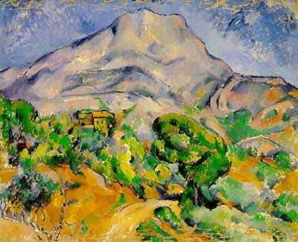
Continuing to look at art as a unique aspect of language, there is an interaction taking place when art is viewed. There are several interactions. There is the art and the viewer, one viewer to another viewer, the viewer to the artist (whether present or not) and, finally, there is the viewer to him/herself. Again looking at Berger’s Ways of Seeing, “We never look at just one thing; we are always looking at the relation between things and ourselves.” (Berger, p. 9) While every piece of art does not evoke (or even intend to evoke) reflection of self or ideas, art can invite or startle or force us into questioning established knowledge or ideas. The drawings of Leonardo da Vinci are an example, such as his View of a Fetus in the Womb, which offered the viewer a perspective that was not available through other means. Yet still, we can never experience Mont Sainte-Victoire as Cezanne did. Dominic Lopes, referencing musical performances writes “we evaluate performances as aesthetic in their own right, since, as is obvious, properties of a token need not be expressed by its type.” He continues, “Accordingly, a good work can be given poor performances as a poor work given performances that are, qua performances, good but not redeeming.”
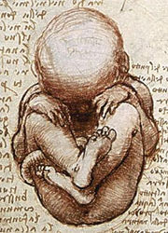
How is interactive art then different from art? Definitions vary slightly, but most will include that interactive art involves the viewer by inviting and allowing the viewer to interface with the artwork. Whether this interface needs to change, contribute to, or complete the piece is not what I will address. But I will address how the interactive piece invites the viewer to interaction. This is important because without that invitation, and then without the viewer accepting that offer, nothing occurs differently that traditional viewing. Further, viewers need an invitation because tradition tells us that art cannot be touched. So the first point of interaction is the invitation, which is the first point at which the viewer is offered a choice. “We only see what we look at. To look is an act of choice.” (Berger, p.8)
Art and interactive art have more in common than not. The both provide the opportunity for interaction, only the type of interaction differs. There is always a potential dialogue between art and viewer. For example, Jeff Koon’s Two Ball 50/50 Tank was a piece of work that completely perplexed me when I saw it. A friend of mine and I discussed it for hours after.

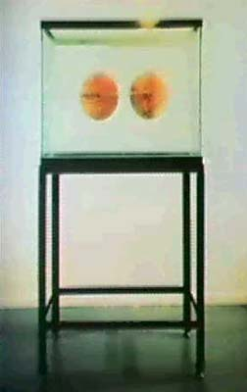
Dialogue continues beyond the experience. We are curious and we like answers. We like questions. Once we answer something we form an additional question. I am still thinking about the basketballs because I need to understand. Peter Shaffer, the author of Equus, a play about an isolated and unpredictable violence against horses by a young man, needed to understand why the young man would blind these horses. His fiction helped him make sense of the world. Shaffer’s dialogue became a piece of art, and a dialogue beyond his proceeded from that play. In a sense this work was interactive because its impact extended beyond the time frame of the performance, just as we each have some piece of art or music that we carry with us somewhere in our memory to be accessed again and again.
But interactive art differs vastly from other art in that it is usually physically touched, which requires us to move beyond comfortable boundaries that have been established about art and sacredness, art and preservation, and the artist and the viewer. So what are the components of interactive art that might be present in all works considered interactive, regardless of the medium? Does all interactive art entice the viewer to participate? Offer an avenue for the viewer to dialogue in some manner? Provide for each viewer having a unique experience? Require the viewer to activate it? If there is no physical contact, can it be called Interactive Art?
As much as I am an artist, I get hedged in by what is expected and what is “right”. Preferring things in neat packages, my desire is to have a clean set of qualities present in all interactive art. But the difficulty in doing this is similar to the difficulty of defining it. Samuel Butler said, "A definition is the enclosing a wilderness of ideas within a wall of words." I believe that as I investigate beyond this paper and immerse myself more in my own work, I will come to some better idea, but for now I will focus on the enticement of the viewer, as this is the starting place of dialogue.
In Marco Evaristti’s The Goldfish Blender, the viewer is enticed by several things, the immediate one being the incongruity. In our society we do not use blenders on live animals and goldfish in particular are equated with being childhood pets. Another enticement is curiosity. Will the blender work and will my pressing the button actually kill this goldfish? A viewer who does not press the button is not interacting any less than a viewer who does. The internal questions are the dialogue, are the interactions.
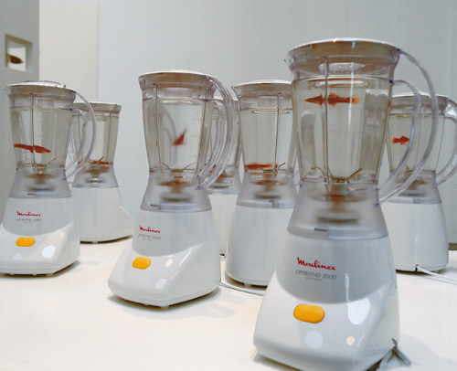

I have said of my own work that I not only want to entice the viewer into interacting in some manner (which may include touching) , but that I wish to create tension in the viewer, some tugging at their moral or perceptual boundaries. I have only been able to say this clearly since being in the Critical and Creative Thinking program. Not quite self-indulgent enough to dredge up the archives of my own psycho-babble, I will still offer that, like most artists, I wish to connect to others through this language and, like most people, the connection I wish to make is one that reinforces my sameness or similarity with others; something reassuring me that my desires and my fears and are not grossly divergent, but common to others in the world.
I once said in philosophy class that a person raised by wolves is more wolf than human because what makes us human is interaction with one another, the reflection of ourselves in the eyes of others, and our ability to reflect something back to them. There is an intimacy created when a stranger can regard my work and understand something of themselves, or be moved, which to me is them identifying a sameness. This is my connecting using my language. I don’t want to be alone in the world and, often, we have the sense that we are alone through some feeling or experience that is uniquely ours, perhaps negative, perhaps immoral, but, in fact, internal struggles as well as internal joys, are more common than we think. This is what I want to pull from the viewers of my work. Do they need to touch the work to access this, or speak it once they have? I don’t believe so. But they need to be drawn toward that possibility and offered that choice.
Several questions that I find important to interactive art (and my work) are: In what way should or does the artist anticipate response? What are enticements and how do they fit with what we know of human nature? What enticement exists in traditional art? What interaction occurs without touch? And how might enticement extend past the experience (once the viewer has left the gallery and gone home).
In his book, The Power of Images, David Freedberg opens his chapter on response and repression, saying, “People are sexually aroused by pictures and sculptures; they break pictures and sculptures, mutilate them, kiss them, cry before them, and go on journeys to them; they are calmed by them, stirred by them, and incited to revolt.” This, referencing paintings and sculptures, is clearly describing a dialogue between the work and the viewer, though not all of these involve physical touch.
Later in the book, Freedberg quotes Mark Twain from Twain’s book Tramp Abroad. The quote is Twain’s response to viewing Titian’s painting, Venus.
there, against the wall, without obstructing rap or leaf, you may look your fill upon the foulest, the vilest, the obscenest picture the world possesses -- Titian's Venus. It isn't that she is naked and stretched out on a bed --no, it is the attitude of one of her arms and hand. If I ventured to describe that attitude there would be a fine howl --but there the Venus lies for anybody to gloat over that wants to --and there she has a right to lie, for she is a work of art, and art has its privileges. (Freedberg, p. 343)

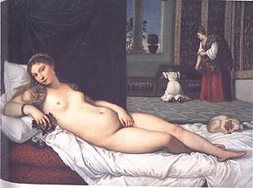

I love Twain’s response as much as I love his seemingly disdainful assertion, “art has its privileges”. He proceeded to describe his interpretation of the response of others as they looked at the painting, and his description leaves no question about his own response. Each viewer is making a choice about how to proceed with their interaction of the piece. Though he describes young men “gazing long and absorbedly at her”, Twain my have been the one most absorbed, just as I was with the basketballs in the fish tank.
In college, I exhibited a large reclining nude. My goal was to sensually arouse viewers and draw them closer, though I recognized that some would be uncomfortable even from afar by her nudity. I made her very large so that she dominated the wall even from a distance. But some people came closer and those that came the closest discovered and could read text that ran along the shadows of her body. The words were, in my mind, a reward for their investment. But the information relayed by the words were not pleasant and I assumed that there would be some who would struggle with the association of words with the image that a few moments ago they were stirred by. This was tension that I enjoyed trying to create. I believe this is tension that replicates arousal and investment and information in real relationships. While I have no record of that piece (I traded it off with another art student), I would want to return to that idea. It is subtle but important interaction, and is very similar, I think, to that of Twain with Titian’s Venus of Urbino.
The question of what interaction occurs without touch is answered in every example provided so far. Metacognition, done in solitude with ones own thoughts or in partnerships and discussion with others around you, is interactivity. Interactive art is in a way a test. It is seeing how far a viewer will go beyond comfort zones, beyond surface information. Human nature is curious and we sometimes are drawn to do what we are not supposed to do or not supposed to gaze upon. Taboo topics and situations are enticing. Sex is enticing, and it is still taboo. Not in a blatant way, but in a meaningful way. Because it is human nature to be drawn toward taboo, because we seek knowledge (and how can you learn about something that is off limits?), taboo subjects are a natural enticement.
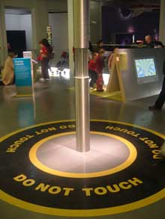
The Do Not Touch installation by Christian Moeller is a stainless steel pole with electricity running through it. A warning sign surrounds it. But it is the directive “do not touch” that entices the touch.

Robert Mapplethorpe’s work comes to the mind of most when taboo and censorship is being discussed. I don’t want to spend too much time on his work specifically, but want to note his piece Selfportrait/Whip. Because it is a self-portrait, and because his gaze is to the viewer while he exposes himself in an act of sexual taboo (both the act and the display of it are taboo), here is a clear example of a dialogue between the artist and the viewer. And here I imagine that Mapplethorpe did anticipate his audience’s response. And the dialogue that his work incited, continues and has now been added here.
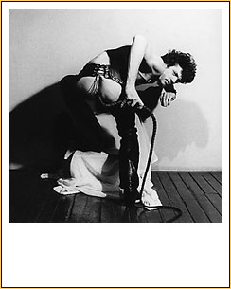
I’d like also to refer to Marina Ambramovic’s performance piece of 1974, where she sat passively for 6 hours, allowing the audience to select from a table of objects with which they could use to touch her (these objects including “weapons”). In this example, the enticement is the allowance, the breaking of personal boundaries with no obvious consequence. But there is consequence, and there is influence. These is personal memory and there is the public nature of the work. Nobody went unobserved. When we are observed, even without speech, we are in conversation with others about expectations and norms.
One of the considerations for my own work is when the interaction will be public and when a work will require the interaction to be private. Similar to the difference in viewing a piece of art in a gallery and from viewing the same image in your home, surrounded by personal objects, interacting with art among others, affects the interaction. I have a pair of red phones connected with a long line. My idea is to have this phone connect strangers from one room to another room in a gallery. One end would be for listening the other for speaking. I thought initially that each would be in their own “booth” but I am enamored with the tension that could be created if the listener were to simply be sitting at a table with people walking about. Without even needing to speak to others while they are listening (and I’d direct them to not speak anyway), seeing others and occasionally making eye contact, or overhearing other conversations as they listen to the voice at the other end, all influence their experience of the piece.
One of the assurances that traditional art viewing affords us is anonymity and privacy. Despite Twain’s observation of the young men looking at the painting of Venus, he could not really know what is in their minds and behind their stares. Our thoughts are private unless we choose to share them. I enjoy the choice being offered, and being encouraged, but I see the importance of the inner dialogue, either by itself or as a lead-in to dialogue with others.
Pat Keck’s Man Discovering Something fascinated me. When I saw this, I saw a man’s posture that suggested he is startled, stopped in his tracks by what he sees. What does he see? He sees a form of his own image, his shadow. But what is unique and surprising to his shadow? His eyes are vacant? Clear? He is discovering something. Is it somethingabout himself? This is not “a” man, but “Man”. I connect with the image personally. I am he. When have I last looked at my shadow? What does my shadow tell me? Can I affect my shadow?
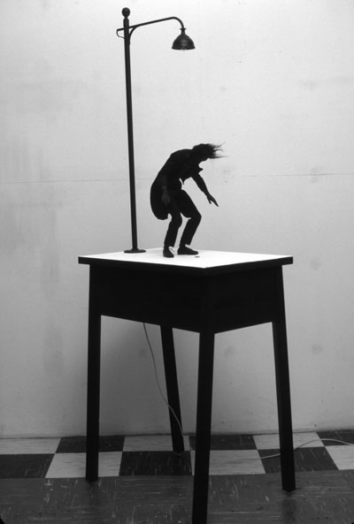
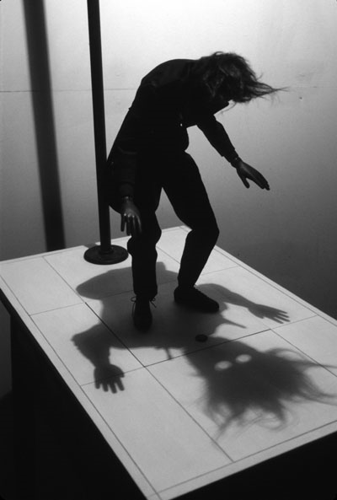

Like Keck’s piece, I would like for my work to get at personal questions. Interactive art can do this in concrete ways. When I created the eggs for the students in class, I hoped that they would realize that there was something inside of them. What was inside was not of great consequence, though this was not known nor was it the point. The point was to provide them with something frail, something traditionally nurtured, yet also offer some enticement to be discovered so that each student would be faced with the choice to destroy the egg or keep it whole.
But this was a small sample of a larger piece that also speaks to fragility and choice, an exchange of one thing (a sacrifice) for something else. Based on an affair, this work is a larger egg (of paper mache), more elaborately and provocatively painted with the entwinement of the two adulteress lovers. In this piece though, the viewer has windows to the inside of the egg where fragments of the story are available to read if the egg is lifted and turned. It is also obvious (then) that the egg contains a scrolled sheet of paper. It is the quintessential affair, fragile yet contained, the perception of permanence and impenetrability enticing the continuation. With this piece, while I do not wish for a viewer to break open the work, I do wish for the viewer to consider what breaking into the affair would mean. Ultimately, I would hope that the piece is broken, either by accidental mishandling or by ceremony.
I attended the opening reception of a show at Art Interactive, in Central Square. I was surprised. What surprised me was that the works there all utilized technology, yet they still struggled with success. One piece was a box with a video of a caged animal (the video creating the illusion of an animal being there). As I approached, the animal’s breathing intensified and it eventually threw itself at the front of the cage (the screen), causing some mechanism in the box to simultaneously turn on and the box moved (as if the animal’s forward thrust moved the cage). But I didn’t understand the piece. And I believe that due to the large number of people there and the surrounding noises, the trigger was in a looped response so that the animal no longer responded to individual motion or presence.
Another piece that intrigued me and which I felt was quite successful was a video of an interactive piece that had already occurred. Two artists collaborated to create a realistic enough female mannequin who was placed, late at night, in a rather questionable part of town. The gaze and interactions and reactions of strangers was then videotaped and shown at the gallery. I enjoyed that piece because it was about the unique (albeit assumed) responses of strangers in the alley and then the responses of the gallery audience to those responses. It reminded me of all the times I have watched someone watching someone else, genuine human interaction, despite awareness by all.
Part of me is glad to have seen that the struggle is there not only for me, but for other artists as well. Interestingly, few of the pieces invited actual touch, but instead were triggered by motion. One of my pieces would have been a good candidate for that show. Not big on giving my work titles (as titles influence and change viewer experience), I will refer to this piece as Touch. Anticipating audience response, believing that, like myself, many people want to connect with others, I would like to create Touch in order to allow viewers to share stories. The mesh form a woman with a hinged door at the bottom and an opening at the top, would allow viewers to come and write some story, some experience of touch, of connection, of intimacy and add it to the piece. They would then open the door and take the story left by someone else.
It wasn’t until I was writing this paper that it occurred to me how much would be outside of my control. What if someone puts in a story that is sad or bad? What is bad? I myself will not be able to experience every piece. It makes me feel loss. How odd. How inappropriate. How appropriate. How interesting. I immediately want to think of some way to preserve each piece so that I get the entire experience. I am back to preservation, and to control. I want to move away from this. I want to counter this inclination, because this is what I would like my art to free me from and free the viewers from as well. Letting go is a stage to interactive art, as much as it is part of life.
I am excellent at tidying up. I have always written the well-balanced essays, introduction, middle, end, main idea and supporting paragraphs. This can’t end like that. Because it is not the end. This is the 5th hour of a 39 hour drive and the head is resting at the edge of the window and the sun is beating and the tongue is hanging out slightly trying to taste wind and I am holding the paper in my hand, turning it, over and over, trying to see what is familiar, what is wanting to emerge. This is taking longer than I expected. This time I need something unfamiliar to emerge. I need to let go.
And I realize as I come to the end of this page, that my ideas are being held by you, the reader. I am typing on a digital page as I sit in my living room, the scent of olives and garlic swimming up toward the slightly oil-spotted ceiling, but you experience my words without these additional sensory offerings. There is no touch, this paper is not printed out, or, if it is, the fingerprints on it are not mine. I write the words that you read, and you echo them back, the echo carrying a sound I hadn’t considered, and I listen, and change some of the words, which is what makes this a dialogue.

