Not for citation without author’s permission

Comments for “Heterogeneity and heritability: Responses from sociology, philosophy, and history of science” session 4S Vancouver 11/06.

Stephen M. Downes
Philosophy
University of Utah

Peter Taylor says that: “The possible heterogeneity of factors is not mentioned as an issue in the extensive entry on heredity and heritability in the Stanford Online Encyclopedia of Philosophy (Downes 2004) or the key sources cited therein (e.g. Sarkar 1998; Kaplan 2000). Clearly, there is room to draw philosophers into debate about the conceptual oversights or missteps I have identified in sect. 2 (As well as inTaylor 2006a; Taylor 2006b; Taylor 2006c) and to refine, rethink, or extend my arguments and their conceptual basis. I have already encountered skepticism about the relevance of agricultural methods to the analysis of human variation. My response has been to note that human heritability estimation is based on data that are less ideal than agricultural crop trials so it cannot somehow, miraculously, allow researchers to support claims about more general notions of genetic or environmental causality” (11).

The familiar notion of heterogeneity is genetic heterogeneity: different genes or gene combinations produce the same phenotypes. Taylor has a different notion of heterogeneity in mind: different genes and environment combinations produce the same phenotypes. He construes it as a negative thesis: it is incorrect to assume that when “similar responses of different individual types are observed” similar conjunctions of genetic and environmental effects have been involved in producing those effects.

I am not sure that Taylor’s heterogeneity thesis is conceptually distinct from some combination of epistatic variation, gene environment interaction and gene environment covariation (as these concepts appear in equation 1’’ below). The idea of invoking these relations is that the effects of the genotype and environment are hard to extract from the variance in the traits across generations. Most philosophers’ work on heritability has pushed one or other version of this point leading to a rough consensus among philosophers that heritability analysis, in the form of the analysis of variance, does not get at genetic causation of human traits. There is one strong voice of opposition here, that of Nevan Sesardic (e.g. 2005). There is also a move towards a more nuanced analysis of heritability currently being spearheaded in philosophy. Shaffner’s recent work points to the relevance of realized heritability and relations between heritability studies and molecular work. James Tabery (Pittsburgh) is also pursuing interesting work on heritability and Katie Plaisance is working on the partitioning of environments in human behavioral genetics.

I also note that norms of reaction approaches, such as those championed by Kaplan (along with Pigliucci (See e.g. 2001)) are one of the key the relevant alternative approaches to standard heritability type studies. These approaches are designed to capture and account for just the kind of heterogeneity that Taylor points to (see figures below). Pursuing the norm of reaction approach indicates the limitations of heritability analyses and also illustrates the difference between cases in which we have genotypic information available (as well as relatively controlled environments) and cases in which we have neither and still try to extract information about genetic causation.

Taylor makes a good point that we can learn from agriculture and animal breeding but I would push the point in a somewhat different way than him. Heritability features in population genetics via realized heritability and the associated breeders’ equation (equation 5 below). In this context, heritability is invoked as a test of selection. I contend that the difference between human behavioral genetics and population genetics in general is not the fact that one (or perhaps both to differing degrees) underplay heterogeneity but is that in human behavioral genetics heritability analysis has been removed from its context, which is primarily the study of natural selection.

Heritability: Some Terminology and Equations.

(1) V_{P} = V_{G} + V_{E} (the phenotypic variance is the variance due to genes plus the variance due to the organisms' environment).

(2) h_{b}² = V_{G}/V_{P} (broad sense heritability, h_{b}² is “the proportion of phenotypic differences due to all sources of genetic variance” Plomin 1990, 234).

(3) h² = V_{A}/V_{P} (narrow sense heritability, h², is “the proportion of phenotypic variance due solely to additive genetic variance” (Plomin 1990, 234). “Additive genetic variation (V_{A}) is variation among individuals due to the additive effects of genes” (Freeman & Heron, 206).
Contrasting with additive variance is dominance variance (V_{D}): when two alleles (A and a) are responsible for the organism's height and an organism with aa is 1.0 units high, an organism with AA is 2.0 units high but an organism with Aa is also only 2.0 units high.
Variance in phenotype can result from gene interaction effects, or epistactic variance, V_{I}: alleles at one locus have an effect on the phenotype that is dependent upon alleles at one or more other loci. There may be a contribution to phenotypic variance from gene/environment interaction, V_{G X E}: the effect of the environment on the phenotype differs between genotypes. V_{P} can be effected by non-random correlations between genotypes and environments referred to as gene environment covariation, COV(G,E): e.g. if plants with a genotype that tends to produce large plants also select nutrient rich environments and plants with a genotype that tends to produce small plants also select nutrient poor environments the variance in height would be increased. If the relation was switched the variance would decrease (Futuyma 1998). Factoring all the above in we have the following:

(1″) V_{P} = V_{A} + V_{D} + V_{I} + V_{E} + V_{G X E} + COV(G,E) and

(4′) V_{G} = V_{A} + V_{D} + V_{I}

Realized heritability:
(5) h² = R/S and (5’) R = h²S

S is the selection differential (difference in mean trait of selected individuals from mean trait of general population. E.g. we might select very tall plants from a population in a breeding experiment, their mean height differs from the mean height of the general population.).

R is response to selection, the difference between the mean trait for the offspring of selected population and the original mean for the trait.

Example of a norm of reaction:

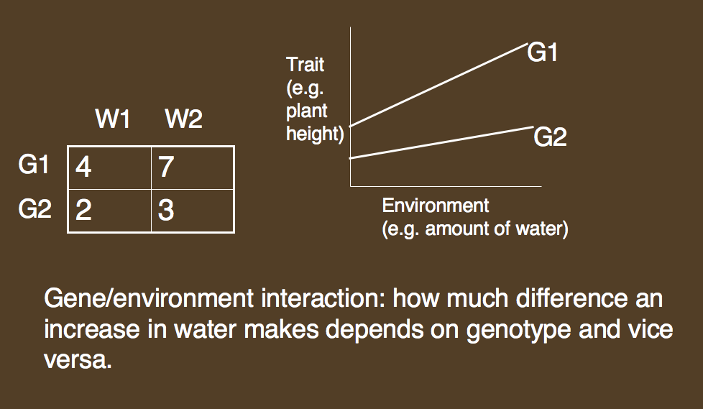

Taylor’s heterogeneity?:

References.

Downes, S. M. (2004) "Heredity and Heritability." Stanford Encyclopedia of Philosophy Volume, DOI:
Kaplan, J. (2000). The Limits and Lies of Human Genetic Research. London, Routledge.
Pigliucci, M. (2001). Phenotypic Plasticity: Beyond Nature and Nurture. Baltimore, Johns Hopkins University Press.
Sarkar, S. (1998). Genetics and Reductionism. Cambridge, Cambridge University Press.
Sesardic, N. (2005). Making Sense of Heritability. Cambridge, Cambridge University Press.
Taylor, P. J. (2006a). "Heritability and heterogeneity: I. The limited relevance of heritability in investigation of genetic and environmental factors." Biological Theory: Integrating Development, Evolution and Cognition 1(2).
Taylor, P. J. (2006b). "Heritability and heterogeneity: II. The irrelevance of heritability in explaining differences between means for different human groups or generations." Biological Theory: Integrating Development, Evolution and Cognition 1(4).
Taylor, P. J. (2006c). "The analysis of variance is an analysis of causes (of a very circumscribed kind)." International Journal of Epidemiology 35: 527-531.

