Peter J. Taylor, Science in a Changing World program, University of Massachusetts Boston

peter.taylor@umb.edu

"His nature, her nurture-or what good are conceptual critiques for tackling practical concerns about the development of gendered individuals?"

<http://bit.ly/ishpssb15> for sources and other follow up

Last September a colleague from gender studies read—or tried to read—the introduction to my new book, “Nature-Nurture? No” ([http://bit.ly/NNN2014](http://bit.ly/NNN2014" \t "_blank)).

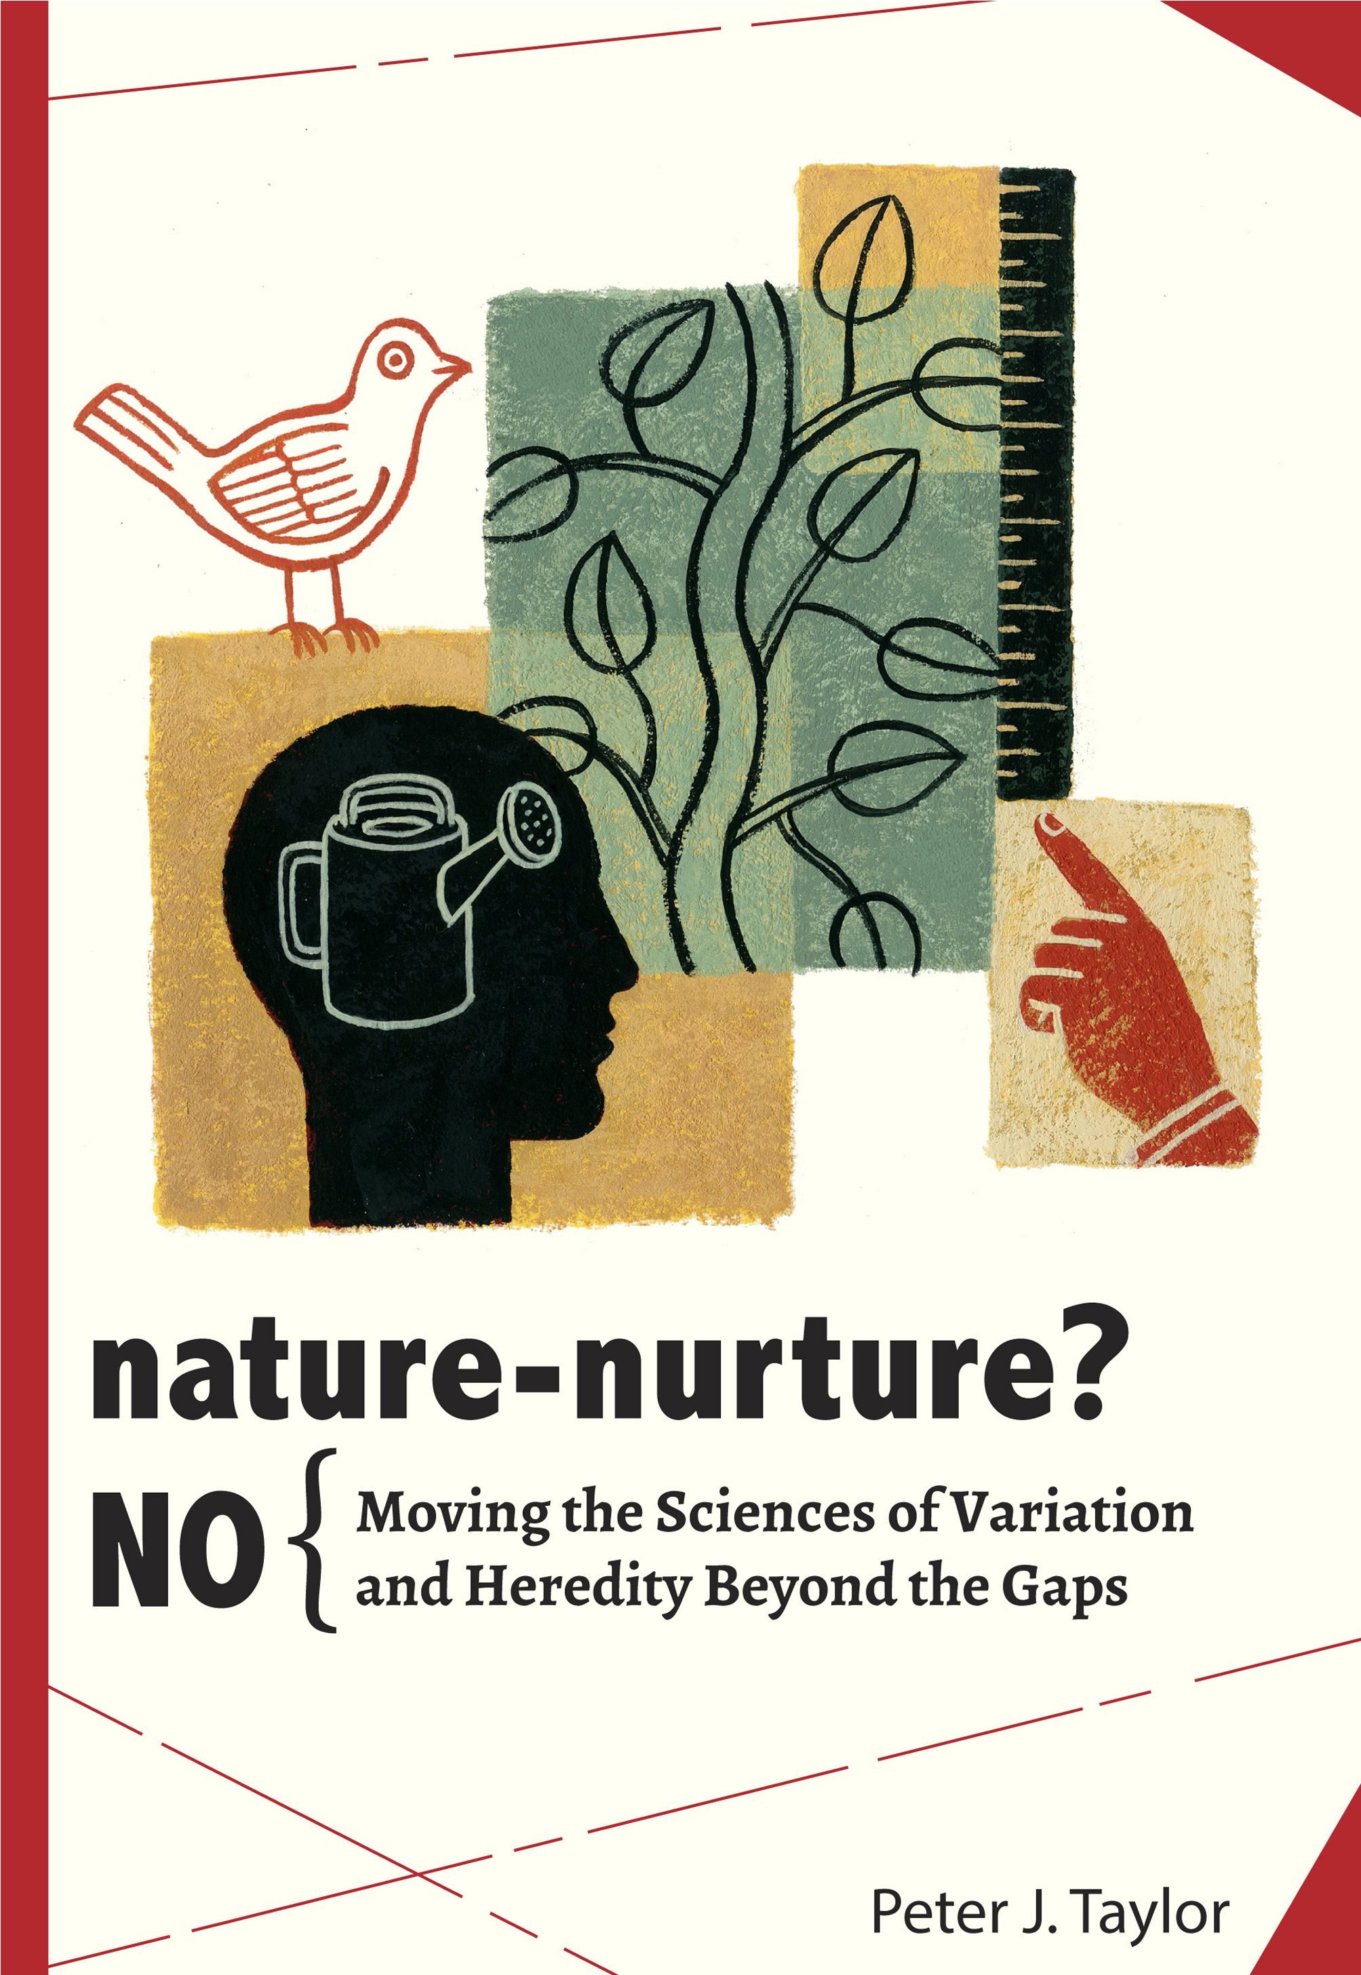

She asked me somewhat testily “What does this have to do with nature-nurture issues that feminists discuss? What can we do with your analysis?” This paper is about my subsequent exploration of her “nature versus nurture” versus the one central to the book. Along the way I have distinguished not just two—“his and her”—but five conceptually distinct nature-nurture sciences, identified the gaps between them, and puzzled over the ways that are conflated or seen to reinforce one another.

In relation to my title question—what good are conceptual critiques for tackling practical concerns about the development of gendered individuals?— the three take home messages are that: conceptual critique (of the forms I shall describe) clears space for focusing on the development of gendered individuals; this counters a persistent essentialism about gender; and these first two messages have implications well beyond issues raised by feminist scholars.

Let me start by gesturing to the wider implications of persistent essentialism by pointing to an irony: Dawkins, the outspoken atheist, shares some deep conceptual assumptions with believers of religion.

|  |  |  |
| --- | --- | --- |
| **Deep conceptual assumption** | **Dawkins, atheist** | **Religious believers** |
| 1. There is an agent within any apparent agent–the living being does not develop without being directed by something else. | Selfish gene | Soul |
| 2. There must be some standard external to organisms in order for them to know what they should do. | Ever-acting natural selection | God |
| 1+2 = The directing agent within is mirrored by the directions that X should follow. | X = organisms as survival machines | X = people believing in the religion |
| 3. It is OK to base your account of the world on unobservables Y if it is hard for you personally to make sense of the world if the unobservable did not exist. | Y = fitness associated with alleles | Y= God’s will |

The point is not to discredit Dawkins. It is to point to the deep historical roots of thinking that there has to be an agent within any apparent agent. The very words we have remind us of that: “agent,” “actor,” “person”—which derives from persona that has its etymological roots in the masks worn in Roman drama. Reciprocally, let us note that there are no ready words for some thing that gains structuredness through dynamic interaction among structurednesses. (This is what cognitive theorist Hendriks-Jansen was grappling with when he explained the emergence of “self” through an infant’s lower-level activities eliciting, typically, responses that assume the infant’s intentionality or selfhood.)

Let me follow up this last remark with a second gesture—to what a focus on the development of gendered individuals looks like. This has been the focus of Anne Fausto-Sterling’s research for several years. She notes gender differences in mundane parent-infant interactions, such as in how mothers handle and touch their infants during the first year. I put this idea into a simulation I made for her:

* Two genital forms; two gender norms.
* Spread of initial positions of infant with respect to the genitally concordant norms. As the children develop, they are subject to attraction to the closest norm as well as, especially after puberty, to the genitally concordant norm. These two attractions may pull in different directions.
* Reinforcement by adults of attraction either to closest norm or to genitally concordant norm.

By varying the proportion of adults who reinforce the attraction to the closest norm the clustering of young adults around two genitally concordant norms can be replaced by a wider spread and, at high proportions, to more clusters.

|  |  |  |
| --- | --- | --- |
|  |  |  |
| **Birth -> 13 y.o. -> 18 y.o.** | |

The young adults raised in a less bifurcated gender landscape are the adults of the next generation, so we can imagine the landscape becoming progressively less bifurcated.

Finally, to set the scene, what are the “practical concerns” referred to in the talk title: “tackling practical concerns about the development of gendered individuals.”

\* How difficult is it to change the typical distributions of a trait, such as aggression, substance abuse, suicide attempts, modes of sexual arousal, as they differ among males and females? Expectations of brilliance across academic disciplines (more in physics and computer science, economics and philosophy), underlie gender distributions in academic disciplines.

\* When change has happened, in what ways has it come about, e.g.,

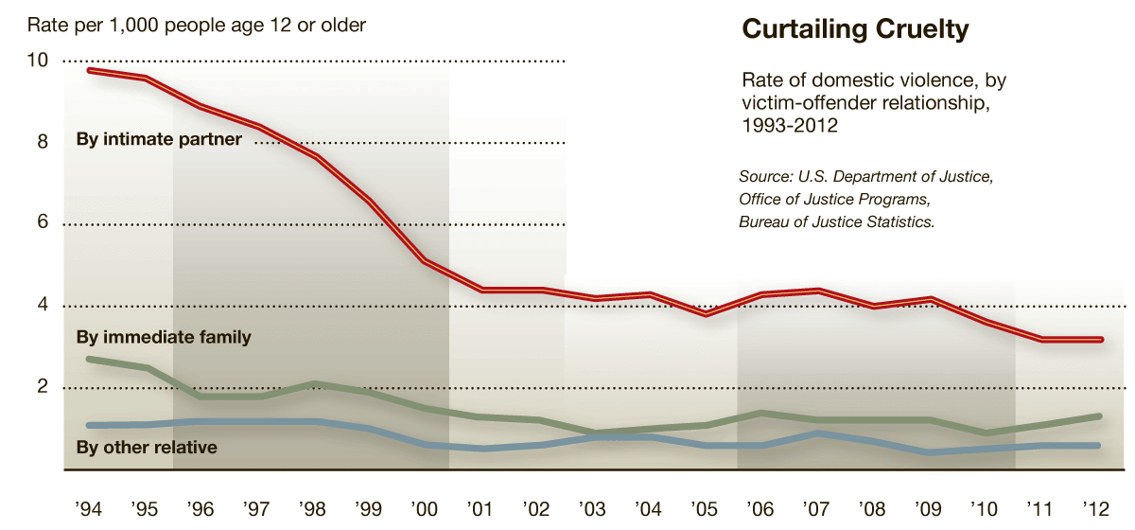

OK, now to *conceptual critiques* so I can support the thesis of the paper, namely, when tackling such practical concerns it helps to have cleared space for focusing on the development of gendered individuals.

My feminist colleague was construing nature versus nurture as a matter of fixity versus flexibility in the development of traits in individuals over their life course. Another construal of nature vs. nurture is the relative degrees of hereditary versus environmental influences on the variation in some observable trait, e.g., the claim that IQ test scores have a heritability of 60-80%.



There are more construals of nature versus nurture than these two:



For this paper, let us leave the evolutionary construal in the background and focus on the other four. To separate them is to say there are gaps—conceptual and methodological—between them. My book, with its subtitle “Moving the sciences of variation and heredity beyond the gaps” focuses on gaps between these three:



Adding in the 4th construal, there are more gaps:



I will delve into the gaps shortly. Yet, to have to do work to separate the construals is to imply that they are often not recognized and to puzzle over the reasons:



E.g., The idea that IQ test scores have a heritability of 60-80% might make it seem plausible that we’ll find the genes involved in differences among people in general. Those genes would surely be good candidates for investigating whether genes are involved in the so-called black-white achievement gap—the persistent difference in average test scores for African-Americans and Euro-Americans in the USA. In turn, a genetic basis for between-racial-group averages, in combination with the basic XX-XY chromosomal difference for most males and females, makes it seem plausible that genes are involved in between-sex differences for some given trait that is related to an issue of practical concern, e.g., modes of sexual arousal or sexual aggression. Finally, to the extent that genes are involved, there is more fixity than flexibility.

Separating the construals and clarifying the gaps is one way to disturb these mutual reinforcements (and thus to clear space for focusing on the development of gendered individuals—or clear away ideas that confound or confuse that endeavor). Let me try to separate the construals quickly by depicting them as variants of the basic idea of partitioning variation:



Now the first construal= Partition variation in some observable trait:



Trait value = Sum of contributions from Variety + Location + Variety-Location combination (over and above the first 2 contributions) + Residual.

Construal 2: Partition variation in some observable trait in relation to some measured genetic and environmental factors:



Trait value = Sum of contributions from coefficient1 \* value of genetic factor + coefficient2 \* value of environmental factor + coefficient3 \* value of genetic factor \* value of environmental factor + Residual.

Construal 3: Factors associated with between-group averages



Construal 4: Fixity versus flexibility in development of a trait:



A combination of construals 3 and 4 might look like:



If these depictions help you see the construals as separate, you may still imagine that results or insights from one can be translated into another. E.g., the standard interpretation of heritability is the “contribution of genetic differences to observed differences among individuals” so a strong genetic contribution makes the trait “a potentially worthwhile candidate for molecular research.” One way to highlight the gap is to point out that heritability is the proportion of variation in the given trait associated with the genotypic means, where “genotype” is a synonym in agriculture for cultivated variety. This gets shortened to genotypic variance and, then, misleadingly, to genetic variance, even though no knowledge of genes is required or produced by the analysis of the trait variation.

Another way to highlight the gap is to point out the possibility of “underlying heterogeneity”:

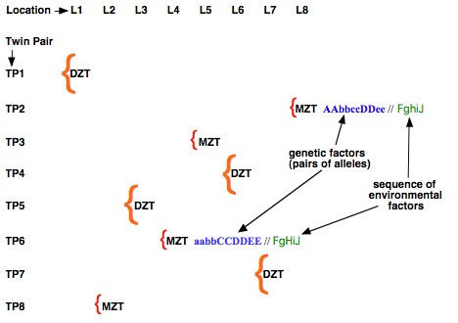

In short, even if the similarity among twins or a set of close relatives is associated with similarity of (yet-to-be-identified) genetic factors, the factors may not be the same from one set of relatives to the next, or from one environment to the next. Given this possibility, a high heritability value for a trait is not a reliable basis for choosing among traits to investigate by molecular techniques. The possibility of “underlying heterogeneity” also helps explain why identification of causally relevant genetic variants by genomic science, most notably by Genome-Wide Association studies, has not produced the results and insights originally hoped for. Heritability estimates are not without justifiable uses, but they are limited to specific situations—but that’s a topic for another talk, or for discussion period.

Also for another time is to spell out the conceptual difficulties in bridging each of the other gaps:



For today’s talk, remember the mutual reinforcement that comes from overlooking or downplaying the gaps.



For example, to the extent that groups are seen as types, it is more difficult to think about underlying heterogeneity. Contrast:



with



What good is conceptual critique? Conceptual critique of the form I am sketching today means exposing the gaps, clarifying the difficulties—or impossibilities—in bridging them, and undermining the conceptual reinforcements.





In doing so, we clear space and clear away confounding ideas so we can focus on the development of gendered individuals—in particular, doing so without the baseline being typologies. To my feminist colleague, I’d say, that’s what my conceptual critique is good for.



But let me qualify or refine that answer by noting that the possible heterogeneity of factors that underlie patterns in observed traits has not yet been recognized as a significant issue, either by quantitative geneticists or by philosophers and other critical commentators on heritability research. It is not mentioned as an issue in the extensive entry on heredity and heritability in the *Stanford Online Encyclopedia of Philosophy* (Downes 2004), in the key sources cited therein (e.g., Sarkar 1998; Kaplan 2000), or in the rebuttal of many critiques of heritability studies by Sesardic (2005). Or in the many, many books of the last two decades that explain why and how we need to get beyond nature vs. nurture:

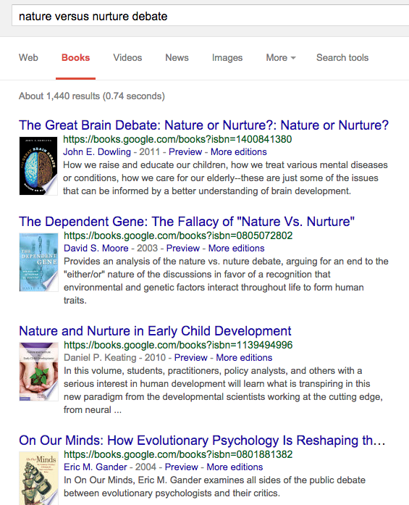

When I note that, despite decades of nature-nurture debates, the possibility of underlying heterogeneity has not been an issue, I see that as a warrant to explore deeper, longer-standing framings through historical and sociological analysis. Thus my observation about the parallels between a Dawkins view of genes and religious views of the soul. Let me parry that into a closing conjecture about the title question of the whole session: It may be that behavioral genetics is so controversial because the opposing intellectual armies uncritically share much in common.

**References**

<http://bit.ly/ishpssb15> for sources and other follow up