

Table of Contents
Table of Contents 1
Letter from Rob Pratt and/or Mitch Adams Error! Bookmark not defined.
EXECUTIVE SUMMARY 2
Defining the Clean Energy Industry 5
Clean Energy for Sustained Economic Growth 6
Growing Demand for Clean Energy 7
The Case for Investing in Clean Energy 8
Existing Strengths Creates Opportunity 9
The Massachusetts Innovation Economy 10
Clean Energy Industry in Massachusetts 10
Clean Energy Cluster Employment 26
Forecasting Cluster Employment 27
Forecast Methodology 27
Forecast Assumptions 29
Scenarios and Results 31
Conclusions 33
Appendix A - Clean Energy Cluster Technology 36
Active Solar Industry 37
Wind Industry 39
Fuel Cell Industry 42
Bioenergy Industry 45
Hydro & Ocean Power Industry 48
Energy Efficiency Industry Overview 51
Enabling Technology Industry Overview 56
High-Performance Buildings & Green Systems Industry Overview 58
Innovation Services Industry Overview 61
Appendix B: Companies Surveyed by the University of Massachusetts 63
Companies Surveyed by the University of Massachusetts 64
Appendix C - UMASS Employment Model 66
UMASS Employment Model 67

EXECUTIVE SUMMARY

Working with the University of Massachusetts, the Massachusetts Technology Collaborative’s Renewable Energy Trust conducted a detailed analysis of the state’s clean energy cluster. This report finds that the Commonwealth has a robust clean energy cluster which accounts for more than 10,000 local jobs.

Massachusetts is among the nation’s leaders in high-tech clean energy manufacturing with companies such as Evergreen Solar in Marlborough and RWE Schott Solar in Billerica producing cutting-edge photovoltaic panels. Spire Corporation in Bedford is one of the world’s largest suppliers of equipment, technology and services for manufacturing solar electric cells. The state’s clean energy industry has a global reach – exporting millions of dollars of products and services to overseas markets.

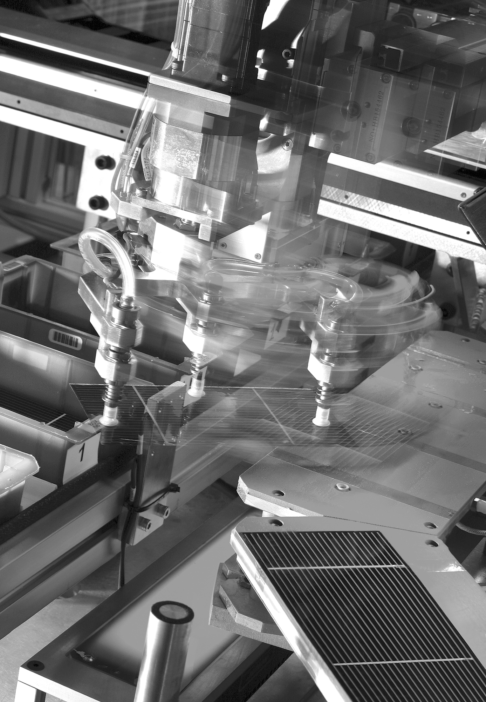
Evergreen Solar, Inc. in Marlborough is a highly successful local company which develops, manufactures and markets solar power products that provide reliable and environmentally clean electric power in places throughout the world. The Renewable Energy Trust made a $2.5 million equity investment to help the company make a major expansion and create new jobs in one of the state’s economic target areas. Evergreen is also conducting research and development at its Marlborough facility, and many of the company’s products are being installed on homes, schools and other buildings across the state.

Today, approximately one third of the total clean energy employment is in manufacturing and new renewable energy installations, while the remainder is attributed to energy efficiency products and programs.

For the purposes of this analysis, the clean energy industry is comprised of firms deriving all or a portion of their business from:

- design, manufacture, construction and operation of technologies which generate electricity and energy using renewable resources
- creation and implementation of energy efficiency equipment and techniques
- design and execution of energy conservation measures
- installation and management of distributed energy resources and programs on both the supply- and demand-side of the market.

Strong and steadily growing demand for clean energy technologies and products make this sector an attractive target for the state to invest resources that will spur job growth and strengthen local companies. Seventeen states in this country have adopted aggressive standards requiring the use of electricity generated by clean, renewable sources. This comes at a time when innovation is leading to more cost-competitive renewable technologies.

The clean energy cluster in Massachusetts is gaining significant momentum. For Massachusetts in 2002, 40 renewable energy firms – with employment of nearly 1,000 people and revenues exceeding $100M – posted annual growth rates of between 40-77%. Wind employment doubled. Employment in the photovoltaic sector – the state’s largest renewable energy employer – tripled, and revenue more than doubled.

Local companies are conducting research and development as well as pilot manufacturing in communities across the state. Potential breakthroughs in solar cell costs, led globally by Massachusetts-based Konarka Technologies, could further accelerate photovoltaic market uptake around the world. From 1997-2002, fuel cell employment increased nearly eight-fold, and revenue increased by a factor of ten.



Konarka Technologies, Inc. is a Massachusetts success story. Entrepreneurs established a company that quickly created new jobs, implemented technology developed at the University of Massachusetts and expanded into redeveloped mill space in Lowell. The Trust awarded Konarka a $1.5 million loan to build a pilot production line in its Lowell facility to develop a state-of-the-art, lightweight technology that converts both sunlight and indoor light into electrical energy. Helping exciting young companies grow out of the state's world-class universities and create new jobs is something the Trust is working to replicate in regions across the Commonwealth.

The analysis conducted by UMass and experts from the Renewable Energy Trust outlines the strengths and weaknesses of each clean energy industry segment by technology. For example, the Massachusetts wind industry is strengthened by ample wind resources and the state’s Renewable Portfolio Standard requiring an escalating commitment to clean energy generation. The wind industry is weakened, however, by a lack of local wind turbine manufacturers and difficulty siting wind installations.

Overall, the high tech economy in Massachusetts is well positioned to support major expansions in clean energy – active solar, wind, fuel cell, bioenergy, energy efficiency, and hydro electric generation technologies – during the next decade. The state has a solid foundation of scientific expertise, a highly-technical workforce, and exceptional institutional and financial services assets. By leveraging and coordinating existing strengths, the state can grow jobs and increase its share of the global clean energy market.

Specifically, Massachusetts has a highly competitive power electronics sector, which includes components and sub-assemblies that support renewable energy technologies. The report forecasts that in this area alone, the state could realize up to 5,500 jobs by 2015.

Another area of potential job growth is in local renewable energy installations. Conservative estimates suggest that 4,000 new jobs could be created during the next decade due to the state’s commitment to renewable energy generation and increasing rate of installation of clean energy technologies. With funding from the Renewable Energy Trust, the number of solar installations alone has soared in the past two years. There are more than 200 systems installed and an additional pipeline that includes hundreds of projects across the state.

The reasons for investing in the state’s clean energy industry are compelling. Massachusetts is poised to experience significant job growth that reaches beyond the narrow niche of renewable technologies while enjoying the environmental benefits that accrue from increased energy efficiency and clean energy generation.

As a leading technology state, the Commonwealth has a tremendous opportunity to develop next generation technologies that will revolutionize the clean energy industry yielding economic and environmental advances for citizens throughout the state.

Defining the Clean Energy Industry
R&D
Manufacturing
Distribution
Includes:
Sourcing of
components, sub-assemblies, & enabling technologies
Sales
Direct & Indirect; Channels includes construction
Value-Added
Resellers;
Includes installation

End
Use
Residential;
Commercial;
Industrial;
Government
Service & Support
Post-sale operations & maintenance; Education, & consulting.
Public & Private Capital & Innovation Services

Supported by both public & private funding
Clean Energy Value Chain

The clean energy industry encompasses technologies, products, and services relating to the generation of electricity from the sun, the wind, and other renewable resources and to the more productive use of all energy sources.

There is no universally accepted, all inclusive, definition of the clean energy industry. For the purpose of this report, however, the industry is comprised of firms deriving all or a portion of their business from:
- design, manufacture, construction and operation of technologies which generate electricity and energy using renewable resources,
- creation and implementation of energy efficiency equipment and techniques
- design and execution of energy conservation measures, and
- installation and management of distributed energy resources and programs, on both the supply- and demand-side of the market.

These five industry segments utilize a distinct, yet shared, value chain. Common components, distribution channels, and support services link these segments together to create the Clean Energy Cluster. Leveraging these overlaps can help to optimize clean energy industry investment for maximum job creation and overall cluster growth.

.

Clean Energy for Sustained Economic Growth

The transition to clean energy—green electricity, energy efficiency, and energy conservation—is gathering momentum. Renewable technologies are competing successfully in a growing number of markets. Countries around the globe are trying to make energy resources go further, and Japan, Germany, and other industrialized nations are taking aggressive steps to diversify their energy supply portfolios. Meanwhile, the “true costs” of fossil fuels and other conventional sources are becoming both more evident and more severe. From clean energy comes a better world.

The growing global economy has an insatiable need for electricity. As demand increases, clean energy—renewable electricity, energy efficiency, energy conservation, and distributed energy resources—has a critical role to play in managing global electricity needs. Driven by the higher and increasingly unstable total costs – environmental, economic and social – of fossil fuels and other conventional sources, more and more countries are turning to clean energy to play an important role in meeting future electricity demand and sustaining economic growth. Several clean energy technologies are now becoming mainstream, and therefore many countries are taking aggressive steps to diversify fuel supply, and increase energy reliability and security.

To meet global demand, the clean energy industry requires capital, research and development capacity, and the technological infrastructure to deliver new energy solutions to market – capabilities that are among Massachusetts’ greatest strengths. Further developing the clean energy cluster presents a considerable opportunity for the Massachusetts economy.

This report focuses on electricity generated using renewable resources and on energy efficiency in buildings and stationary lighting and power delivery systems. Leveraging overlaps in their shared value chain – components, distribution channels, investment capital etc. - can help to optimize clean energy industry investment for maximum job creation and overall cluster growth

The following industry segments make up the Clean Energy Industry:
- Renewable Energy: active solar, wind, fuel cell, bioenergy, and hydro electric generation technologies
- Energy Efficiency: electricity end-use, building, and grid-connected applications
- Enabling Technology: power electronics, storage, cables and wires, sensors and instrumentation, control systems, materials and manufacturing technology
- High-Performance Buildings & Green Systems: sustainable design and integrated clean energy applications for buildings
- Innovation Services: R&D, venture capital, financing, consulting, policy, public education and outreach, and workforce education and training

These five industry segments utilize a distinct, yet shared, value chain. Common components, distribution channels, and support services link these segments together to create the Clean Energy Cluster. Leveraging these overlaps can help to optimize clean energy industry investment for maximum job creation and overall cluster growth.

Growing Demand for Clean Energy
The market for clean energy technologies, products and services is expected to experience substantial and sustained growth. Globally, the market for electricity from renewable resources is projected to increase by 57 percent through 2025. The global market for fuel cells, wind, and solar PV alone is projected to grow from $6.7 billion in 2000 to $77 billion in 2010.
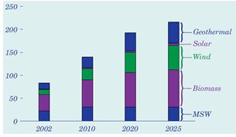 Source: EIA Annual Energy Outlook 2004, DOE/EIA-0383(2004), January 2004

Chart 1 - Non-hydroelectric Renewable Electricity Generation by Energy Source – 2002-2025 (billion kW)

In 2002, total U.S. generation from all renewable sources was around 6% of total U.S. demand. Large hydroelectric facilities accounted for 75% of this total. By 2025, wind, biomass, solar, and other renewable resources in the U.S. are estimated to produce more than three times what they did in 2002 (Chart 1). Output from domestic wind turbines will increase by almost a factor of five, and generation from bioenergy facilities will almost double. Solar photovoltaic (PV) systems connected to the electric power grid are expected to be producing more than eight times as much power as they did in 2002.

The global market for energy efficiency products, currently estimated at $115 billion, is projected to grow to over $150 billion by the end of this decade.

Two factors underscore the positive outlook for clean energy demand. Seventeen U.S. states have established Renewable Portfolio Standards (“RPS”) that require increasing percentages of electricity to be generated from renewable resources. Fifteen U.S. states have also established funds for investment in the renewable energy sector – with expected financial assets of $4 billion combined by 2018. Additionally, 20 states have established funds to promote energy efficiency. Massachusetts is a clear market leader by enacting all three of these policies.
Renewable Portfolio Standards
RPS mandates require electricity suppliers to purchase an increasing amount of renewable electricity or renewable energy certificates on behalf of their customers. If the RPS focuses on new generation, it drives the demand to construct additional renewable facilities.

The second factor is the improved cost-competitiveness of renewables. Chart 2 shows how renewable technology cost decreases over the last seven years are projected to continue through 2020. Wind energy is cost competitive with grid-provided today, while other renewable sources continue to improve their economics.

Chart 2 – Renewable Energy Cost Trajectories
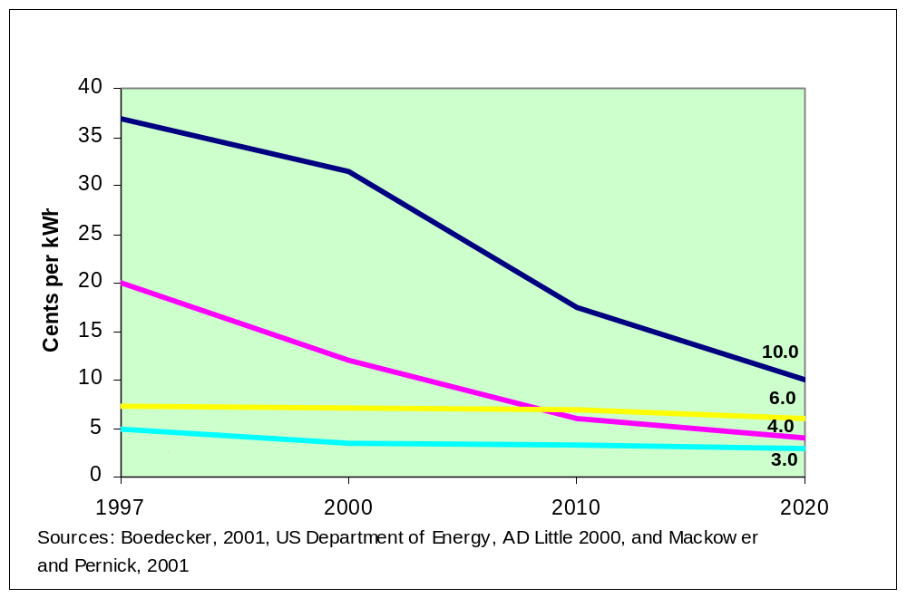

The Case for Investing in Clean Energy

By all accounts, the clean energy sector today represents a significant and rapidly growing business opportunity. Recent global events, including unrest in petroleum producing countries, leading to rising oil and natural gas prices, have combined to create a surge of interest in the clean energy industry from policymakers, private businesses and individuals. Though still largely driven by policy and regulation, clean energy technologies are making huge leaps in performance and reliability, with some – such as wind and biomass – already cost-competitive with traditional fossil-fuel, grid-based electricity. The confluence of policy, technology and environmental conditions, are drawing significant public and private investment.
Annual Installation Capital Cost Growth
 | Market Size  2003($B) | Market Size Forecast  2013 ($B) | Compound Annual Growth Rate
Solar (PV) | $4.7 | $30.8 | 20.68%
Wind | $7.5 | $47.6 | 20.30%
Fuel Cells | $0.7 | $13.6 | 34.54%
Total: | $12.9 | $92.0
Source: Clean Edge: “Clean Energy Trends” March, 2004

- Japan, Germany, and Spain are leading the way in the installation of solar and wind energy. Driven by government policy, subsidies and high electricity tariffs, Japanese companies have become the global leaders in the production of PV modules. Spain’s wind sector is booming, with 62% growth (1995-2003)- the fastest growth rate in Europe, the third largest wind turbine manufacturer, and global leadership in renewable energy facility development.
- In developing countries such as China, India, Brazil, and South Africa, governments are investing heavily to ensure that clean energy is an important part of the solution to their rapidly expanding energy needs. Large commitments to solar energy in rural, off-grid areas have led PV module manufacturers to invest directly in these markets.
- General Electric, BP, Shell, Sharp, Kyocera and other global leaders are acquiring and expanding clean energy offerings. Both BP and Shell have created renewable energy divisions, with manufacturing capacity in solar, biomass and other renewable technologies. GE recently acquired Astropower’s PV business, and has leveraged Enron’s wind assets into the world’s second-largest producer of wind turbines, taking US $2B in orders from 2002 to 2003 with $1.5B revenues projected for 2004.
- Institutional investors are allocating capital to the “clean technology” space, following the lead of CalPERS, the nation’s largest pension fund, which has pledged $700 million to the sector.
- Traditional venture firms such as Kleiner Perkins, Benchmark Capital, Mayfield, Carlyle Group, and 3i Group have each invested in clean energy companies in the past year. Private equity and venture capital have invested $3 billion in the clean technology sector since the beginning of 2002, increasing clean energy’s share of VC investing to an all-time high of 6.4%.

Existing Strengths Creates Opportunity

There are convincing market signals that this growth is sustainable. Massachusetts has an opportunity to increase jobs, capital flow, and global market share in the next decade. There are two primary reasons. First, the global expansion of the clean energy sector is projected to be significant and sustained over several decades. This clean energy transition would help improve energy security, stabilize energy prices through fuel diversity, increase resource productivity, and promote sustainable development. To this end, Massachusetts’ clean energy cluster can benefit by capturing a large share of this growing market.

Second, the Commonwealth’s existing business strengths are aligned with the requirements of this market. The Massachusetts Innovation Economy is strong and is built on a solid foundation of scientific expertise, a highly-technical workforce, and exceptional institutional and financial assets. By leveraging and coordinating existing strengths, the state could promote local economic growth and new job creation, and increase its share of the global clean energy market.

The Massachusetts Innovation Economy

The Massachusetts Innovation Economy is among the most knowledge-intensive in the United States. It thrives because scientific understanding, technical skills, investment capital and entrepreneurial initiative are inherent strengths of the Commonwealth’s workforce.

Historically, the Commonwealth has maintained a competitive advantage in high-technology sectors because its system of innovation is robust. Innovation creates new products, companies, and industries, which lead to new jobs. Key drivers include significant federal R&D investments, leading-edge universities and research institutions, highly skilled and well-educated workers, substantial venture capital investment, and a culture that supports entrepreneurial thinking and interdisciplinary collaboration.

Following the manufacturing “link” as an example, several renewable technologies have commercialized products for off-grid, grid-connected, and on-site consumer applications. There are numerous manufacturers – particularly in the PV market – and have common needs in the areas of enabling technology, installation and support services. The opportunity exists to create future job growth by building capacity in such areas that complement the shared manufacturing, installation, and service needs of multiple renewable energy technologies.

These inherent strengths represent advantages that can be used to cultivate success in the clean energy cluster. The prospects for job and revenue creation in Massachusetts’ Clean Energy Cluster depend on how well the Commonwealth develops competencies in areas that serve multiple markets, technologies, and customer bases.

Clean Energy Industry in Massachusetts

Solar Power in Massachusetts
The Massachusetts photovoltaic (PV) sector accounts for over one-third of U.S. production, and it serves global PV markets. Its leading edge is developed through active industry, government, and academic collaborations. The state’s highly skilled workforce, leading universities, venture capital community, and entrepreneurial environment reinforce a substantial presence in advanced solar technology.

Massachusetts Hosts Significant Technology and Manufacturing Capacity

Evergreen Solar (Marlboro) is a developer and manufacturer of PV modules. The company uses a continuous, highly-efficient string ribbon process to produce low-cost PV devices. Evergreen Solar’s products have proven effective and highly reliable in off-grid, grid connected, and remote applications.

Konarka Technologies (Lowell) is pioneering the development of nanoscale, dye-sensitized PV materials embedded within a plastic substrate. These flexible, formable materials could lead to low-cost devices suitable for incorporation within almost any surface. Konarka products plug directly into electronic devices and provide power in a stand-alone, wireless environment. The company has manufacturing facilities in Lowell and sells products internationally.

RWE Schott Solar (Billerica) is one of the world’s largest designers and manufacturers of complete solar energy systems (silicon devices). The company’s patented edge-defined, film-fed growth process reduces materials requirements and yields high-efficiency cells, and its reflector technology promises additional cost-performance improvements. RWE Schott Solar provides products to large-scale commercial projects, industrial remote power systems, and individual utility-tie systems around the globe.

Spire Corp. (Bedford) is one of the world’s largest suppliers of equipment and technology needed to manufacture solar photovoltaic panels. Spire also offers services including solar cell and module materials supply, management and marketing support and systems design and engineering. More than 90% of the photovoltaic modules on the market today were made using Spire equipment and production lines.

The Massachusetts Solar Industry’s Competitive Position

Strengths
- Manufacturers with leading-edge technology in PV and PV-manufacturing equipment
- Presence in global PV markets
- Disruptive technology in the pipeline
- Qualifies for Massachusetts Renewable Portfolio Standard (RPS)

Weaknesses
- Small home installation market
- Losing market share in global market
- Solar resource not robust in Northeast

Opportunities
- Rapidly expanding global market
- Increasing domestic demand

Threats
- Aggressive growth by global competitors with substantial financial resources, strong brands, and widely established distribution
- Inconsistent support programs relative to other countries (Japan, Germany)

Wind Energy in Massachusetts
The Massachusetts wind sector’s greatest strength – a substantial wind resource base – is largely untapped. The state has some of the best offshore wind potential in the country, which is created by the proximity of consistently high wind speeds, shallow waters, and substantial load centers. Aesthetic, ecological, and other siting concerns are barriers to utility-scale projects within the Commonwealth, while unclear permitting requirements and interconnection standards present obstacles to wind installations at all scales.
Large Scale Wind Exploration
enXco and Berkshire Wind Power are developing two wind projects, 30 MW and 15 MW respectively, in western MA. Both are expected to be on-line in 2005.

MA-based Cape Wind Associates has proposed a 130 turbine installation for construction five miles off the shore of Cape Cod. It would be the first U.S. offshore wind park, with a total of 420 MW.
A single utility-scale wind turbine supplying electricity to the community of Hull is the most tangible evidence of the state’s wind energy development potential. The project has been so successful, the town is exploring the installation of three more turbines. Additional projects in process include the 130-turbine project proposed for Nantucket Sound, the two multi-unit installations proposed for the western part of the state, and the multitude of smaller projects being explored by Massachusetts communities.

No major wind turbine company has based manufacturing capacity in the state. However, manufacturers of enabling technologies thrive in Massachusetts, and provide the state’s strongest presence in the wind energy sector. As wind development on the East Coast increases, the opportunity to host wind turbine manufacturing may follow.

Massachusetts Provides Support for Wind Energy Development

SecondWind (Somerville) manufactures monitoring and control systems for installed turbines, and supplies many of the world’s leading wind project developers and operators. In addition, its wind measurement, data collection, and remote communications systems are being used to evaluate potential wind power sites and to validate wind resources.

UPC Wind Partners (Newton) is a developer and owner of commercial scale wind power plants. In conjunction with UPC Group, the principles of UPC Wind Partners have installed hundreds of MWs of wind turbine generators, and completed some of the world’s largest wind energy project financings. The company is developing multiple projects in New England and across the country.

Offshore Wind Energy Collaborative (OWEC): World-class institutions and companies such as the Massachusetts Institute of Technology, the University of Massachusetts, the Woods Hole Oceanographic Institution, GE Wind Energy, and the U.S. Department of Energy are collaborating with the Massachusetts Technology Collaborative (MTC) to establish OWEC in Massachusetts. The OWEC may evolve into a national laboratory to jointly study and resolve the many issues raised by the deepwater offshore wind opportunity. This would provide Massachusetts with global leadership in the field and a significant opportunity for job growth in the wind industry.

The Massachusetts Wind Industry’s Competitive Position

Strengths
- Ample wind resources
- Eligible for the state Renewable Portfolio Standard (RPS)
- Popular technology for voluntary green programs
- Strong presence in enabling technology

Weaknesses
- No local wind turbine manufacturing base
- Limited number and size of shore-based sites due to State’s population density
- Local zoning laws often require variances due to size of turbines

Opportunities
- Substantial off-shore wind resources
- Developing expertise in deep water off-shore development (OWEC)
- Potential to export deep off-shore capabilities worldwide

Threats
- Unattractive location for development relative to other states
- Aesthetics remain a concern in many (population dense) communities
- Bird, bat, and general ecological impact need continuous assessment

Fuel Cell Energy in Massachusetts
Massachusetts is home to one of the largest fuel cell clusters in the U.S. A 2002 survey by the University of Massachusetts revealed 18 firms directly involved in fuel cell development, with over 400 employees and nearly $50 million in revenues– a 56% increase over the previous year. More broadly, the fledgling Massachusetts Hydrogen Coalition currently has approximately 86 members in 2004 – another strong signal of the likely increase in fuel cell development, and Massachusetts companies’ willingness to invest in this area.
Butane Isn’t Just for Lighters Anymore
Micro-sized fuel cells may eventually power our cell phones and laptops. Lilliputian Systems in Woburn, MA for example, is working toward such a fuel cell for which each charge would just require spare butane – less than the size of a cartridge for a cigarette lighter.

Massachusetts Brings Fuel Cell Technologies to Market

Acumentrics (Westwood) is developing tubular solid oxide fuel cell (SOFC) stacks for stationary power markets and already has prototype units in the field. The company is one of only six teams chosen by the U.S. Department of Energy to receive a $74 million cost share grant. This program has a ten year goal to develop highly efficient and clean small-scale solid-state ceramic fuel cells with a factory cost as low as $400 per kilowatt.

Ballard Material Products (Lowell) produces advanced carbon papers and fabrics which can be used both as conductive, highly-permeable gas diffusion layers for proton exchange membrane (PEM ) fuel cells, and as durable high-friction components in automobile transmissions.

CellTech Power (Westborough) is working on technology similar to SOFC, also for stationary power markets. The Company has successfully demonstrated its first 1KW prototype. CellTech currently employs 27 people and has raised $10.4M in venture capital.

Lilliputian Systems (Woburn) is exploring the development of miniature SOFCs in place of batteries. Such a fuel cell, fabricated using technology developed at MIT, promise an energy density of about 4 times a battery of equivalent size. This product could provide a tremendous boost to the functionality of portable and wireless applications.

Nuvera Fuel Cells (Cambridge) is developing PEM fuel cells, fuel reformers, and integrated systems for stationary power and transportation markets. Its prototypes, which range in scale from 4 to 300 kW, are being demonstrated in automotive, distributed generation, and cogeneration applications.

Protonex Technology (Southborough) focuses on PEMFC technology as well as a variant for portable power and off-grid stationary power markets. The company’s products, which range from 10 W to 1 kW in capacity and were developed for military uses, are being adapted to power mobile electronic equipment in small commercial and small industrial applications.

The Massachusetts Fuel Cell Industry’s Competitive Position

Strengths
- Current local companies on leading edge of technology development
- Strong research institutions, entrepreneurial culture, and venture capital.

Weaknesses
- State RPS does not extend to fuel cells powered by natural gas.
Opportunities
- Work cooperatively with neighboring Connecticut cluster to grow the most vibrant and commercially successful fuel cell cluster in the world.
- Military interest is pushing packaging of fuel cell systems

Threats
- No “winner” technology yet. Performance of first-to-market systems will set expectations.
- Improvements in batteries may overshadow micro-fuel cells

Bioenergy in Massachusetts
The Massachusetts bioenergy sector accounts for approximately 110 jobs at 13 facilities. Currently, facilities running on Municipal Solid Waste (MSW), Landfill Gas (LFG), and wood-based fuels account for about two-thirds of total renewable generation in the Commonwealth. Most of the employment is associated with operating and maintaining these facilities, rather than with developing and manufacturing bioenergy technologies.
Landfill Gas-to Electricity in MA
The Ameresco-Chicopee Project is a 5.7 MW landfill gas-to-electricity project in Chicopee, MA, went on line in early 2004.

In the Commonwealth, two other projects came on-line since 2000: GRS-Fall River (5.2 MW) and Plainville (5 MW).

The SEMASS Resource Recovery Facility (Rochester) is the largest bioenergy plant in the state with a nominal capacity of 84 MW. As a waste incinerator, it provides an alternative to sending waste to landfills, handling 3,000 tons of solid waste per day from more than 20 communities in southeastern Massachusetts.
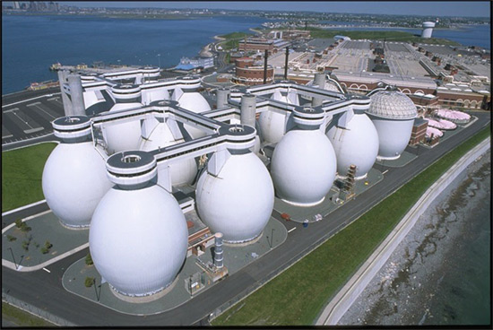
MWRA’s Deer Island Anaerobic Digesters
An anaerobic digester generates electricity for the city of Boston’s waste water treatment plant. The facility generates steam and electricity from a 4MW steam turbine fueled from anaerobic digester gas. Other large cities in the Commonwealth could consider adding digesters to their wastewater treatment plants.

Massachusetts is Home to Bioenergy Entrepreneurs

Agrivida (Cambridge) is developing a variety of environmentally friendly products including fuel bioethanol, textiles, specialty chemicals, and paper materials, all of which are produced from renewable farm crops. The company has developed a variety of corn optimized for ethanol production. This is expected to substantially reduce the costs of ethanol production from corn feedstocks while yielding waste biomass for electricity generation.

Ameresco (Framingham) is not only a developer of Bioenergy power plants, but also a fully integrated energy services company. Ameresco recently completed a landfill gas to energy project in Chicopee, MA and also offers energy conservation, energy procurement and risk management services to commercial, industrial and governmental consumers.

Biomass Combustion Systems (Princeton) designs and constructs wood-fired boiler and furnace systems for heating applications. The Company also provides consulting on project viability and management. BCS consultants have designed and installed more than 300 wood fired systems through out the United States.

GreenFuel Technologies (Cambridge) and Biological Energy (Somerville) are investigating the use of bioreactors containing naturally evolved or genetically engineered microbes for industrial-scale production of hydrogen fuel.

The Massachusetts Bioenergy Industry’s Competitive Position

Strengths
- Good availability of bioenergy fuel supply, particularly in western Massachusetts
- Eligible for MA RPS, with appropriate technology and emissions controls, excluding MSW

Weaknesses
- No in-state manufacturing.
- Multiple technologies cause fragmentation; difficult to concentrate effort and investment.
Opportunities
- Better land-use through increased landfill life and improved land quality
- Removing clean wood waste from MSW waste streams for higher value uses

Threats
- Total fuel cost is high, mainly due to transportation costs
- As a combustion-based technology, public perception tends to be negative.

Hydro & Ocean Power in Massachusetts
Hydro projects are under way at historic mill facilities in Massachusetts. In Amesbury, tidal currents of the Merrimack River spin the two-way turbines of Verdant Power (Arlington, VA) anchored in the river’s north channel under the Chain Bridge. Currently sized as a demonstration – enough to power 20 homes – the project could grow to 500 kW, enough to power 500 homes.
Hydro power provides about one-third of the green power in the state, through more than 80 facilities. These units range from large dams and pumped-storage facilities in western Massachusetts to small-scale facilities located throughout the state.

Economic growth opportunities for the state’s hydro and ocean technology sector will come from repowering underperforming or dormant hydro facilities, and from installations of emerging generating technologies.

Commonwealth has History and Experience with Hydropower

Enel North America (Andover) is a leading owner and operator of renewable energy plants, with facilities in 16 States. Enel, the world’s largest publicly traded utility, entered the U.S. through its acquisition of CHI Energy, Inc. in December 2000, and recently established its consolidated headquarters in Andover. Through CHI, Enel gained expertise in the development, ownership, and operation of environmentally friendly small hydroelectric projects. Enel North America is also active in wind and biomass power generation.

Daniel O’Connell’s Sons (Holyoke) are construction managers and general contractors. The company is expert in infrastructure construction, including hydroelectric dams. In the Deerfield River Dam project, DOC served as general contractor during the removal of an existing structure and installation of a new concrete dam with adjustable crest gates.

Swift River Company (Hamilton) serves as project developer and financier for hydroelectric generating plants throughout New England. Since 1983, Swift River Co. has owned certain hydro facilities, and sold others to entities including CHI. Today, the company derives a significant amount of business from the rehabilitation, expansion, and maintenance of existing sites.

The Massachusetts Hydroelectric Industry’s Competitive Position

Strengths
- Existing sites with potential for re-powering without significant environmental impact
- Significant coastal resource to support emerging tidal and wave technologies

Weaknesses
- No instate manufacturing of new technology
- Not eligible for Massachusetts RPS
- Less popular with public than other renewable generation
- Many facilities will require costly and time-consuming re-licensing to continue operation
Opportunities
- Re-power existing facilities
- To position state as home for new technology development

Threats
- Environmental impact mitigation can make re-licensing and permitting a challenge

Energy Efficiency in Massachusetts
The energy efficiency sector accounts for the majority of current employment in Massachusetts’ Clean Energy Industry. The sector is fueled largely by the energy efficiency programs funded by electricity ratepayers. In 2001, direct program expenditures totaled $135 million, and program participants spent $48 million. These funds were used to procure efficiency products and services. Money saved by program participants and other consumers generate the potential for additional economic activity in the state. All Massachusetts Technology Collaborative Green Buildings and Infrastructure demonstration projects require awardees to maximize participation under the State’s separately funded energy efficiency programs.

Energy Efficiency in Massachusetts is Robust and Growing

A few examples in each of three parts of the energy efficiency sector provide evidence of the innovative contributions being made by Massachusetts companies:

Energy Efficiency Hardware & Manufacturing:
Aircuity (Newton) manufactures performance monitoring and optimization tools for heating, ventilation, and air conditioning (HVAC) systems. Its products integrate sensing, data management, analysis, and reporting capabilities to provide building and facility system operators with real-time information for maximizing the energy efficiency of HVAC systems while improving comfort and indoor air quality.

Efficiency & Conservation Services:
Alliant Energy Integrated Services Company (Lowell) is involved in selling and delivering high value energy and environmental services to commercial, industrial and institutional customers. Such services include energy infrastructure project development and construction management; energy planning, procurement and risk management services; and environmental engineering and site remediation services.

Conservation Services Group (Westborough) CSG and CSG Services provide building performance services (lighting, ventilation, water conservation, etc), energy efficiency and demand reduction services, and appliance recycling for residential, commercial and industrial consumers. The company also has extensive experience with renewable energy power plant development, policy consulting, renewable energy system engineering, and project management.

Select Energy Services (Natick) maintains the expertise to offer a broad range of energy services, including energy plant design and construction, building systems maintenance and service, and distributed generation resource management. Select Energy Services designed and built the country's largest fuel cell installation, and is one of only two national firms chosen by the U.S. Department of Energy to develop photovoltaic systems at federal facilities.

Demand Response Services:
EnerNOC, Inc. (Boston) aggregates energy users and enables them to efficiently respond to periods of peak demand or supply shortfalls and be paid – through existing ISO programs – for reducing their electricity demand. A combination of software and on-site hardware allow EnerNOC to manage customer generators and load from a remote location. The company has helped ISO-NE successfully shed and reduce load during peak periods by dispatching customers’ back-up generators and by powering down non-essential load.

Lanthorn Technologies, Inc. (Boston) helps utilities achieve additional value from their automated meter reading deployments through enhanced AMR functionality, integrated load response and expanded customer service offerings. They provide demand response event manager and analysis tools, along with load control, automation tools and notifications and alerts.

Enabling Technology in Massachusetts
The Massachusetts enabling technology sector is strong, and some companies are already players in global markets.

The current status and future potential of the sector are tied directly to the Massachusetts Innovation Economy and its longstanding leadership in semiconductor science and technology, computer hardware and software, instrumentation and controls, systems integration, communications, and R&D. As the cluster continues to mature, these firms are likely to increase their emphasis and resource commitment to clean energy applications.

Enabling Technology in Massachusetts has Broad Reach

American Superconductor (Westborough) is a world leader in developing and manufacturing products using superconductor wires and power electronic converters for the electric power infrastructure. American Superconductor's products can dramatically increase the bandwidth and reliability of power delivery grids, reduce manufacturing and operating costs, and conserve resources used to produce electric power. The company manufactures superconducting products in Massachusetts, including energy storage systems, generators, and power electronics devices.

Beacon Power (Wilmington) designs and manufactures power conversion and sustainable energy storage systems for the distributed generation, renewable energy, and backup power markets. Products include inverters for off-grid and grid-connected solar PV systems integrated with battery storage units, and flywheel storage systems for UPS and power quality applications.

ElectraStor (Pittsfield) is developing nickel-hydrogen battery technology for both transportation and stationary power applications. ElectraStor’s goal is to become the preferred energy storage technology in the fast growing hybrid-electric vehicle markets including buses, trucks and automobiles.

Solectria (Woburn) manufactures integrated power electronics solutions, as well as individual components and subsystems for off-grid and grid-connected solar, wind, fuel cell, and energy storage systems. In addition, the company offers battery banks and ultracapacitors. Solectria’s products are currently used in battery-electric, hybrid electric, and fuel cell cars and buses.

High-Performance Buildings & Green Systems in Massachusetts
Massachusetts is recognized as a national leader in the high-performance buildings and green systems sector. The state hosts the first federal building to achieve a “gold” rating under the LEED (Leadership in Energy and Environmental Design) Green Building Rating System, as well as award-winning corporate and institutional buildings. Through the Massachusetts Technology Collaborative Green Buildings initiative, dozens of facilities are being constructed or renovated, including multi- and single-family housing, commercial, municipal, corporate, and educational buildings. Genzyme Corporation recently completed a new 12-story corporate headquarters, and has applied for LEED’s most prestigious “platinum” rating for its incorporation of renewable energy, efficiency products, and sustainable materials. Specific features include 2,800 square feet of roof-mounted photovoltaic cells, a double façade of exterior glass for thermal benefits, and a 12-story atrium to help deliver ambient light to workstations. The Genzyme Headquarters was recognized in 2004 by the American Institute of Architects’ Committee on the Environment as one of the ten best examples of green design and construction. Another of the ten best was the Woods Hole Research Center’s Ordway Building – another Massachusetts Technology Collaborative Green Buildings Award recipient.
The LEED framework is anchored in five core areas:

- Sustainable Site Development
- Water Savings
- Energy & Efficiency
- Materials Selection
- Indoor Environmental Quality
The extraordinary design and features of these buildings rank it far above typical building projects in complexity. Nonetheless, it is important evidence of what can ultimately be accomplished. It is critical to emphasize, however, that great gains can be made today by incorporating far more simplistic and cost effective design measures and equipment retrofits.

Through the state’s green schools initiative, sustainable design and clean energy technologies are being applied in both new construction and renovation projects. At the Michael E. Capuano Early Childhood Center in Somerville, a highly skilled design and construction team demonstrated the depth of experience and the future development potential of the Commonwealth’s green buildings workforce. The Capuano School received Honorable Mention from the Sustainable Building Industry Council, under its Exemplary Sustainable Building Awards program. The Capuano School is of 16 pilot program participants under the Renewable Energy Trust’s Green Schools Initiative.

Creating a Healthy Learning Environment in Somerville

The Michael E. Capuano Early Childhood Center in Somerville is the direct result of the city’s effort to conserve public funds, protect the environment, and provide a unique educational experience for its students. As the first LEED-registered public school in New England, the school combines high performance design, energy efficiency and renewable energy to reduce energy costs, lower carbon dioxide emissions, and provide tools for educating children about renewable energy. Earlier this year, the Center won first prize in the “Places of Learning” category in the annual Northeast Green Building Awards competition.

When planning for the school began, Somerville’s high energy cost was a major concern for the Department of Public Works. The Department sought to incorporate durable, low-maintenance building materials and energy efficient systems into the Capuano School.

The school’s design team followed through by designing the building to reduce costs, save energy, and create a healthy environment for students. Particular emphasis was placed on indoor air quality and acoustics to maximize the health and productivity of students and teachers.

The school features roof-top solar panels – supplying 35 kilowatts of generating capacity – and a 400 Watt wind turbine, for educational purposes. Between this system and the energy-saving features in the building, the school will use 41% less energy than a standard school. This translates to $60,000 in annual savings for the city. The building also uses 26% less indoor water and 56% less outdoor water than a typical school. During construction, over 600 tons of construction waste was recycled.

Capuano School Team Demonstrates Massachusetts’ Expertise

HMFH Architects, Inc. (Cambridge) recognized one of Somerville’s highest priorities was to save operating and maintenance costs. By using energy modeling as a decision-making tool, maximizing natural light to save electricity costs, and encouraging Somerville to take advantage of MTC grants for renewable energy technologies and energy efficiency measures, HMFH was able to lead Somerville to a design that will save 41% more energy than a conventional school, translating to $60,000/year in savings.

Lam Partners (Cambridge) was hired by HMFH to develop a high quality design to maximize the use of daylight. Studies show that high quality natural lighting can lead to improved student learning rates. The Lam Partners design includes skylights, light-dimming fixtures, and clerestory windows with light shelves – allowing light to bounce deeper into classroom spaces.

Solar Design Associates (Harvard) was retained to coordinate design and installation of a 35 kW roof-mounted solar array and a 400 watt demonstration-size wind turbine. Data from the solar panels and the wind turbine are being collected and will be available online for educational purposes.

T.R. White Company, Inc. (Boston) – project general contractor – recognized the competitive advantage of successfully constructing the first LEED-registered public school in New England, and followed through. Building a LEED certifiable school is challenging, especially given the restrictive nature of the Massachusetts public bidding laws.

Innovation Services in Massachusetts
The Massachusetts innovation services sector is a significant contributor to the present status of the state’s clean energy cluster. Two areas are particularly important: R&D and policy and market development.

Federal R&D funding, along with the venture capital and other investments it induces, is as critical to the state’s clean energy sector as it is to the overall Massachusetts Innovation Economy. At present, local universities, colleges, and other R&D organizations alone account for between 10 and 20% of total employment in the clean energy cluster, and the Commonwealth ranks among the Top 10 states in terms of research excellence and talent generation relating to renewable energy technology.

R&D organizations located in the state are actively engaged in basic energy sciences research, next-generation product development, prototyping and field-testing activities, and application-oriented efforts to solve complex technical and manufacturing challenges that constrain the cost-competitiveness of existing technologies. They include major university-based research and industry support centers, as well as contract R&D firms funded by the U.S. Department of Energy, U.S. Department of Defense, National Aeronautics and Space Administration, and other federal agencies. Several prominent university-industry R&D centers are highlighted briefly below.
Local universities, colleges, and other R&D organizations alone account for between 10% and 20% of total employment in the [Mass.] clean energy industry.
Source: Battelle/MassInsight, “Choosing to Lead:”

At the University of Massachusetts in Boston, the Environmental Business and Technology Center (EBTC) assists envirotechnology firms in commercializing, financing and exporting their products and technology. EBTC also works with state and federal agencies and engages University faculty for industry-specific projects.

At the University of Massachusetts in Amherst, the Renewable Energy Research Laboratory focuses on wind power, conducting R&D in resource assessment, project siting and performance, and turbine dynamics and control. The Building Energy Efficiency Program conducts modeling studies to optimize the thermal performance of windows and other building envelope components.

At the University of Massachusetts in Lowell, the Center for Sustainable Energy emphasizes solar power, particularly for rural electrification in developing countries.

At Worcester Polytechnic Institute, the Fuel Cell Laboratory is conducting R&D on advanced materials and designs for PEMFCs and direct methanol fuel cells. The Center for Inorganic Membrane Studies is exploring the use of palladium-based membranes methods for hydrogen production.

Clean Energy Cluster Employment
Through research conducted by the University of Massachusetts and funded by the Massachusetts Technology Collaborative, this report identifies over 10,000 FTE jobs in the Massachusetts clean energy cluster. Today, approximately one third of employment is in manufacturing and new renewable energy installations; the remainder is attributed to energy efficiency. The report forecasts several FTE job growth options, discussing the potential impact of manufacturing – for both local use and global export – and new renewable energy installations on local employment. Taken along side Massachusetts’ expertise in innovation and precision manufacturing, this report suggests a valuable opportunity for clean energy in Massachusetts.

Depending on Massachusetts’ global market penetration and on local appetite for renewable energy installations, the Clean Energy Cluster could more than triple current FTE jobs by 2015. If local manufacturers match the projected ten-year global clean energy growth rate of 21%, and if approximately one third of all new capacity required to achieve the RPS target is installed in Massachusetts, total cluster FTE jobs could reach 36,750 by 2015. If global market penetration continues to erode, and if new local installations are scant, this analysis forecasts 17,400 FTE jobs by 2015. Chart 3 shows the projecting of Clean Energy Cluster employment under those three scenarios - “Cluster Contraction”, “Maintain Status Quo” and “Attain Global Rate”.

Chart 3 – Cumulative Clean Energy Cluster Employment
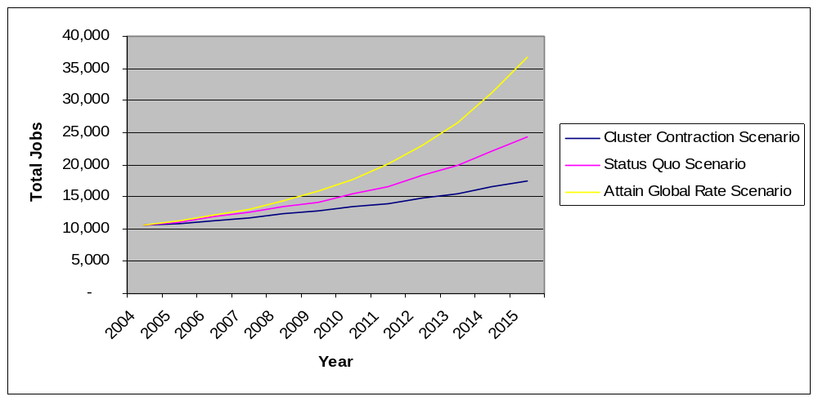

Forecasting Cluster Employment
This section details the methodology, assumptions and results of forecasts of cluster FTE jobs under three scenarios. The purpose of this forecast is to better understand the clean energy economic and employment opportunity for Massachusetts.

Clean Energy Cluster Jobs - Baseline Estimate Methodology
Two methodologies were used to establish, and verify, the estimated 10,000 FTE jobs in the Clean Energy cluster today and create a baseline. One method is a “top down” approach; it associates spending on renewable generation technology and energy efficiency with job creation, and megawatts of manufacturing, installation, and maintenance of clean energy equipment with new full time equivalent jobs required to build and maintain this capacity. The second method is a “bottom up” approach; it uses proprietary data series to classify firms in detail, and then aggregates this data at the statewide level.

Top Down Estimation Approach
Estimates for the Top Down approach are based on two primary sources – reports from the Renewable Energy Policy Project (REPP) and the Electric Power Research Institute (EPRI). The REPP Report surveys businesses throughout the supply chain to determine person-hours required in the direct manufacture, construction, operation, and maintenance of solar photovoltaic and commercial scale wind projects. Basic inputs (e.g. steel) and multiplier effects are not included because such jobs are not a direct result of discrete renewable energy installations. Operations and maintenance (O&M) are included for 10 years. Variability in job duration is accounted for by converting all labor into person-years per megawatt installed and summing over 10 years of O&M. This method can be applied when installation, operation and maintenance jobs are created in Massachusetts even if manufacturing jobs are not. The REPP Report supports our PV, PV equipment manufacturing, and wind employment assumptions.

Employment related to the manufacture of power electronics is calculated separately, by multiplying:
(a) an estimate of the total US market for each type of renewable energy, by
(b) the proportion of power electronics in the total installed cost of each technology, and (c) Massachusetts’ estimated share of national manufacturing of these components. (This estimate is generated by examining Massachusetts’ share of national manufacturing for some representative NAIC codes)

To estimate energy efficiency employment, UMASS relied on a Massachusetts Division of Energy Resources regional economic (REMI) model, rather than a direct counting. The model estimates FTE jobs per million dollars of program expenditures. In addition to the regulated energy efficiency program, UMASS estimates additional energy efficiency employment spurred by non-program spending.

In a report for the California Energy Commission, the Electric Power Research Institute calculated jobs and wages in renewable energy. EPRI assumes 20% of construction and 50% of maintenance costs flow to local labor, including component manufacturing. Jobs attributable to other maintenance and transportation (e.g. drivers for biomass fuel and geothermal chemicals) are added to these direct labor figures to get operation-maintenance-transportation (O-M-T) employees per MW. The EPRI Report supports our landfill gas, biogas, biomass, and small hydroelectric employment assumptions.

Since there is no comparable report for fuel cell employment, UMASS looked to a California study which assumed fuel cells have a substantially similar job creation profile to PV. UMASS followed this assumption, and applies the PV job numbers derived in the REPP report. In addition, to reflect the important contribution of funded research, UMASS assumes 10 fuel cell jobs per $M of funding, calculated by dividing total fuel cell employment in Massachusetts by the total dollar value of all research and development contracts.

In aggregate, the Top Down approach yields the following results for employment in the manufacture, installation and maintenance of renewable energy generating capacity:

Renewable Energy Jobs
per MW or $M (person-years)
Technology | Install | O & M | Mfg | (units)
Solar Photovoltaic | 17.53 | 0.26 | 12.02 | /MW
PV Equipment Mfg |  |  | 6.00 | /$M
Wind | 1.33 | 0.10 | 1.42 | /MW
Fuel Cell | 17.53 | 0.26 | 15.46 | /MW
Fuel Cell Research |  |  | 10.00 | /$M
Biomass | 4.29 | 1.53 |  | /MW
Landfill Gas & Biogas | 3.71 | 2.28 |  | /MW
Small Hydroelectric | 5.71 | 1.14 |  | /MW
Power Electronics |  |  | 6.45 | /$M
Energy Efficiency (state program expenditures) |  |  | 12.36 | /$M
Energy Efficiency (non-state expenditures) |  |  | 10.05 | /$M

Bottom Up Estimation Approach
The Bottom Up approach uses proprietary data sets (IMarket and Corptech) and NAIC codes to measure both employment and the number of companies at the core of the clean energy cluster. UMASS selected 25 NAIC codes, out of a possible 700, based on the relevance to clean energy and whether or not Massachusetts firms were present in the category. Based on IMarket data, there were almost 300 firms in these 25 most relevant sectors in 2003. Based on a previous study UMASS’ determined there are an additional 42 firms employing over 1100 people not covered by these NAIC codes. UMASS used the Corptech data set to capture this additional activity.

The final twenty-five NAIC codes are listed below:
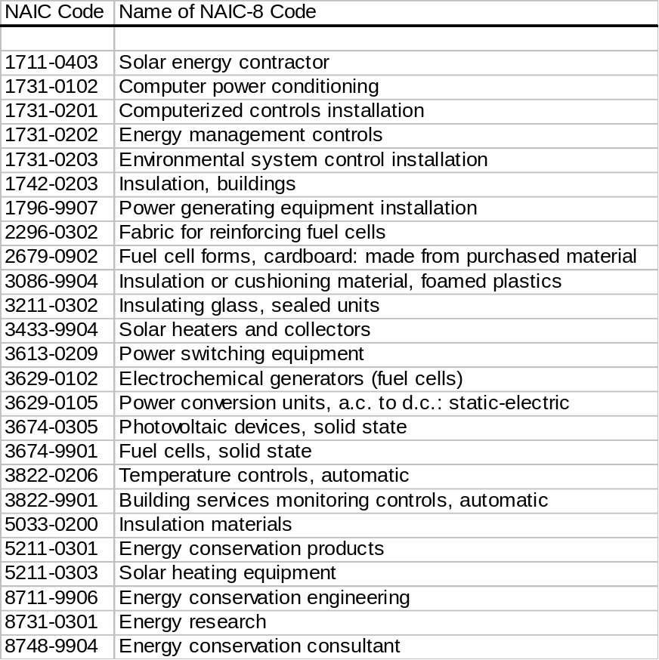

Finally, UMASS conducted a written survey of 140 Massachusetts firms identified during the IMarket NAIC code analysis. The survey asked for lists of major products, with emphasis on clean energy. The survey then focused on the proportion of firm business devoted to the clean energy segment. Firms were polled regarding new product potential in the clean energy sector, and were asked to provide a list of major competitors, customers, and suppliers. Finally, they were asked about current and projected employment and revenues. In response, 26 firms completed the survey and 12 firms indicated no involvement in clean energy. The survey was supplemented by telephone interviews of firms in the energy efficiency and power electronics sectors.

After completing both Top Down and Bottom Up analysis, UMASS established that both methodologies converged on approximately 10,000 FTE jobs.

Forecast Background and Assumptions
Building on the UMass study, this report develops high-level forecasts for multiple clean energy activities and projects a range of employment outcome for Massachusetts
under three scenarios – “Cluster Contraction”, “Maintain Status Quo” and “Attain Global Rate”. This analysis demonstrates the employment implications of investing, or not investing, in certain clean energy activities. The model separates the clean energy market into two parts: (1) manufacturing – defined as the fabrication and/or assembly of components used in building and interconnecting clean electricity generators; and (2) installation, operation and maintenance – defined as the physical construction and management of new clean electricity generation in Massachusetts;

Manufacturing jobs are typically with technology and product companies that serve the global clean energy market. These companies share the opportunity of global growth and exposure to the threat of global competition. Installation, operation and maintenance FTE jobs are created only when new renewable energy generators are installed within, or closely proximate to, the Commonwealth of Massachusetts. Opportunities for employment growth in this area is driven – or limited – primarily by local market forces and by government regulation.

Forecasts of manufacturing-related employment rely on an assumption of the global growth rate for selected renewable energy technologies over the next ten years. This information was obtained from Clean Edge’s Clean Energy Trends 2004 report; the weighted average ten-year projected growth rate is 21%. Subsequently, the employment forecast assumes Massachusetts manufacturers grow at only 7% or one third of that rate in the “Cluster Contraction”, or 14% (two thirds of this rate) in the Status Quo scenario. In the Attain Global Growth scenario, manufacturing growth matches this rate. The resulting grow rates are applied to current in-state production volume not only for manufacturing of primary renewable energy components, but also for power electronics and other enabling technologies.

Forecasts of installation, operation and maintenance employment are based on four common assumptions and one variable assumption:
- The future distribution of new installed capacity, by renewable generating technology, is assumed to approximate the following:
  - Solar: 0.6%
  - Wind: 66%
  - Fuel Cell: 0.4%
  - Biomass 20%
  - Landfill Gas/Biogas: 6%
  - Small Hydroelectric 7%
The above assumptions are based on current installed capacity, new permit applications, renewable “fuel” resources available in New England and interviews with industry experts.

- Thirty (30%) of new installed capacity is assumed to be installed in Massachusetts; the balance is spread throughout New England, and any installation, O&M employment will inure to the benefit of the host state.

- The state’s Renewable Portfolio Standard targets will remain unchanged through 2015 – namely, that the requirement will increase by 0.5% per annum through 2009 and by 1.0% per year thereafter.

- A varying assumption about whether or not enough new capacity is installed to meet the RPS requirement through the end of the forecast period.

Finally, due to its maturity, energy efficiency’s contribution to future cluster employment is characterized by consistent but measured growth – 2% per year – in all scenarios. While energy efficiency is expected to continue to play a fundamental role in clean energy employment, it is assumed this part of the market is least likely to experience dramatic shifts and growth based on policy and investment during the forecast period.

Forecast Scenarios and Results
Employment is projected for three scenarios of Clean Energy Cluster development. Each starts with a baseline of 10,000 FTE jobs today, and projects cluster employment through 2015 using a shared forecasting model. Each scenario – “status quo,” “contraction,” and “attain global growth” – presents a unique employment projection based on specific assumptions, the categories of which are explained above.

Status Quo Scenario
In the Status Quo Scenario, our base case, local manufacturing grows more slowly than its global competition, and enough new capacity is installed to meet the RPS target.

It is assumed that, consistent with today’s documented trend, Massachusetts’ clean energy manufacturing experiences a modest, but consistent, erosion of global market share – relative to competitors such as Germany and Japan. In this case, it is assumed Massachusetts manufacturing output grows at only two thirds of the global rate. Second, it is assumed that 100% of new renewable generating capacity necessary to meet the RPS is installed. Under these conditions the potential exists to create approximately 13,750 new FTE jobs for the sector over the next 10 years, resulting in a total 24,250 clean energy FTE jobs by 2015.

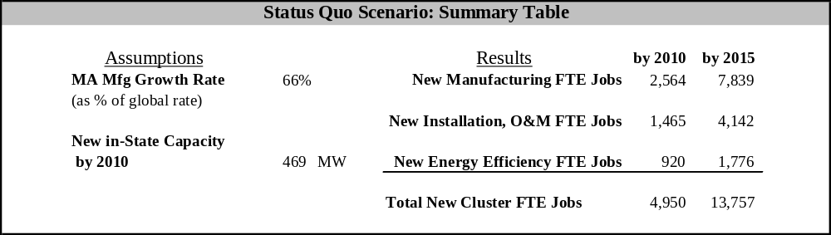

Notwithstanding the installation of enough new renewable capacity to meet the RPS, a positive impact on Massachusetts employment is sensitive to where this capacity is located. Installing 10% of new generators in Massachusetts could create 1,381 FTE jobs by 2015, while installing 60% could yield six times as many FTE jobs (8,285) in the same period.

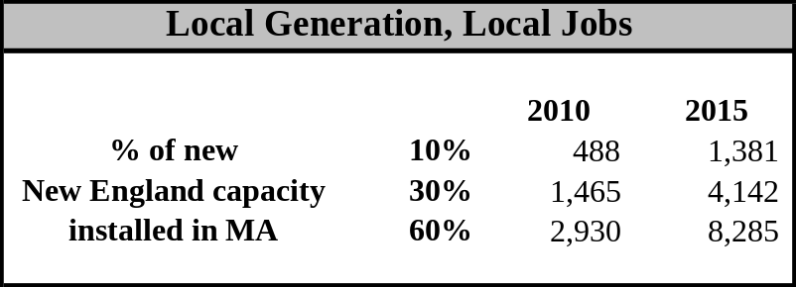

Cluster Contraction Scenario
In the Contraction Scenario, local manufacturing loses dramatic market share to its global competition, and only two thirds of the new capacity necessary to meet the RPS is installed.

It is assumed that Massachusetts does not address its global competitive position, and its clean energy manufacturing grows at only one third of the global rate for the forecast period. This represents the loss of one of today’s significant local clean energy manufacturing companies. It is further assumed that only two thirds of new renewable installations necessary to meet RPS-driven demand through 2015 are installed. Under these conditions the potential exists for 7,000 new FTE jobs, and a total of 17,400 clean energy FTE jobs by 2015.

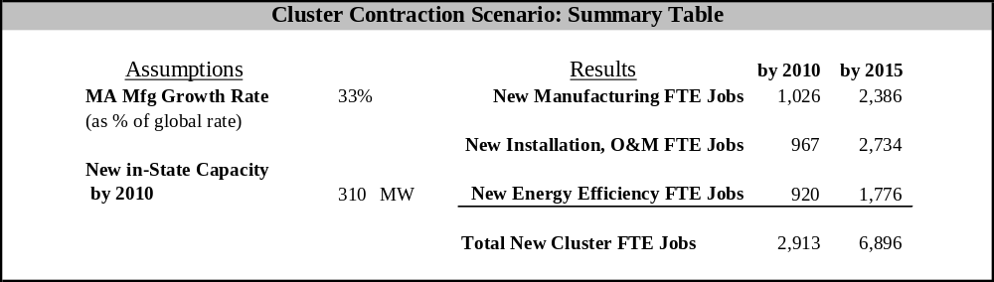

Attain Global Growth Rate Scenario
In the Attain Global Growth Rate Scenario, local manufacturing achieves the same rate of growth as the global market, and local installations are sufficient to meet the RPS.

The forecast assumes consistent policy and investment enable Massachusetts’ clean energy manufacturing to reverse the current trend and grow at the same rate – a weighted average 21% - as the global clean energy market through 2015. In this case it is also assumed that new installed capacity meets RPS-driven demand. With investment that generates this level of performance, the potential exists to create over 26,000 new FTE jobs for the sector over the next 10 years, resulting in a total of up to 36,750 clean energy FTE jobs by 2015.

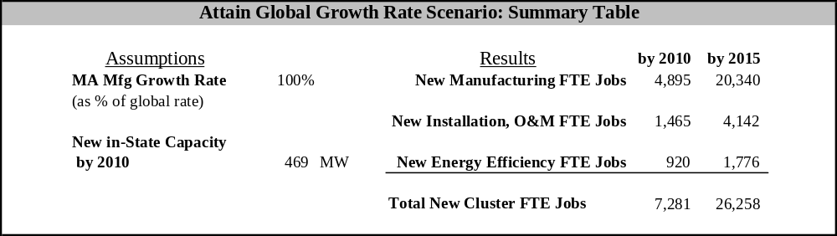

Within this scenario, any event or support that impacts the annual growth rate of power electronics may have a significant impact on new FTE jobs. For example, if power electronics growth during the 2004 to 2015 period slows from our scenario assumption of 21% to 10%, the opportunity cost could be nearly 1,000 new FTE jobs in the next five years alone. If power electronics became a near-term priority and the growth rate was influenced to 35% per year, the result would be nearly 2,000 new FTE jobs above our current scenario result. The chart below forecasts new power electronics FTE jobs from 2004 through 2010 and 2015 based on changes in sector growth rate.

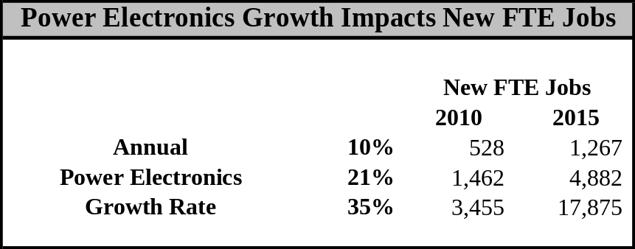

Conclusions
The Clean Energy Cluster is a significant employer in Massachusetts today, responsible for approximately 10,000 FTE jobs. If consistently supported, this cluster holds the potential to provide more total jobs in the next ten years than the historic cornerstone industry of Textiles and Apparel.

Established financial and research institutions, consistent access to highly skilled labor for precision fabrication, and a culture rooted in entrepreneurship and innovation stand out as Massachusetts’ competitive advantage. The Commonwealth faces a unique and opportunity to capitalize on rapid growth in the global clean energy market, and should focus on defending and investing in these strengths in order to advance the cluster.

This report and the accompanying scenario analysis offer insight into several areas where effort and investment may yield strong new FTE jobs:

Power Electronics Sector
Massachusetts has current and historic excellence in power electronics. This includes components and sub-assemblies that can be shipped globally to support a variety of renewable energy technologies. If Massachusetts’ power electronics manufacturers match global growth, this sector alone could be responsible for as many as 5,500 total FTE jobs by 2015. In exploring the potential contribution of this sector, we observe that 10% annual growth from 2004 through 2015 could yield approximately 2,000 total FTE jobs, while out-pacing the global market with 35% annual growth could create up to 18,500 total sector FTE jobs. A focused approach to support Massachusetts power electronics may be a significant way to capture global clean energy market share.

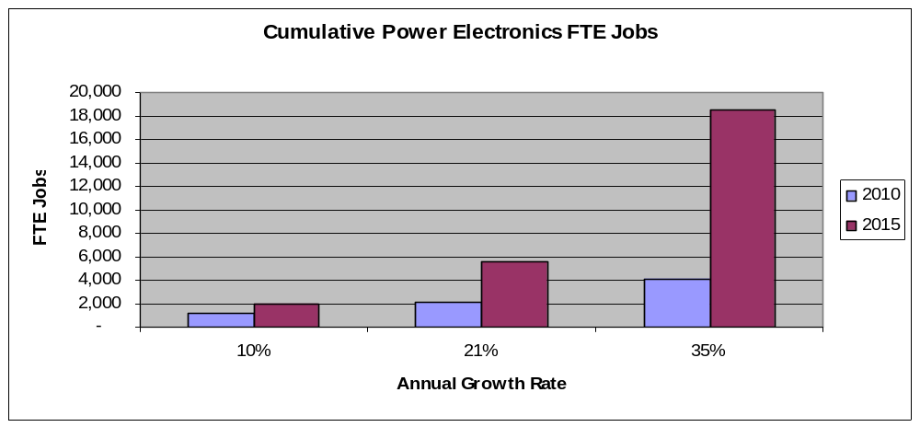

Local Renewable Energy Installations
A second area where the employment outcome can be affected is new renewable energy installations. Over the next ten years regional RPS requirements will spur the development of thousands of megawatts of new renewable energy capacity. The construction, operation and maintenance of these facilities denote long-term employment. However, due to the breadth of the New England power pool, Massachusetts cannot assume a pro-rata share of these FTE jobs. The Commonwealth must take an active role if it desires the skilled labor, tax and other benefits of local renewable energy facilities.

Taking only the current Massachusetts RPS into consideration, if 50% of the necessary new capacity is installed in the Commonwealth, approximately 7,000 new FTE jobs could result by 2015. Conversely, if finding locations for new facilities is unnecessarily burdensome, or if neighboring states are more enthusiastic about building and hosting new generation, the installation of 10% of new capacity in MA could result in under 1,400 jobs through 2015. If a median 30% of the capacity required to meet the MA RPS is installed in-state, approximately 4,000 new FTE jobs could result by 2015.

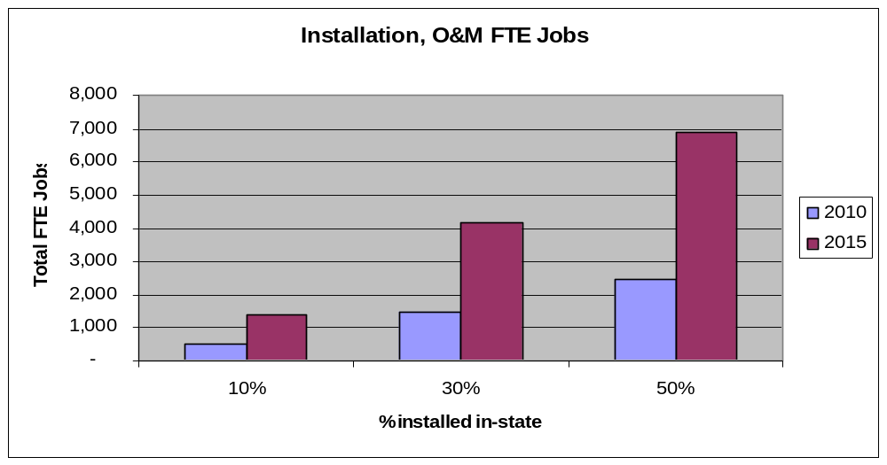

Massachusetts Growth Policy
Sustainable employment and economic growth in Clean Energy – including the power electronics and local installations findings above – depend on consistent regulatory policy. If Massachusetts Clean Energy businesses are expected to thrive in the global market, they must develop and execute long-term strategies. Policies and programs that connote commitment to this cluster will foster corporate investment in employee training, new research, and new manufacturing. Only from this base of consistent policy and investment can long-term strategy be executed.

While opinions vary regarding methods of overcoming the challenges for clean energy development, the need for more diverse, reliable, and efficient sources of power is palpable. A nascent but growing industry cluster has the potential to bring great and lasting rewards to the Commonwealth.

Appendix A - Clean Energy Cluster Technology

Renewable Energy Technologies
The five renewable electricity generating technologies defined as part of this Clean Energy Cluster report are: active solar, wind, fuel cells, bioenergy, and hydro & ocean power. The commercial success of these technologies depends on their cost-performance characteristics in certain applications, the industry cluster’s ability to deliver the requisite front- and back-end support, and the market’s willingness to embrace a technology change.

Active Solar Industry
Solar energy may be collected and used in the form of light and heat, or it may be converted into electricity or fuel. Active solar technologies produce electricity, heat, or hydrogen fuel and include photovoltaics (PV), solar thermal systems, and advanced solar technologies. “Passive solar” is addressed in the “High-Performance Buildings & Green Systems” section.

Market Assessment

Market | Size | Growth Rate
Global | $ 5B | 20% per annum
Market | Size | Market Share
U.S. | $ 650M | 13% global market share;
MA | $ 215M | 33% of U.S. production

Market Trends
Photovoltaic (PV) technology was invented in the United States, but a few European and Japanese manufacturers now dominate the market.
Photovoltaic Industry Shipments: growth through on-grid applications
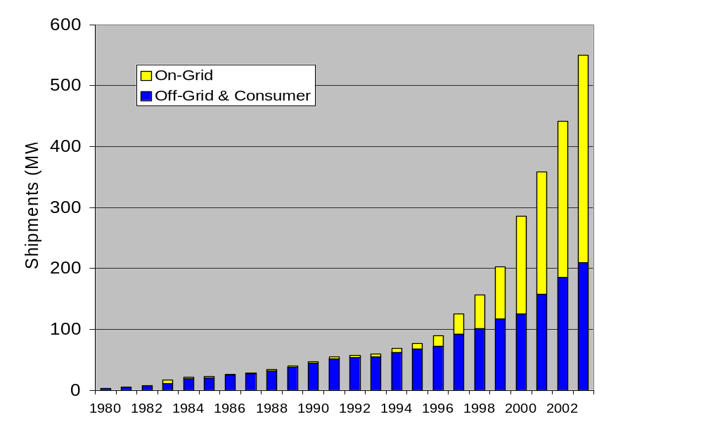
U.S. market share has been steadily decreasing from 45% in 1995 to approximately 13% in 2003, even though production volume in the U.S. doubled during that period. In 1999 Japan became the dominant PV producer with a 40% market share, which has grown to 47% in 2003, due to a 455% increase in production during that period. Worldwide PV production in 2004 will exceed 800 MW with 3,000 MW per year forecast by 2010.

Market Drivers
Globally, the existing key PV markets include stand-alone industrial, communications, and transportation systems such as water pumps, highway call boxes, navigation buoys, and other applications where grid connection is not possible or is prohibitively expensive. In 2002, off-grid applications represented about 36% of the world market for PV. Consumer products, such as calculators and outdoor lighting, currently represent about 8%-10% of the PV market.

Grid-tied PV market continues to be driven by subsidies and other government sponsored programs, demonstration installations and demand by environmentally conscious consumers. Both Japan and Germany set aggressive targets several years ago, leading to rapid market growth. Japan’s goal is to increase PV demand by 400 MW per year through 2010, while Germany’s goal is to boost installed capacity by 100 MW per year through 2005. In the U.S., where such explicit national goals are absent, state clean energy funds are the primary drivers of the grid-tied PV market. A number of U.S. states have net metering provisions, RPS requirements, tax incentives, and other factors to encourage consumer-side, or distributed generation applications for PV.

Development trends suggest that PV module manufacturing costs – representing 50% of total installed cost – will continue to fall at the rate of 5% - 7% per year. The remaining 50% also continues to decline as installation experience and standardization of grid interconnection rule increase. A strong international market will continue to drive cost trends and technological improvements.

Solar Photovoltaic

Status
- Cost-competitive in off-grid markets
- Proven, reliable, low maintenance technology

Advantages
- No pollutant or greenhouse emissions
- Silent and visually unobtrusive
- Scalable and versatile
- Very low operating costs
- Reliable
- Peak output coincident with peak load

Disadvantages
- High capital and installation costs
- Intermittency of solar resource

Technology Overview
PV technology employs semiconductor materials to convert direct or diffuse sunlight into electricity. Devices consist of a PV cell or a group of cells organized into a panel. They may be used individually or connected in an array. PV systems typically include ancillary components such as a DC-AC power inverter and battery storage is common in off-grid PV installations to provide back-up.

Single crystal and polycrystalline silicon PV devices currently dominate the solar marketplace with a 93% market share. They offer higher efficiencies (12-14%) and proven field performance, but they have relatively high materials costs. Numerous manufacturing innovations are being pursued to improve efficiency and to reduce materials requirements. New technologies using plastic-based PV are being hotly pursued as a way to greatly reduce the costs of PV.
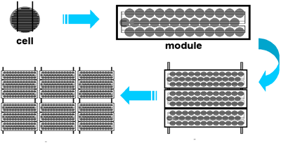
Photovoltaic cells, modules, panels and arrays.

Solar thermal systems absorb the energy carried by sunlight and then transfer heat to a working fluid such as water or air. Solar thermal electric technologies employ arrays of reflective mirrors to concentrate direct sunlight to produce steam which powers steam turbine driven generators. Conventional solar thermal systems, cost effective today, provide domestic hot water or space heating on a scale ranging from small residential buildings to large industrial facilities.

Future price decreases for PV technology are based on improvements in process yield and throughput, along with development of lower-cost packaging, and achievement of economies of scale. Access to capital may define progress in these areas. In applications where PV technology is not cost-competitive, subsidies and policy mechanisms can help expand markets by defining value for “green attributes” (i.e. Renewable Energy Credits) and reducing barriers to consumer-side applications.

Wind Industry
Wind turbines harness the energy of flowing air and transform mechanical energy from spinning blades into electricity. Wind energy is the world’s fastest growing source of electricity, on a percentage basis. Wind technology is cost-competitive today and the global resource base is substantial.

Wind Industry Market Trends

Market | Size | Growth Rate
Global | $ 9B | 26.5% per annum
Market | Size | Market Share
U.S. | $ 1.5 B | 16% global capacity;
MA | $ 1 M | < 1MW installed

The Market Assessment
Most of the industry’s recent expansion has been in Europe; and a few European manufacturers of utility-scale turbines lead the worldwide market. However, U.S.-based GE Wind Energy has made itself a formidable competitor after purchasing the assets of Enron Wind. In 2003, GE supplied 50% of the turbines installed in the U.S., and was second in worldwide turbine sales. The U.S. also has a strong small-wind turbine industry sector. In 2001, annual sales of the U.S. small wind turbine industry were estimated to be 13,400 turbines, valued at about $20 million.

Technology Overview
Wind Power Around the World
In 2003, the world's total wind capacity reached 40,000 MW – enough to power 9 million American households (or 8.4% of total U.S. residential use).

The wind industry has had an average growth rate of 26.5% for the last five years.

Sources: “World Market Update 2003,” BTM Consult ApS and “Global Wind Energy Market Report 2004,” AWEA
Wind technology is relatively mature, and modern wind machines are similar in form across a wide capacity range, in both land-based and offshore systems. Economies of scale are driving larger turbine development. Large-scale turbines range from 500 kW to more than 4 MW in capacity.

Large, modern wind turbines include four main physical components: the rotor, the nacelle, the tower, and the foundation. The rotor generally consists of three light weight blades attached to a central hub. Within the nacelle, the spinning rotor is connected to an electrical generator, either directly or via a transmission. The rotor and nacelle are atop a tower, and electrical lines exit the foundation to a utility sub-station.

Control system instrumentation and power electronics monitor, manage, and optimize its operations. They maximize electrical output under varying conditions, and manage the generating unit’s interconnection to the power grid or to on-site loads.

Competitive Landscape
The wind energy sector is segmented largely by end-use, which determines a turbine’s size and power rating. Large units are commonly deployed in bulk power, “central generation,” projects incorporating up to 100 turbines (or more) connected directly to the electric grid. Small (below 30 kW) and medium (30 to 500 kW) turbines serve remote power needs and grid-connected home, farm, business and community applications. Depending upon local wind resources, small and medium turbines can represent the lowest-cost source of power in developing nations and in off-grid applications.

European and other nations have established ambitious wind energy development targets, backed up by consistent and substantial financial incentive programs. By 2010, installed wind capacity in Europe is expected to account for more than 5% of the region’s electricity supply. In the United States, total capacity is projected to account for 0.9% of U.S. generation by 2025, even in the absence of federal targets. State RPS and climate policies are expected to expand wind’s national role over this period, but growth projections are constrained by siting challenges and by uncertainties regarding the long-term outlook for the federal production tax credit.

Wind Turbines

Status
- Cost-competitive in diverse markets

Advantages
- No pollutant or greenhouse emissions
- Reliable operation
- Scalable and versatile
- Relatively short construction timeline

Disadvantages
- Siting challenges
- Bird and other ecological impacts
- Wind intermittency
- Potentially long development lead-time

Over 8,100 MW of wind capacity was installed in 2003 alone, increasing worldwide capacity by 26%. U.S. capacity approached 6,400 MW (16% of total worldwide) by adding 1,687 MW in 2003. Wind turbines supply 50% of the electricity consumed in the Navarra region in northern Spain, while Denmark gets some 20% of its power from wind. Germany has more than twice as much installed capacity as any other country – wind energy supplies about 6% of the country’s power requirements and also currently employs 45,400 people.
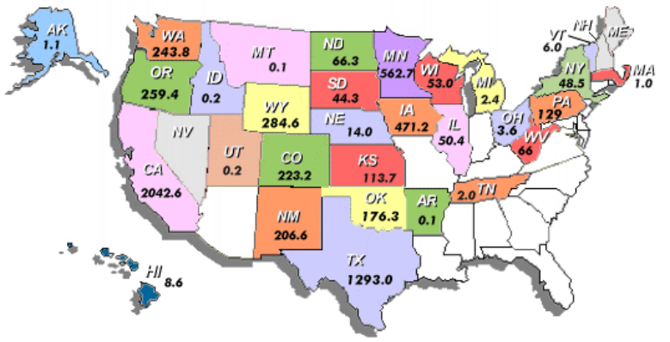
Chartxxx:Total Installed U.S. Wind Energy Capacity:
6,374 MW as of Jan 22, 2004. Source, AWEA.

In the U.S., wind energy supplies less than 1% of the country’s overall electricity needs, despite ample resources. Chart 3 shows that wind capacity is concentrated in California (2,043 MW), Texas (1,293 MW), and the mid-west.

Innovations at the component level—e.g., in blade materials, designs, and control systems and in platforms for deepwater environments—are expected to influence the competition among large manufacturers.
Powering Communities with Wind
Across the nation, communities are erecting 1-3 small or large wind turbines to stabilize electricity costs for street lighting, public schools and libraries. The turbines are also visible testaments of the town’s commitment to the environment and energy independence.

Small wind turbines are particularly well suited for rural areas. Applications include battery charging for sailboats, small cabins, and small systems for home use. The U.S. Department of Energy estimates that small wind turbines could meet 3% of U.S. electricity consumption by 2020. U.S. companies are well positioned in these markets, but the barriers to entry are low and the potential for disruption is great.

Fuel Cell Industry
Fuel cell technology converts hydrogen via chemical reaction into electricity and heat. Over the past 5 years, shipments have grown dramatically as fuel cells emerge from the research labs and demonstrate their ability to compete with internal combustion engines and batteries.

The Market Opportunity
CHARTXXX– Fuel Cell Production by Region
Source: Fuel Cell Today
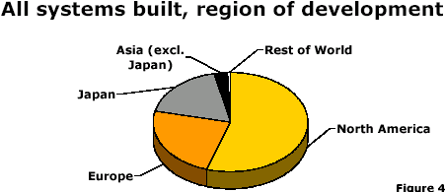
Fuel cells have astonishingly broad application potential. Uses include back-up generation, transportation, military programs and portable electronics. Market size assessments vary widely, but portable electronics – such as cell phones and laptop computers – alone represent a $50 billion market. One recent study suggests that in the US, revenues associated with prototyping and testing, as well as actual sales of fuel cell products, will increase tenfold to $1.1 billion by 2008 and reach $4.6 billion by 2013. North America dominates the fuel cell industry by the number of systems produced, yet programs such as Japan’s push for household units, or the commitment to transportation and hydrogen R&D in the EU, indicate that other countries may not be far behind.

Fuel Cell Industry
Market | Size | Growth Rate
Global | Sales: $ 338M  R&D: $ 859M  Total: $1.2B | 34.5% per annum  (forecasted CAGR)
Market | Size | Market Share
U.S. | Sales: $ 119M  R&D: $ 460M  Total: $579M | 36% of global share;  62% of global share
MA | Sales: $ 46M  R&D: $ 179M (est.)  Total: $225M | 39% of U.S. sales

Although fuel cells are making material progress toward commercialization, a heavy reliance on development financing and government support will be necessary in the near term. Chart XXX depicts the dollar support to the industry last year from governments.

Chart Xxx – Government Support For Fuel Cell Industry
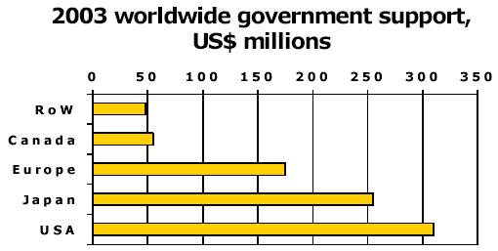
Source: Fuel Cell Today

The current costs of fuel cells and their stage of technology development mean that today’s market relies on early adopters such as the military and others who value portable and backup power. To be commercially viable for the automotive market, a proton exchange membrane (PEM) fuel cell must cost on the order of $60 – 100 per kW. For stationary power, installed fuel cell costs must approach $1,500 per kW. Current shipments of PEM fuel cells are roughly $10,000/kW, and Solid Oxide (SO) fuel cells are just starting to break below $20,000/kW.

Technology Overview
Fuel cells use a continuous fuel supply of hydrogen (which can be derived from carbon-based fuels or water). Fuel cells carry the advantage of being relatively small, quiet, and clean. For these reasons they can be installed close to where electricity is needed. Fuel cells are being developed in sizes appropriate for commercial buildings, automobile use, portable military applications and consumer electronics such as cell phones and laptops.

Multiple fuel cell technologies exist, and there is no clear “winner” among today’s fuel cell options. Each technology has its advantages and disadvantages.

Table XXX Fuel Cell Technologies
Fuel Cell Membrane | Operating Temperature | Efficiency | Status
Solid Oxide  (SOFC) | 800° - 1800°F | 50 - 65% | - Demonstration units sized from < 1 kW to 100 kW  - Development focuses on large-scale generation  - Small-scale stationary power, portable power, and transportation applications are being examined
Molten Carbonate  (MCFC) | 1200°F | 45 - 60% | - Demonstration units range from 10 kW to 2 MW  - Development focuses on large-scale and distributed generation markets
Alkaline  (AFC) | 300° - 400°F | 60% | - Commonly used in space power applications  - Presently too costly for mass markets
Phosphoric Acid  (PAFC) | 200° - 220°F | 40 - 45% | - 200 kW and smaller units are commercially available for cogeneration & distributed gen.  - Costs are expected to constrain applications
Proton Exchange Membrane  (PEM) | 175°F | 30 - 60% | - Expected to be the dominant technology for transportation, portable power, and residential applications  - Direct Methanol (DMFC) variation being developed for portable and consumer applications

Fuel cells create useful by-products such as heat and potable water, which can be used to off set other needs on site. Due to the present lack of hydrogen distribution infrastructure, producing hydrogen with renewable electricity is a practical and competitive means in some applications. Reforming natural gas currently represents the most cost effective means of bulk hydrogen production.

Competitive Landscape

In portable power markets, small- and micro-scale fuel cells are rapidly approaching cost-competitiveness, particularly for high-drain applications such as laptops. Low-power fuel cells are expected to compete with battery technology for market share within the next 5 years.
Fuel Cells
Status
- Near-commercial for portable applications;
- Demonstration for large-scale generation and transportation applications
- Unproven long term reliability of stacks

Advantages
- No harmful emissions
- Versatile and scalable
- High-quality power
- Quiet and visually unobtrusive

Disadvantages
- Reliance on fuels with delivery infrastructure inferior to that of diesel or gasoline
- Reliability, durability and cost need to improve dramatically

At present, activity in the fuel cell sector is largely R&D. Most installations have been highly subsidized demonstration projects. A survey among 16 North American publicly-traded fuel cell companies in 2002 indicates ratios of 170% R&D expenditures vs. revenues in 2001 and 119% in 2002. Private dollars into fuel cell ventures began during the late 1990s and spiked in 2000 with over $311 million raised by fuel cell firms that year, largely represented by the IPO’s of Proton Energy Systems and H Power. Investment has waned, however, as investors look for commercialization of the technologies.

Bioenergy Industry
Bioenergy technology converts the chemical energy stored in organic matter or by-products, into electricity and heat. Bioenergy is defined as biomass, landfill gas, and municipal solid waste for power generation. Today, bioenergy is complex and efficient, and can convert solid, liquid or gaseous organic materials into useful energy using a wide variety of technologies. New England has ample bioenergy supply resources, presenting an opportunity for growth in the sector.

The Market Opportunity
In the United States, bioenergy for power generation is a $15 billion industry, concentrated in the Northeast, Southeast and on the West Coast. Industrial process heating and combined heat-and-power systems, along with home heating systems, represent bioenergy’s predominant uses. 35,000 MW of biomass power generation is installed in the world today, not including municipal solid waste (MSW) incinerators or landfill gas-fired plants.

Market | Size | Growth Rate
Global | 35,000 MW | Mature; growth in  niche applications
Market | Size | Market Share
U.S. | $ 15B  8,750 MW | 25% global market share
MA | 330 MW | 3.8% of U.S. production

In the U.S., bioenergy accounted for 4% of total energy production in 2003 and more than two-thirds of this energy was consumed for industrial and residential heating purposes. Electricity output from bioenergy, which does not include steam or heat, was almost 59 billion kWh in 2002, accounting for 1.6% of overall U.S. generation. Most of this electricity is generated by industrial heat-and-power systems operating on wood or wood wastes. 7,000 MW of capacity in the U.S. is derived from forest product industry and agricultural residues, another 2,500 MW is municipal solid waste incinerators and 500 MW of landfill gas-fired capacity.

Technology Overview
Table XX shows an overview of the different forms of fuel, sources of bioenergy fuel and technologies used to convert the fuel to electricity and heat. Bioenergy fuel sources are broken into three categories: (1) primary – the fuel is the primary goal of processing, (2) secondary – the fuel is a usable waste product and (3) derivative – waste from another process can be treated to create usable fuel.

Table XXX – Bioenergy Fuel Sources, Forms of Fuel and Technologies

 |  | Fuel Source
 |  | Wood/Wood Waste  /Biomass  (timber, forestry residues, crops) | Solid Waste  (garbage or trash) | Other  (agricultural crops/ residue, sludge, farm and animal waste)
Form of Fuel | Solid  (little or no pre-processing) | - Direct combustion in a stoker-boiler biomass generator  - Co-firing at a coal-fired power plant with  (5-15% biomass) | - Municipal solid waste incinerators burn garbage directly to create electricity | - Fast-growing energy crops (and some farming residues) can be dried and combusted to create electricity
Form of Fuel | Gasified  (gasification or gas from decomposition) | - Gasified (biomass gasification) and burned simultaneously in a fluidized bed generator  - Gasified then burned in a conventional generator (gas engine, gas turbine, or furnace to create electricity or heat.) | - Organic decomposition at municipal solid waste landfills produces landfill gas, which can be treated and burned in a conventional generator | - Anaerobic digestion converts sludge and animal waste to digester gas – burned in conventional generators  - b) Energy crops can be turned into ethanol (i.e. gasified) and used in automobiles
Form of Fuel | Liquid  (liquefied through pyrolysis) | - Wood is liquefied into bio-oil or oils (soybean, canola, recycled cooking grease) which are processed into bio-diesel and burned in modified conventional generators or in automobiles | - N/A | - “Black liquor” waste from pulp and paper processing is a bio-oil  - Scientists are exploring using cooking oils and other materials as a diesel fuel substitute

.

Currently, the largest source of bioenergy electricity in the U.S. is solid wood or wood waste fuels, using direct-combustion technology. Biomass can be burned alone – or co-fired with coal or other fuels – within a conventional boiler or other combustion chamber to produce steam, spin a turbine, and generate electricity and heat. Agricultural engineers are working to develop substitutes for forest-based fuels. By developing fast growing, high-density energy crops, researchers hope to decrease worldwide impacts on forests.

The second largest source of bioenergy electricity is municipal solid waste. MSW is the total waste from humans that is not reused or recycled and excludes industrial waste, agricultural waste, and sewage sludge. In the U.S. today, 98 waste-to-energy facilities generate an equivalent of 2700 MW of electricity.

Competitive Landscape
Bioenergy generating facilities exist in almost every U.S. state, and generally range from 20 to 50 MW. Electrical output from bioenergy facilities in 2025 is projected to be almost double the 2002 level. Most of the increase is expected to come from new combined heat-and-power facilities, followed by dedicated biomass plants and landfill gas projects. Generation from biomass co-firing in coal-fired plants is also expected to increase, and output from MSW incinerators is expected to increase slightly, although no new MSW incinerators are expected to be built.

The competitiveness of all bioenergy technologies depends strongly on the cost and the characteristics of the fuel source. The most economic bioenergy fuels are residues, wastes, and by-products. Because woody biomass has a low energy density compared to other fuels, transportation costs must be minimized. For biomass generators without adequate on-site fuel supply, the largest distance considered economic between the resource supply and the generator is 100 miles. For solid biomass, genetic engineering is an active R&D area, with goals to design dedicated feedstocks that have higher energy content, and are easier to handle.

The U.S. Department of Energy estimates that 70% of the biomass power plants in the domestic pulp and paper industry are aging. These direct-firing combined heat and power facilities will need to be replaced or repowered in the next 10 to 15 years. This creates a window of opportunity for woody biomass (in the short term) and biomass gasification systems (in the long-term). Biomass gasification could double electrical output from the same resource input. These efficiency advantages—along with advances in feedstock engineering and fuel processing—are expected to make biogasification systems cost-competitive.

Bioenergy Fuel and Technologies

Status
- Cost competitive with grid power today
- Proven technology

Advantages
- Reduced pollutant emissions
- Neutral, or reduced, greenhouse emissions
- Scalable and applicable for cogeneration
- Continuous and reliable
- Resource efficient, using wastes and by-products

Disadvantages
- Applications are feedstock-dependent
- Land intensive
- Creates solid waste by-product

Bioenergy’s contribution to the global electricity supply portfolio is projected to expand in both the near and longer terms as the costs of generating technologies and feedstocks decrease, and environmental policy commitments take effect. The expansion of the bioenergy sector creates opportunities for fuel suppliers and project developers, as well as manufacturers of fuel harvesting and energy conversion technologies.

Hydro & Ocean Power Industry
Hydroelectric and ocean-based electricity generating systems capture the energy of water in motion. Ocean thermal systems tap the solar heat absorbed by marine waters. Hydroelectric power is among the most mature forms of clean energy generation. While the history of hydropower revolves around large scale dams, environmental concerns over damming means growth in this technology will likely reside in smaller run-of-river and ocean-based applications.

The Market Opportunity
Hydropower provides one-fifth of the world's electricity, second only to fossil fuels. The U.S. is a global hydropower leader, with 14% of the 650,000 MW installed worldwide. In the U.S. today, hydroelectric power is used to meet approximately 7% of our nation’s electricity needs. Over 2150 hydropower facilities -- comprising 80,000 MW of installed capacity -- are located throughout all of the 50 states. The remaining 10,000+ MW of U.S. hydropower comes in the form of pumped storage. The Department of Energy recently completed a resource assessment identifying a potential 30,000 MW of undeveloped hydroelectric capacity. Notwithstanding these undeveloped resources, certain energy analysts expect almost no new capacity to be added through 2020.

Market | Size | Growth Rate
Global | 650,000 MW | Effectively none
Market | Size | Market Share
U.S. | 80,000 MW | 14% global market share;
MA | 1,725 MW | 2.2% US market

Technology Overview
Hydro technology is fundamentally the same regardless of the type of hydropower facility. The kinetic energy of flowing water spins a turbine, producing mechanical energy that is converted into electricity by a generator. Additional components include dams, foundations, and penstocks, as well as the power electronics, instrumentation, and power lines associated with all renewable generation facilities.

Conventional hydro turbines are installed either within or adjacent to dams and diversion structures. Hydro dams, or impoundment facilities, create artificial head between upstream and downstream waters, increasing the amount of kinetic energy that can be converted into electricity. Hydro diversion structures, or run-of-river facilities, redirect a portion of the flow to take advantage of natural head, enabling kinetic energy to be harnessed with a relatively lesser impact on the aquatic environment.

An impoundment hydropower plant dams water in a reservoir
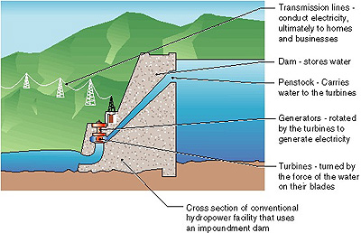
Source: http://www.eere.energy.gov/windandhydro/hydro_plant_types.html

Pumped-storage hydro plants integrate one or more reservoirs with a diversion structure. Electricity is consumed to pump water upstream for storage. During high-demand periods, the stored water is released to generate electricity. If the pumping load is carried by wind or other renewable resources, these storage facilities represent an option for addressing renewable intermittency issues.

Large scale hydro technology is very mature, and the adverse impacts on upstream and downstream habitats, fish populations, and water quality are well documented. For both retrofit and new installations, advanced operating strategies and high-energy turbine designs are being developed to increase conversion and reduce adverse environmental impacts.

Competitive Landscape
Hydro technology has long been the world’s primary source of renewable power. Today, hydropower facilities are highly cost competitive with other sources of electricity. Because the hydro industry is mature and global in scope, existing market participants are expected to continue to dominate.

Most other economic activity in the hydro and ocean energy sector is geared toward the demonstration of new technologies. Numerous low-head, free-flow concepts are being tested for river and tidal applications. The systems being developed by U.S., Canadian, and European manufacturers are expected to be suitable for off-grid power on islands and in other remote regions, as well as in grid-connected applications over all scales.

Hydro and Ocean Technologies

Status
- Mature and cost-competitive (conventional hydro)
- Emerging (low-head hydro, ocean energy)

Advantages
- No pollutant or greenhouse emissions
- Scalable
- Continuous (hydro, tidal current, ocean thermal)
- Intermittent but predictable (wave, tidal barrage)
- Reliable

Disadvantages
- Siting challenges due to aesthetics and potential ecological impacts.

Run-of-river, tidal, and wave applications still face challenges. Environmental concerns are similar to those associated with conventional hydro facilities. They include the possible effects on aquatic life, riparian and marine processes, visual aesthetics, and recreational and commercial activities. Significant technology gaps must be overcome in the areas of mooring and foundations, underwater cabling, and energy storage. For ocean-based technologies, high-energy sites are far from load centers, and all marine environments pose major engineering challenges due to corrosion, access limitations, and how to deal with severe storms.

Energy Efficiency Industry Overview
Energy-efficient technologies reduce the amount of electricity and fuel required for specific uses. Much of the energy efficiency business can trace its roots back to responses to the oil shocks in the 1970’s and energy conservation. This report looks at end-use, building, and power grid applications.

Market Opportunity
The energy efficiency sector is the largest and most mature segment of the clean energy industry. It is also the sector with the most direct link to economic productivity: Money saved on energy is invested in new jobs and equipment, with ripple effects throughout the local cluster and economy.

Today, the energy efficiency sector is driven by new motivations that have overtaken cost reduction as the sector’s most important marketing messages. These include:
- Reliability and security are enhanced by modern control and monitoring systems, distributed generation and back-up power sources on site, multiple transmission feeds to large end users, and improved internal wiring;
- Financial benefits of load shedding and flexible scheduling in response to either real-time electric pricing or demand response requests from the grid;
- Infrastructure improvements and deferred-maintenance corrections, using private capital where either public appropriations or customer capital budgets are lacking;
- Marketing, public relations, and corporate citizenship benefits derived from energy efficiency as an environmental stewardship decision.

There are three primary product and service areas:
  - end-use technologies, including energy efficient appliances and hardware,
  - efficiency in fuels and electricity in building applications, and
  - power grid and distribution-level technologies.

End-use technologies include a very large number of systems and equipment categories that are specified, distributed, installed, and serviced (and in some cases manufactured) in Massachusetts buildings. The most energy-intensive of these include:
- Lighting equipment and controls – almost entirely transformed for energy efficiency during the past decade;
- Energy management systems- including central controllers, actuators, sensors, storage, and wiring, which have been installed largely as upgrades;
Energy Savings = Less Pollution, More $
Last year alone, Americans, through the ENERGY STAR program, saved enough energy to power 20 million homes and avoid greenhouse gas emissions equivalent to 18 million cars - all while saving $9 billion.
Source: EPA Website http://www.energystar.gov/index.cfm?c=about.ab_index
- Water and wastewater treatment plants – typically the greatest energy user in municipal budgets – as well as specialized plants for industrial processes;
- Computers, printers, networking systems, and other office equipment - all of which becomes obsolescent within a few years and replaced with more efficient models;
- Industrial equipment - used in paper mills, extrusion and molding processes, conveyors and handling systems, cooking and food processing, kilns and industrial ovens, cold storage and refrigeration, air compression and manufacture of industrial gases, mines and quarries, cement plants, lumber mills, painting and finishing, asphalt production, textile manufacture, printing, etc. Each of these is well represented in Massachusetts. There is an active and prosperous industry focused entirely on supplying, servicing, and improving the energy-efficiency of these systems.
- Household and commercial appliances - including refrigerators and freezers, stoves and ovens, air conditioners, and dishwashers, all are rated for energy efficiency and sold competitively on that basis. No one can look at an old model and not be impressed by how far the technology has progressed in a relatively few years.
Energy Savings = Less Pollution, More $
Last year alone, Americans, through the ENERGY STAR program, saved enough energy to power 20 million homes and avoid greenhouse gas emissions equivalent to 18 million cars - all while saving $9 billion.
Source: EPA Website http://www.energystar.gov/index.cfm?c=about.ab_index
- Heating, ventilating and air conditioning (HVAC) systems - these include boilers and burners, chillers, fans, and distribution systems. All of these involve new technologies that substantially reduce energy consumption per unit of output. In many cases, old models have been made obsolete by newer, more efficient designs such as heat pumps, variable-volume systems, waste recovery, load-responsive cycling, energy storage, and other solutions adopted for greater efficiency. The installation of these systems in new construction, combined with their retrofit in existing facilities, occupies thousands of workers daily.

Fuel/electricity efficiency in Building Applications relies on all of the above technologies and on efficient construction technologies involving the building envelope (insulation, fenestration, infiltration sealing, solar loading control, ground coupling, handling of internal loads, etc.) These technologies support not only indoor air and lighting quality, and the health, morale, and productivity of occupants, but also cost reduction. Because building occupants include customers, students, physicians, and workers whose comfort and well-being contribute directly to economic vitality, the “green building” concept is rapidly capturing the support of political leaders and the whole value chain between architect and user. Billions of dollars are scheduled to be spent over the next few years on construction of facilities that have proven most affected by such “green” choices: notably education, health care, retail, cultural, athletic, hospitality, entertainment, transportation, and energy-intensive industrial facilities.
The “Energy Cycle” common to all large facilities is depicted in Chart XX. In each element of the cycle, opportunities abound for investment in greater efficiency. Such opportunities pay for themselves out of future operating savings, reduced maintenance costs, and capturing the value of eliminated waste. Efficiency investments are frequently labor-intensive, creating new jobs as more facilities are constructed and renovated.

Chart XX – Large Facility Energy Cycle
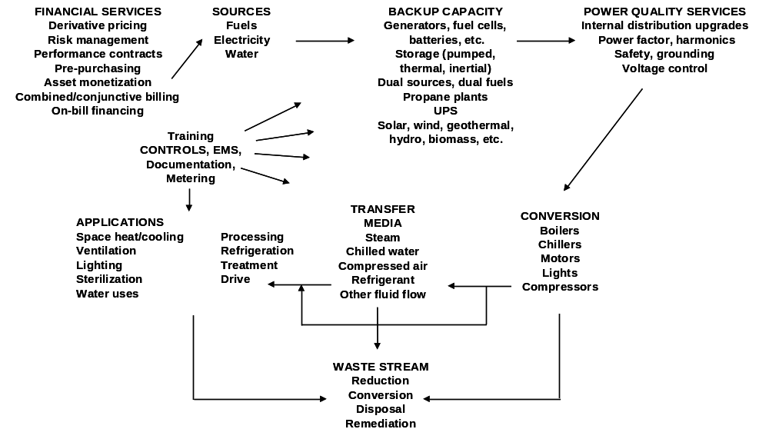

Power grid technologies are responding very fast to concerns about reliability of supply, quality of delivered energy (essential for sensitive computer and industrial process systems), security and diversity of fuel sources, and environmental responsibility, as well as basic considerations of cost and stability. These concerns are driving a largely new industry in five parts:
- Distributed generation and demand-response load control
- Combined heat-and-power (cogeneration) plants, some using renewable inputs such as fuel cells, biodiesel, biomass, and industrial waste.
- Efficiency of the delivery systems – transmission/distribution, transformers, switching, power factor correction, voltage support, frequency conversion and other power electronics, and related systems. New technologies such as superconductors and supercapacitors are making their way rapidly out of the research laboratory.
- Back-up systems of generation and storage for uninterruptible supply
- Reliable, fast, transparent dispatching of generation and transmission capacity to avoid grid breakdowns

Technology Overview
Energy efficiency technology has seen substantial development in each of the primary product and service areas.

End-use technologies: Natural and mechanical ventilation systems increase air circulation and remove heat from buildings, improving energy efficiency by reducing the need for air conditioning. Mechanical options augment windows, doors, vents, and other natural ventilation systems. They include portable, window- and ceiling-mounted, and whole-house fans. During colder months, portable and ceiling fans can increase heating efficiency by improving air circulation.

Building applications: Options for building envelop efficiency are numerous, and undergoing continuous improvement. Insulation, for example, comes in a variety of forms and materials. Rolled batt and blanket products, usually made of fiberglass or rock wool, are designed for use between studs and joints or as a floor covering in unfinished attics. Loose fill, usually fiberglass, rock wool, or recycled cellulose, is poured or blown into existing walls or attics. Spray-foam insulation is an emerging solution for retrofit and new construction. It is injected in liquid form, and it expands to completely fill wall and floor spaces.
Energy Star Label – a Familiar Sight

Today, the ENERGY STAR label is featured on more than 40 types of products as well as on new homes and buildings. More than 9,000 organizations have become ENERGY STAR partners and are committed to improving the energy efficiency of products, homes and businesses.
Source: EPA Website

In certain cases, building materials play a dual role. Doors and windows not only are part of the building envelope, but also they serve lighting, solar heating, and ventilation functions. Pre-hung exterior doors with a metal or fiberglass skin and foam-core insulation offer significant efficiency advantages over standard wooden doors. For all windows and for doors that incorporate glass panes, recent efficiency gains are attributable to the use of insulated frames, dual- and triple-pane systems containing insulating gas layers, and low-emissivity coatings. Glazings are available with different insulation, daylight transmittance, and solar heat gain characteristics. Storm doors and windows can increase efficiency in buildings with older doors and windows, and they can be fitted with screens to enhance natural ventilation.

Monitoring and control systems optimize energy use in built environments. Examples include programmable thermostats, zonal space conditioning and ventilation systems, and automated lighting controls, all of which help ensure that energy is consumed only when and where building occupants benefit. In the most energy-efficient buildings, conservation measures, efficiency technologies, and renewable systems work together to minimize or eliminate dependence on the power grid and fuel delivery infrastructures.

Power grid technologies: Grid operations and control systems monitor the condition of the power delivery network and provide real-time direction on electrical output from generating facilities and on power flow over transmission and distribution lines. These complex systems are critical to the efficient and reliable operation of the power grid and of power markets.

Power electronics enhance power quality while avoiding the need to install new capacity. Solid-state, silicon-based devices are increasingly being deployed to replace conventional electromechanical switches and to add new control functionalities. Specialized high-power silicon devices are being used for high-value applications, and new materials platforms are being explored that offer the potential for devices with much higher voltage and current ratings, better switching characteristics, and significant size and cost reductions.

Energy storage systems can improve grid efficiency and reliability by dispatching stored electricity when needed. Storage capacity can maximize the use of low-cost generating facilities by allowing them to operate at full rather than partial power during low-demand periods. Storage units can also reduce requirements for spinning reserves to meet changing demands, and they can eliminate the need for inefficient plants to be brought on line during peak-demand periods. Energy storage options include batteries, flywheels, and pumped hydro facilities.

Competitive Landscape
Historically, efficiency markets have been driven by government mandates, such as standards for end-use technologies, codes for buildings, and ratepayer-funded programs for demand-side management. These drivers will continue to be important, but the market-based demand for efficiency products and services is also growing.

Increasingly, energy consumers are becoming aware of the substantial benefits associated with more efficient end-use technologies and buildings. Efficiency reduces energy expenditures, freeing up money for other uses. It decreases emissions and other externalized costs associated with energy consumption. In industrial applications, efficiency can also help to improve the productivity, enhance the quality, and mitigate the environmental impact of manufacturing processes. In home and workplace settings, it can help to enhance comfort and functionality.

Sustained growth is assured for the energy efficiency sector because end-use and building technologies are integrated with the consumer goods, construction, and office supply sectors. Capital cost continues to represent a significant barrier to more rapid expansion in this sector. Energy-efficient products often come at a premium, and notwithstanding the lower life-cycle cost, sticker-price differentials continue to have an impact on consumers. Split incentives are another common barrier. In many commercial and multiple-family buildings and single-family developments, owners and builders are less likely to pay for efficiency improvements when tenants and buyers are the ones who benefit from lower energy bills.

For energy-efficient power grid technologies, near-term prospects for U.S. market growth are uncertain. Competition and restructuring in the electric power sector have placed a premium on cost control, at the expense of investment in infrastructure and R&D. Further, the associated regulatory and business climate uncertainty has exacerbated the situation. Over the longer term, markets for efficient grid technologies will be fueled by the need for major expansions in transmission and distribution infrastructure and in distributed generation that will be required to meet projected demand growth.

Enabling Technology Industry Overview
Enabling technologies provide interconnection, monitoring, management, analysis, storage, and other capabilities that are critical to current applications of clean energy technologies, as well as to future expansion of the clean energy industry.

Market Opportunity
The enabling technology sector encompasses firms involved in the development, manufacturing, and application of power electronics devices, storage technology, cables and wires, sensors and instrumentation, and control systems. It also includes companies that develop and supply the materials and equipment used to manufacture both these technologies and clean energy systems.

Technology Overview
Power electronics devices connect renewable energy generators to the power grid or on-site loads. These solid-state components—analogous to integrated circuits but operating at higher power levels—control electrical output, voltage, frequency, and phase configuration to match circuit conditions and maintain stability. Power electronics devices also ensure efficient operation of grid infrastructure and of rotating components such as generators and motors.

A growing variety of silicon-based devices are available, some of which are particularly important for the clean energy industry. DC-to-AC converters known as inverters are required to transform the DC power produced by PV modules and fuel cells into the AC power used by most end-use systems. In wind applications, AC-to-AC converters enable the use of variable-speed generators, which are more efficient than fixed-speed units because of their capacity to capture an intermittent wind resource. Converters transform variable AC output to 60 Hz, three-phase AC power for grid-connected units and to 60 Hz, single-phase AC power for most consumer loads. Similarly, converters greatly enhance the efficiency of motor and drive systems by continuously matching the amount of mechanical energy delivered to the amount required.

Rapid advances in silicon-based technology have expanded device applicability and driven down prices. However, this semiconductor material has inherent limitations as a power electronics platform, which has important implications for technologies where cost-performance characteristics constrain current applications, such as solar PV and fuel cell systems.

Materials such as silicon carbide and gallium nitride have about twice the bandgap of silicon, which means they do not conduct as easily and can thus withstand much higher temperatures while retaining control of electronic operations. These improved characteristics are expected to enable significant improvements in device performance and substantial reductions in device size and cost. Experimental wide-bandgap devices offering much higher voltage and current ratings and operating temperatures than conventional devices have been demonstrated, and extensive R&D is under way to address materials quality and device manufacturing challenges.

Storage technology represents a solution for addressing the intermittency challenges that constrain the cost-competitiveness of several renewable resources. At present, storage is most commonly integrated with renewables in small-scale applications, many of which are for remote power. For example lead-acid battery systems are used in conjunction with PV or wind technologies to help facilitate a reliable source of electricity, regardless of weather conditions or the time of day. Utility-scale lead-acid batteries and other grid-connected storage options are commercially available, and are usually employed to improve power quality, provide an uninterruptible power supply (UPS), or make use of excess baseload capacity during low-demand periods.

Cables and wires: Cable and wire technology is mature, but two emerging areas are of particular interest to the clean energy industry.

First, high-voltage DC cable systems are expected to improve the economics of large wind, wave, or other installations in far-offshore environments, where energy levels are higher and aesthetic concerns are reduced or eliminated. Over lengthy cable circuits, lower resistance losses and other advantages over standard AC systems are expected to make DC systems the preferred option for transmitting bulk power to onshore power grids, pending further advances in power electronics technology.

Second, the widespread use of HTS cables and wires in power grid and end-use applications could play a significant role in meeting the growing demand for electricity because HTS materials offer the potential for much greater current densities and much lower losses than conventional conductors. First-generation HTS wires are commercially available, and they are being tested, demonstrated, and used in cable, motor, storage, generator, power electronics, and other systems. Second-generation wires, expected to enter commercial production in the next couple years, may deliver the cost-performance characteristics necessary for HTS-based systems to compete with a broad array of technologies that incorporate conventional conductors.

Sensors and instrumentation provide the data and information required to site, install, operate, and maintain clean energy systems. Applications range from assessing wind speeds and other environmental conditions, to monitoring reaction kinetics within fuel cell stacks and biomass firing systems. In these and other applications, sensors and instrumentation are vital for determining site-specific requirements, adjusting operations based on weather and other conditions, and for diagnosing and resolving problems.

Control systems use the data and information generated by sensors and instrumentation to optimize performance in response to changing conditions. Either automatically or under direct human supervision, computerized controllers are employed to maximize power production from renewable energy technologies, coordinate their operations with the power grid or on-site loads, and reduce the impacts of faults and other disturbances. Automated control functions are increasingly being integrated within clean energy systems, as well as in external power electronics devices. In many cases, grid-connected technologies can also respond to signals from remote operations and control centers.

Competitive Landscape
The enabling technology sector is positioned for significant and sustained growth as markets for clean energy technologies expand. What makes this sector unique is that cost reductions and performance improvements in enabling technologies will enhance the cost-competitiveness of all clean energy systems. Accordingly, the pace of progress in this sector could well pace the rate of growth in other clean energy sectors.

Major technical barriers exist in areas such as power electronics, storage, and HTS materials, but significant institutional barriers also exist. For example, enabling technologies arise from many different industries, some of which are clearly focused on renewables and efficiency and others for which clean energy applications currently account for only a small fraction of total economic activity. In these latter cases, resource commitments to these applications may lag, slowing progress.

High-Performance Buildings & Green Systems Industry Overview
High-performance buildings and green systems integrate clean energy technologies with sustainable design practices to maximize the productivity of resources, enhance operational functions, and improve living and working conditions.

Market Opportunity
The high-performance buildings and green systems sector includes organizations involved in creating built environments and community infrastructures in which resource optimization is an integral consideration throughout design, construction, and operation. Several broad categories of organizations participate in the sector. These include, but are not limited to: builders, property owners (including government agencies), architects, engineers, financing institutions, construction firms, appraisers, and companies involved in selling and servicing clean energy systems.

Technology Overview
The focus is on sustainable design practices and on integrated clean energy applications, which involve the use of renewable generation technologies characterized elsewhere in this report as well as other renewable energy systems.
LEED Standards Save Money
For buildings designed and built to qualify as a green building under the Leadership in Energy and Environmental DesignTM (LEED) System developed by the U.S. Green Building Council, the financial benefits of sustainable design are between $50 and $75 per square foot—over 10 times the current cost premium.

Source: Gregory Kats. “Green Building Costs and Financial Benefits.” 2003.
Sustainable design incorporates issues relating to resource use, public health, human performance, environmental quality, and lifetime costs within the standard design framework. Functional and aesthetic characteristics, as well as capital costs are considered. Typical resource-oriented objectives are to use energy and water efficiently, to take advantage of on-site renewables, to reduce construction-related waste and disturbance, and to employ recycled, low-impact, and nontoxic building materials and finishes. Achieving these objectives generally has positive effects on the health, comfort, and productivity of building occupants, as well as on the overall bottom line.

In buildings, most of these benefits are gained by using proven techniques that maximize energy efficiency, high performance design and renewable technologies working in concert. One example includes passive solar. Orientation is fundamental, enabling full use of windows and other features to provide interior lighting and winter heating, as well as to reduce solar gain in summer. Design measures like these—combined with a tight building envelope, efficient windows, HVAC systems, and advanced controls—minimize the amount of energy required for lighting, space cooling and heating, and water heating. On average, new green buildings are 25 to 30% more efficient than conventional structures built to code, while high-performance buildings can achieve even greater efficiencies.
A Look at Green Building Design
On average, new green buildings are 25 to 30% more efficient than conventional structures built to code, while high-performance buildings can achieve even greater efficiencies.

Source: Gregory Kats. “Green Building Costs and Financial Benefits.” 2003.

Integrated clean energy applications take advantage of on-site resources, employing one or more renewable technologies to supply energy for end-use, space conditioning, and water heating purposes. Because new green facilities require much less electricity and fuel, renewables can account for a significant percentage of their energy needs. Some high-performance buildings rely on renewables for a portion of their energy, and they sell excess power to the grid through net metering agreements. Integrating renewable electricity in existing buildings and community infrastructures can help transform them into green systems.

Active solar technologies, including PV and solar thermal systems, are the most common installation. Electricity is typically generated by standard rooftop-mounted PV panels, but building-integrated technologies—in which PV cells are incorporated in shingles, awnings, windows, or other building features—show promise. Rooftop-mounted solar thermal systems typically supply hot water. In flat-plate collectors, water circulates through a series of pipes enclosed in an insulated box. Solar energy passing through a glass panel on the top of the box is absorbed in the pipes, and heat is transferred to the water moving through them. Heated water is collected in a separate storage tank and then used on demand.

Depending on site characteristics, wind turbines can supply electricity, and geothermal heat pumps can provide space conditioning and water heating. Geothermal systems use the relatively constant temperature of soil as a heat source in cooler months and as heat sink in warmer months. Closed-loop heat pumps circulate a working fluid—typically water mixed with an anti-freezing agent—through a buried pipe, absorbing heat from or rejecting it to the soil. The fluid is run through a heat exchanger to heat or cool air for space conditioning and to supply hot water.

Competitive Landscape
The high-performance buildings and green systems sector accounts for only a small fraction of the overall construction industry, but changing conditions indicate that the market is poised for a rapid and sustained expansion.

To date, the sector has been driven by government-funded demonstration projects and by environmentally conscious consumers ranging from homeowners to major corporations. These “boutique” applications have contributed to the widespread perception that green facilities are much more expensive to build than conventional structures. Studies of these applications are beginning to dispel this notion. Recent data indicate that the average premium is slightly less than 2%, that most of the additional costs are incurred during high-value design processes, and that both design and construction costs are declining as experience increases. More and more corporate headquarters buildings are being designed and built to green building standards – including Genzyme and Manulife.

Moreover, sustainable design offers returns on first-cost investments that conventional buildings do not. Documented benefits include lower costs for energy, waste, and water; increased productivity and health for students, workers, and other building occupants; decreased emissions of pollutants; and reduced operations and maintenance costs. For buildings certified under the Leadership in Energy and Environmental DesignTM (LEED) System developed by the U.S. Green Building Council, the financial benefits of sustainable design are between $50 and $75 per square foot—over 10 times the current cost premium.
Green Buildings - Cost is Coming Down
Recent data indicate that the average premium [of a new green building] is slightly less than 2%.

Gregory Kats. “Green Building Costs and Financial Benefits.” 2003.

These data demonstrate the cost-effectiveness of sustainable design practices. However, the high-performance buildings and green systems sector will continue to face the same first-cost, split-incentive, and other barriers that constrain market penetration for energy-efficient technologies. To accelerate the sector’s growth, educational programs will be required to build awareness of financial benefits, and consistent policies will be needed to help developers and owners capture the full range of benefits.

Innovation Services Industry Overview
Innovation services provide the intellectual, human, and financial capital required to improve cost-competitiveness and successfully commercialize clean energy technologies.

Market Opportunity
The innovation services sector encompasses organizations involved in energy R&D, project and venture financing, consulting, policy and market development, power and ecological asset marketing, and public education and outreach.

Energy R&D services are particularly important, with both the organizations that conduct R&D and those that provide funding contributing at all levels of the clean energy value chain. University and college departments and centers, contract R&D firms and laboratories, consulting and engineering companies, and nonprofit organizations attract federal and state R&D investments, which induce additional private sector R&D investments. This capital is applied to underpin innovations in products and services, develop and refine existing and emerging technologies, build fundamental knowledge, create and transfer expertise, promote entrepreneurial thinking, and fuel start-up and commercialization activities.

Project and venture financing services are delivered by institutional investors, venture capital funds, incubators, and other institutions that support projects and business enterprises in the clean energy sector.

Consulting services provide both startups and established companies with business, engineering, environmental, legal, and other management assistance. For example, they help protect intellectual property and manage human resources and other assets. They assist companies in designing, testing, manufacturing, commercializing, and marketing new technologies. They provide project developers with support throughout assessment, design, regulatory review and permitting, construction and installation, and commissioning processes.

Policy and market development services strive to create favorable conditions for the advancement, purchase, and use of clean energy technologies. Elected and appointed officials at the local, state, national, and global levels develop policy and conduct regulatory governance impacting the generation and sale of energy from all sources. Government programs directly impacting renewable and efficiency products include R&D allocations, tax incentives, supply portfolio requirements, emissions reduction requirements, efficiency standards, interconnection protocols, siting and permitting processes, and zoning conditions.

Power and eco-asset marketing services relate to the sale of power and environmental attributes associated with renewable electricity generation. These attributes take the form of renewable energy credits, emissions allowances, and emissions reduction credits. They are referred to as eco-assets because they derive from policies designed to value the external environmental impacts of power generation – which are reduced or eliminated with renewable electricity. This mechanism can increase the cost-competitiveness of clean energy technologies by enabling the market to value power attributes – assigning extra cost to power generated by fossil fuels, and rewarding investments in energy-efficient and renewable technologies. Providers of power and eco-asset marketing services include generation owners, brokers, and aggregators operating at the wholesale and retail levels.

Public education and outreach services are vital for increasing awareness of the benefits of clean energy, encouraging technology deployment, and building acceptance of renewable installations among businesses, government officials, and the general public. Environmental and consumer advocacy groups, government entities, and a multitude of private sector firms are promoting the use of clean energy technologies.

Competitive Landscape
The best near-term opportunity for accelerating clean energy growth arises from the potential impact of the policy and market development segment. The benefit will manifest itself through consistent, long-term, financial support programs and the open-forum development of uniform policies for clean energy interconnection and permitting standards. Policies and markets must be created to allow the capture of the full benefits of clean energy technologies, and to otherwise level the playing field.

Expanded education and outreach about the benefits of clean energy technologies – and the documented adverse impacts of each form of electricity generation – will be required to build support for institutional restructuring among decision-makers and the general public.

Appendix B: Companies Surveyed by the University of Massachusetts

Companies Surveyed by the University of Massachusetts

Abbess Instruments and Systems, Inc. Holliston MA
Acumentrics Corp. Westwood MA
Acute Power Inc. Attleboro MA
Adcour, Inc. Woburn MA
Advanced Energy Systems, Ltd. Medford MA
Aegis Energy Services, Inc. Springfield MA
AEMC Instruments Foxboro MA
Aerospace Systems, Inc. Burlington MA
Alloy Fabricators of New England, Inc. Randolph MA
Alumiseal Corporation Hanover MA
Ameresco Framingham MA
American Accoustical Products Holliston MA
American Energy Mngmt Corp. Marlborough MA
American Superconductor Corp. Westborough MA
Analog Devices, Inc. Norwood MA
Anchor Insulation Company Providence RI
Andover Controls Corp. Andover MA
Andover Controls Corporation Andover MA
Andover Technology Partners North Andover MA
Applied Energy Management Stockbridge MA
Aqua Laboratories, Inc. Amesbury MA
Artemis Intl Solutions Corp. Burlington MA
Aspen Systems, Inc. Marlborough MA
Aspen Technology, Inc. Cambridge MA
Assurance Technology Corp. Carlisle MA
Astrodyne Corp. Taunton MA
Bales Energy Associates North Hampton MA
Bay State Gas Company Westborough MA
Beacon Power Corp. Wilmington MA
Berkshire Gas Company (The) Pittsfield MA
Berkshire Photovoltaic Services Adams MA
Berkshire Service Solutions, Inc. Pittsfield MA
BlazeTech Corp. Cambridge MA
Bluestone Energy Services, Inc. Braintree MA
Boreal Renewable Energy Dev. Arlington MA
Bruin Corporation Ashland MA
Cape Cod Insulation Hyannis MA
Consortium for Energy Efficiency Boston MA
Center for Ecological Tech Pittsfield MA
Charles River Associates Inc. Boston MA
Circor International, Inc. Burlington MA
CMF Engineering Longmeadow MA
Coghlin Electric/Electronics Westborough MA
Comdel, Inc. Gloucester MA
Consentini Associates Cambridge MA
Conservation Services Group, Inc. Pembroke MA
Conservation Solutions Corporation Acton MA
Contronautics, Inc. Hudson MA
Conway Trader Energy Systems Hadley MA
Cotuit Solar Heat & Hot Water Cotuit MA
D & N Insulation Company Foxboro MA
Datel, Inc. Mansfield MA
DMI (Demand Management Institute) Newton MA
Ecological Engineering Concord MA
ElectroChem, Inc. Woburn MA
Electron Power Systems, Inc. Acton MA
Energy Federation Inc. Westborough MA
Energy Market Decision, Inc. Hopkington MA
Energy Security Analysis, Inc. Wakefield MA
EnergyRebate Inc. Ashland MA
Enviro Safe/Bid Rite Constructon Charlton MA
Environmental Solar Systems Methuen MA
Eua Citizens Conservation Services, Inc.Lowell MA
Evergreen Solar, Inc. Marlboro MA
Extech Instruments Corp. Waltham MA
Falmouth Products, Inc. Falmouth MA
Fencon Associates Orange MA
Fuel Cell Scientific, LLC Stoneham MA
Galaxy Power, Inc. Westborough MA
General Insulation Company Inc.
Giner, Inc. Newton MA
Hershey Energy Systems of MA Newton MA
Honeywell DMC Services, Inc. North Easton MA
Icet, Inc. Norwood MA
InterGen Services Inc. Burlington MA
Intronics, Inc. Norwood MA
Invensys ENE, Inc. Canton MA
Invensys, Inc. Foxboro MA
Kema Consulting Burlington MA
Kilojolts Consulting Group Lexington MA
Konarka Technologies, Inc. Lowell MA
Kopin Corporation Taunton MA
Laboratory for Energy & Environment Cambridge MA
LCI Energy Cambridge MA
Levitan & Associates, Inc. Boston MA
Lytron, Inc. Woburn MA
New Energy Solutions, Inc. Pittsfield MA
Newpro, Inc. Woburn MA
Nexus ENERGYguide East Wellesley Hills MA
Noresco, LLC Westborough MA
NE Energy Efficiency Partnership Lexington MA
Northeast Resource Group, Inc. Plymouth MA
Northern Energy Services, Inc. Northboro MA
Nuvera Fuel Cells, Inc. Cambridge MA
Opticorp Inc. Chelmsford MA
OSRAM SYLVANIA Danvers MA
Patriot Energy Group Woburn MA
PerkinElmer, Inc. Wellesley MA
Pioneer Valley Photovoltaics Greenfield MA
Powerhouse Enterprises Andover MA
Predictive Power Woburn MA
Protonex Technology Corporation Marlborough MA
Retec Group (The) Concord MA
Russelectric, Inc. Hingham MA
RWE Schott Solar Billerica MA
SatCon Technology Corp. Cambridge MA
Schaefer, Inc. Ashland MA
Schweppe Lighting Design, Inc. Concord MA
Select Energy Services, Inc. Natick MA
SEI Boston MA
Skipping Stone, Inc. West Peabody MA
Soluz, Inc. Chelmsford MA
Spire Corp. Bedford MA
Stone & Webster, Inc. Stoughton MA
Sustainable Energy Advantage Natick MA
Synapse Energy Economics, Inc. Cambridge MA
Synergy Investment Inc. Westborough MA
Systems H2O Ayer MA
Tech Environmental Waltham MA
Tellus Institute, Inc. Boston MA
The Conservation Consortium Yarmouth MA
Thermal Insulations , Inc. Quincy MA
TNT Energy LLC Bridgewater MA
Tocco Corporation Billerica MA
Total Power International, Inc. Lowell MA
Tuthill Corp. / Energy Systems Millbury MA
Tysak Engineering Acton MA
Vicor Corp. Andover MA
Viking Industrial Products Marlborough MA
WebGen Systems, Inc. Cambridge MA
Woodland Energy, Inc. Ashburnham MA
World Energy Alternatives, LLC Chelsea MA
XPiQ Inc. Holliston MA
Zapotek Energy Cambridge MA
Ztek Corporation Woburn MA

Appendix C - UMASS Employment Model

UMASS Employment Model

Two methodologies were used to determine the number of full time employees in the Clean Energy cluster. One method is a “top down” approach, associating spending on energy efficiency with job creation, and associating megawatts of manufacturing, installation, and maintenance of clean energy equipment with full time jobs required to build and maintain this capacity. The second method is a “bottom up” approach, using proprietary data series to classify firms at a fine level of detail, and then aggregating this data at the statewide level.

Methodology for Estimating Jobs – the “Top Down” Approach
Our estimates are based on a number of sources that have previously calculated labor per MW for each type of renewable energy. Our main source, Singh et al. (2001), dissects a MW of wind equipment, for example, into its component parts and various types of labor. This enables us to identify jobs directly related to installation as opposed to manufacturing, for example, in the construction of new wind towers. This is relevant because construction and installation employment will be created in Massachusetts even if manufacturing jobs are not.

We project employment in power electronics by multiplying together: (a) estimates of the total US market for each type of renewable energy with (b) the proportion of power electronics in the total installed cost of each technology and (c) Massachusetts’ estimated share of national manufacturing of these components.

To model energy efficiency employment, we used the Massachusetts Division of Energy Resources model to estimate that the state’s $183 million energy efficiency program generated 1841 jobs, or 10.06 jobs per million dollars, in 2001. The report estimates a further 423 jobs, or 2.31 per million dollars, were created as a result of the reinvestment of energy savings. We assume these ratios remain constant in the future. In addition to expenditures in the regulated energy efficiency program, we estimate non-program spending using a report that projects the total US market for energy efficiency, and estimating the Massachusetts market based on the proportion of electric power consumption in the state.

The REPP Report, Singh et al (2001), surveys businesses throughout the supply chain to determine person-hours and skills required in the direct manufacture, construction, operation, and maintenance of three types of projects: residential PV, large wind, and coal-biomass co-fired plants. Basic inputs (e.g. steel) and multiplier effects are not included. Operations and maintenance (O&M) are included for 10 years. Variability in job duration is accounted for by converting all labor into person-years per megawatt installed summed over the 10 years for O&M. Jobs are detailed by both occupational category and activity.

Table A1: Labor Requirements per Megawatt of Photovoltaics ª (in hours)
Project Activity | Prof, Tech, Mgmt | Clerical, Sales | Service | Ag, Fish, For | Proces-sing | Mech Trades | Bench-work | Structural Work | Misc | TOTAL
Glass | 50 |  |  |  | 50 | 50 |  |  | 50 | 200
Plastics | 50 |  |  |  |  | 250 |  |  |  | 300
Silicon | 1,550 | 200 | 200 |  | 3,300 | 200 | 200 |  |  | 5,650
Cell Manufacture | 800 |  |  |  | 1,600 |  | 600 | 50 | 150 | 3,200
Module Assembly | 3,500 |  |  |  | 1,600 |  | 8,250 | 750 | 6,850 | 20,950
Wires | 150 |  |  |  |  | 1,700 |  |  |  | 1,850
Inverters | 750 |  |  |  | 1,000 | 1,000 | 1,000 | 1,000 |  | 4,750
Mounting Frame | 500 | 500 |  |  |  | 150 | 100 | 150 | 100 | 1,500
System Integration | 8,900 | 2,850 |  |  |  |  |  |  |  | 11,750
Distributor/Contractor | 1,500 | 1,500 |  |  |  |  |  |  | 1,000 | 4,000
Installer | 2,500 |  |  |  |  |  |  | 8,000 |  | 10,500
TOTAL | 20,250 | 5,050 | 200 | 0 | 7,550 | 3,350 | 10,150 | 9,950 | 8,150 | 64,650
Service per Year | 500 ^{b} |  |  |  |  |  |  |  |  | 500
Source: (Singh et al., 2001: 12)
ª Based on a 2 kW residential installation.
^{b} 1/10 of the total reported in Singh et al., original figure was for 10 years.

Table A2: Labor Requirements per Megawatt of Wind ª (in hours)
Project Activity | Prof, Tech, Mgmt | Clerical, Sales | Service | Ag, Fish, For | Proces-sing | Mech Trades | Bench-work | Structural Work | Misc | TOTAL
Transportation | 20 | 20 |  |  |  |  |  |  | 120 | 160
Blades | 400 |  |  |  |  | 670 | 670 | 670 |  | 2,410
Couplings | 40 |  |  |  |  | 160 |  | 10 |  | 210
Brakes | 60 |  |  |  |  | 320 |  | 10 |  | 390
Monitoring/Controls | 70 | 50 | 50 |  | 30 |  | 270 |  |  | 470
Gearboxes | 190 | 10 | 10 |  |  | 250 | 60 | 80 |  | 600
Rotor Hubs | 10 |  |  |  | 80 | 80 |  |  |  | 170
Generators | 40 |  |  |  |  | 190 | 110 | 40 |  | 380
Towers | 100 |  |  |  |  | 110 | 30 | 550 |  | 790
Nacelles | 70 |  |  |  |  |  |  | 380 | 20 | 470
Turbines | 60 |  |  |  |  |  |  | 310 |  | 370
Development | 120 |  |  |  |  |  |  |  |  | 120
Installation |  |  |  |  |  |  |  | 530 | 530 | 1,060
TOTAL | 1,180 | 80 | 60 | 0 | 110 | 1,780 | 1,140 | 2,580 | 670 | 7,600
Service per Year | 30 |  | 160 |  |  |  |  |  |  | 190
Source: (Singh et al., 2001: 15)
ª Based on a 37.5 MW wind facility.

The EPRI Report
In a report for the California Energy Commission, the Electric Power Research Institute (2001) calculated jobs and wages in renewable energy in order to estimate tax revenue and energy costs. EPRI’s key assumptions include:
i) Each employee earns $50k and costs the employer $70k
ii) Renewable technologies have the following installed cost, annual maintenance, and direct employment characteristics:

Table A3: Cost and Employment in Renewable Energy
Type | Size | Installed  Cost ($/kW) | Annual Maint.  (% of cost) | Direct  Employees
Wind | 50 MW | 900 | 2.0 | 8
Geothermal | 50 MW | 1400 | 7.0 | 40
Biomass | 50 MW | 1500 | 3.0 | 40
LFG/Biogas | 2 MW | 1300 | 3.0 | 4
Solar Thermal | 100 MW | 2000 | 1.0 | 8
Solar PV | 10 kW | 2500 | 0.1 | 0.01
Small Hydro | 100 kW | 2000 | 1.0 | 0.1
Source (EPRI & CEC, 2001: C5: table C-2)

EPRI assumes 20% of construction and 50% of maintenance costs flow to local labor (including component manufacturing). Jobs attributable to other maintenance and transportation (e.g. drivers for biomass fuel and geothermal chemicals) are added to the direct labor figures above, to get the operation-maintenance-transportation (O-M-T) employees per MW. The results are shown in Table A4:

Table A4: Jobs in Renewable Energy
Type | Mfg. and Constr. Jobs per MW | O-M-T Jobs per MW
Wind | 2.57 | 0.29
Geothermal | 4.00 | 1.67
Biomass | 4.29 | 1.53
LFG/Biogas | 3.71 | 2.28
Solar Thermal | 5.71 | 0.22
Solar PV | 7.14 | 0.12
Small Hydro | 5.71 | 1.14
Source: (EPRI & CEC, 2001: C6: table C-3)

The Mass DOER Report generates employment figures based on a regional economic (REMI) model, rather than a direct counting or estimation of labor. REMI models are based on the flow of transactions between industries, and provide an approximation of jobs in the energy efficiency industry. REMI models generally do not have a linear response; nonetheless Table A5 approximates local job creation per million dollars.

Table A5: Employment Impact of Energy Efficiency Programs in Massachusetts
Job Sector | Jobs | Jobs per $m
Services | 881 | 4.81
Retail Trade | 256 | 1.40
Manufacturing | 255 | 1.39
Construction | 152 | 0.83
Wholesale Trade | 126 | 0.69
Other | 171 | 0.93
Total Direct | 1,841 | 10.06
Indirect | 423 | 2.31
TOTAL | 2,264 | 12.37
Source: (Division of Energy Resources, 2003: 31-35)

Methodology for Estimating Jobs – the “Bottom Up” Approach
This approach uses proprietary data sets (IMarket and Corptech) to measure both employment and the number of companies at the core of clean energy. Based on IMarket data, there were almost 300 firms in the 25 most relevant sectors in 2003. These firms employed over 6,000 people and generated over $3 billion in sales. Based on UMASS’ previous renewable energy study, we determined there are an additional 42 firms employing over 1100 people not covered by these NAIC codes. We used the Corptech data set to capture additional activity in all three clean energy areas. Controlling for overlap with the core renewable sectors and the IMarket database, the Corptech data identified an additional 3400 employees in these sectors. Using this “bottom up” approach, we conclude the clean energy sector employs almost 11,000 people.

Table 1 – Estimates of Clean Energy Sector Employment in 2003
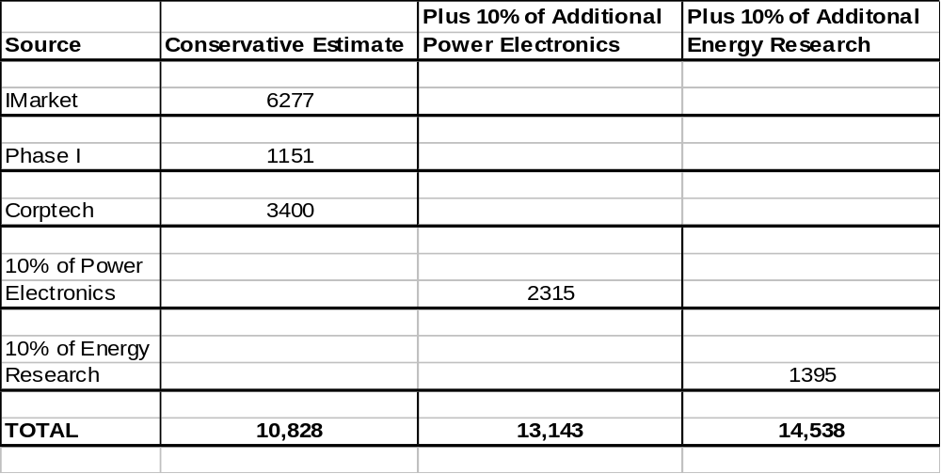 Sources (IMarket, Phase I, and Corptech)

Process for Bottom Up Approach
With rigorous analysis, 700 NAIC codes were culled to a final list of twenty-five based on relevance to clean energy in Massachusetts. These final NAIC codes are listed below:

: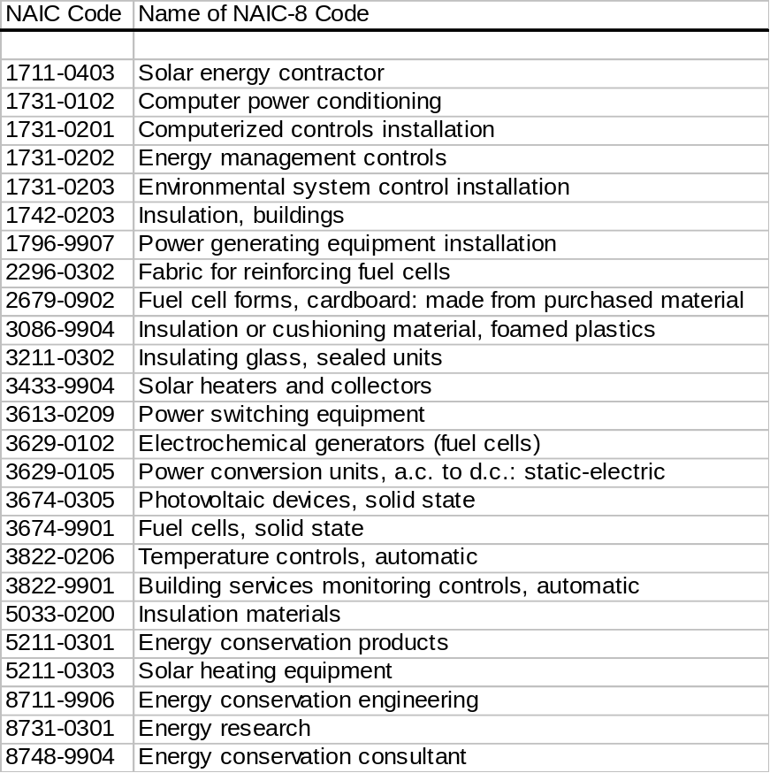

We followed a similar strategy in analyzing the Corptech data. A list of 170 possible codes was developed, and then subsequently narrowed by examining web pages and making direct telephone contact. These remaining codes were divided into three groups. The first group included firms clearly central to the clean energy sectors described in the text. A second group included companies contributing to clean energy via the power electronics sector. The last group combined energy research (clean and otherwise) with electrochemical research and development
A description of each of these groups is provided below:

Group I (Large percentage of clean energy firms in each category)
ENR-SV-C (Energy industry consulting services, HVAC consulting services)
ENR-SV-U (Electric utility/energy providing services)
ENR-SV-CE (Energy management consulting services)
ENR-SV-A (Energy usage analysis; electric power consulting services)
ENR-AL-SO (Solar collector components)
ENR-EM (Energy management)
ENR-EP-U (Uninterruptible power supply systems)
ENR-EP-F (Fuel cell stacks; fuel cells; power modules)
PHO-OE-EV (Photovoltaic cells)
SOF-FM-E (Web-based energy analysis software)

Group II (Power Electronics)
SUB-ES-CA (AC-to-DC converters)
SUB-ES-CB (DC-to-DC converters)
SUB-ES-CC (AC-to-AC converters)
SUB-ES-CD (DC-to-AC converters)
SUB-ES-I (Electrical Power Inverters)
SUB-ES-PP (Programmable Power Supplies)
SUB-ES-PY (Switching Regulated Power Supplies)

Group III (Research)
ENR-SV-R (Energy R&D; Electrochemical R&D services)

Surveys
UMASS conducted a written survey of core clean energy firms in Massachusetts. This survey was supplemented by telephone interviews of key firms in the energy efficiency and power electronics sectors. We also conducted telephone interviews with several industry experts.
The written survey was sent to 140 firms. Twenty six firms responded to the survey. Twelve firms indicated they were not involved in clean energy. The survey asked for lists of major products, with emphasis on those related to clean energy. The survey then focused on the proportion of firm business devoted to the clean energy segment. Firms were polled regarding new product potential in the clean energy sector, and were asked to provide a list of their major competitors, customers, and suppliers. Finally, they were asked about their current and projected employment and revenues.
REFERENCES

Austin Clean Energy Initiative (2002). Enriching Economy and Environment: Making Central Texas the Center for Clean Energy. IC² Institute, University of Texas, Austin. Nov. 2002.
Bernstein, M., Pernin, C., Loeb, S., and Hanson, M. (2002). The Public Benefit of Energy Efficiency to the State of Massachusetts. Report conducted by RAND Science and Technology for the Energy Foundation.

"The Clean Revolution: Technologies from the Leading Edge" http://www.cleanedge.com/reports-gbn.php
"The Clean Revolution: Technologies from the Leading Edge"
UCS website - http://www.ucsusa.org/clean_energy/renewable_energy/page.cfm?pageID=895#ref
ACEEE website - http://www.aceee.org/energy/pbf.htm
EWEA “Wind Energy – The Facts” Report, 2003, Volume 3
GE Chief Executive Jeffrey Immelt: http://www.electricityforum.com/news/may03/gewind.html
Clean Edge “Clean Energy Trends 2004”
http://www.spiresolar.com/index.html
University of Massachusetts Boston, “The Renewable Energy Industry in Massachusetts and New England,” Draft presentation to the Massachusetts Renewable Energy Trust, December 13, 2002.
“Massachusetts Biobased Fuels, Power and Products: State Fact Sheet,” The Biomass Research and Development Initiative, January 2003. http://www.bioproducts-bioenergy.gov/State/pdfs/MA_03.pdf
http://www.eia.doe.gov/cneaf/solar.renewables/page/rea_data/tablec3.html
http://www.ref-fuel..com/locations/semass.htm
http://www.biomasscombustion.com/
http://www.selectenergysi.com/services/default.asp?header=serv
Leadership in Energy and Environmental Design
Battelle/MassInsight, “Choosing to Lead: The Race for National R&D Leadership & New Economy Jobs.”
Clean Edge “Clean Energy Trends 2004”
Paul D. Maycock, Photovoltaic Energy Systems, Inc.
SEBANE, 2001
Navigant Consulting, June 2003.
International Energy Agency, World Energy Outlook 2002.
Navigant Consulting, June 2003.
“Global Wind Energy Market Report 2004,” American Wind Energy Association, March 10, 2004. http://www.awea.org/pubs/documents/globalmarket2004.pdf
“World Market Update 2003,” BTM Consult ApS, March 19, 2004. http://www.btm.dk/Documents/Pressrelease.pdf
U.S. Department of Energy website: http://www.eere.energy.gov/windandhydro/wind_dist_tech.html
"Global Markets, a 10 year perspective," Wind Directions, European Wind Energy Association, March/April 2004, pg 21-23. http://www.ewea.org/documents/wdmarch_lead.pdf
“Annual Energy Outlook 2004 with Projections to 2025,” U.S. Energy Information Administration, January 2004, http://www.eia.doe.gov/oiaf/aeo/index.html.
“Global Wind Energy Market Report 2004,” American Wind Energy Association, March 10, 2004.
EWEA: "Wind Energy - The Facts: Executive Summary." P.2 http://www.ewea.org/06projects_events/proj_WEfacts.htm
EWEA: "Wind Energy - The Facts: Executive Summary." P.2 http://www.ewea.org/06projects_events/proj_WEfacts.htm
EWEA: "Wind Energy - The Facts: Executive Summary." P.2 http://www.ewea.org/06projects_events/proj_WEfacts.htm
U.S. Department of Energy website: http://www.eere.energy.gov/windandhydro/wind_dist_tech.html
The Freedonia Group, Inc. February 23, 2004. Fuel Cells.
Cropper, Mark, Stefan Geiger and David Jollie. November 5, 2003. “Fuel Cell Systems: A survey of worldwide activity.” Fuel Cell Today.
For comparison, internal combustion engines cost $25-50 per kW, and natural gas turbines can be built for $450 per kW.
The Center for Smart Energy. January 2004. “Prospects for the Fuel Cell Sector in the Pacific Northwest,” as well as MTC due diligence and industry interviews.
PriceWaterhouseCoopers. 2003. “2003 Fuel Cell Industry Survey.” P. 3.
Source: VentureOne in: October 4, 2002. “Investment Perspective on the Fuel Cell Industry.” Battelle Energy Products, presented at the 2nd Annual Ohio Fuel Cell Symposium.
“Renewables for Power Generation: Status and Prospects,” International Energy Agency, 2003.
“Biomass: Frequently Asked Questions,” Oak Ridge National Laboratory, DATE
http://www.nrel.gov/analysis/repis/online_access.asp
"Annual Energy Outlook 2004 with Projections to 2025" http://www.eia.doe.gov/oiaf/aeo/electricity.html.
“Biomass: Frequently Asked Questions,” Oak Ridge National Laboratory, DATE
Solid Waste Association of North America’s website: http://www.swana.org/sections/educate/tec_wastetoenergy.aspx
“Annual Energy Outlook with Projectsions to 2025,” Energy Information Administration DOE/EIA-0383(2004), January 2004, http://www.eia.doe.gov/oiaf/aeo/.
U.S. Department of Energy, Energy Information Administration, “Renewable Energy Annual 2001 With Preliminary Data for 2001,” Washington, D.C., 2002.
U.S. Department of Energy Website: http://www.eere.energy.gov/windandhydro/hydro_potential.html
U.S. Department of Energy Website: http://www.eere.energy.gov/windandhydro/hydro_potential.html
U.S. Department of Energy Website: http://www.eere.energy.gov/windandhydro/hydro_potential.html
U.S. Department of Energy Website: http://www.eere.energy.gov/windandhydro/hydro_potential.html
U.S. Department of Energy, NREL Website www.nrel.gov/analysis/repis/online_access.asp
Kats, Gregory. “Green Building Costs and Financial Benefits.” Published by MTC, 2003.
Kats, Gregory. “Green Building Costs and Financial Benefits.” Published by MTC, 2003.
Kats, Gregory. “Green Building Costs and Financial Benefits.” Published by MTC, 2003.
Renewable Energy Policy Report (Singh, et al. 2001) and the EPRI (2001) technology.
Singh et al. (2001) & interviews. A small downward adjustment was made to reflect jobs already included in the PV, wind, and fuel cell sectors – and to otherwise eliminate double counting.
Estimated by examining the Mass. share of national manufacturing for some representative NAIC codes.
Mass DOER (2003).
Austin Clean Energy Initiative (2002).
Firms were identified by staff at the Massachusetts Technology Collaborative.

